
How to spot a government grant or free money scam
https://cyberguardlab.com/blog/government-grant-scam
Independent US household comparison site. Not the vendor. Paid links below may earn a commission. Confirm first-year price, renewal, device limit, and refund terms at checkout.
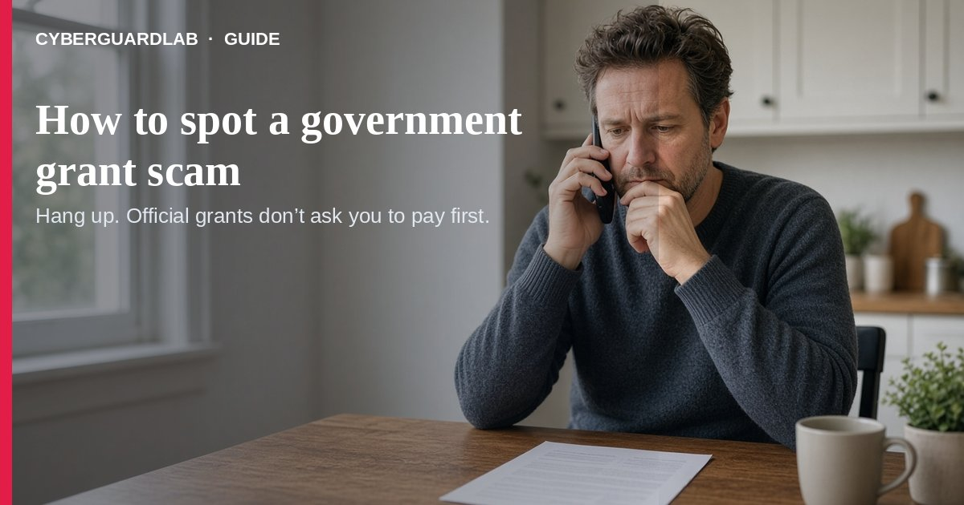
A government grant or “free money” scam promises cash, a personal grant, or stimulus that you did not apply for — then asks you to pay a fee, buy gift cards, send crypto, or share a Social Security or bank number. USA.gov is clear: the government does not offer free money or grants to people for personal needs. Federal grants are typically for states and organizations, not random household payouts. This guide is about unsolicited grant / free-money pitches, not fake IRS tax refunds, Social Security imposters, or student loan forgiveness scams. No purchase required.

1. What USA.gov says about “free money”
- Promises of free money from the government are often scams (texts, email, ads, websites).
- The government does not offer free money or grants for personal needs.
- Real federal help for living expenses goes through official benefit programs — search with USAGov’s benefit finder, not a stranger’s link.
- Grants.gov is mainly for organizations; grants are usually not for personal expenses. See also government grants and loans.

2. Red flags (stop before you pay)
- You never applied, but you “won” a grant or stimulus.
- They demand an upfront processing fee, taxes, or insurance to release the money.
- Payment must be gift cards, wire, cash apps, or cryptocurrency — classic gift card scam patterns.
- They pressure you to act now or lose the award.
- The message is a call, text, or email you did not start — USA.gov notes government agencies typically initiate contact by letter unless you contacted them first.
- Caller ID or a logo looks “official” — that can be spoofed (imposter scams).

3. What to do instead (buy-nothing)
- Hang up, delete the text/email, or close the ad — do not click “claim” links.
- Look up help only on official sites you type yourself: USA.gov no free money, benefit finder, and government grants and loans.
- If you already shared numbers or paid, contact your bank/card issuer, place freezes or fraud alerts as needed, and use IdentityTheft.gov if identity data was exposed.
- Report the pitch: ReportFraud.ftc.gov and USA.gov’s where to report a scam tool — also see our report scam to the FTC guide.
- Treat similar phishing emails the same way: never enter SSNs on pages from unexpected messages.

FAQ

Does the US government give free money grants to individuals for personal needs?
No. USA.gov states the government does not offer free money or grants to people for personal needs.
Paid link
Norton 360 | See the Norton first-year offer

See the Norton first-year offer
Offer page: https://cyberguardlab.com/norton
Ad link: https://trysecurities.com/offer/norton?dtm=gg&cid=

How do I spot a government grant scam?
Unsolicited award + fee/gift-card demand + urgency + contact you did not start. Verify only on USA.gov / Grants.gov yourself.

Where do I find real benefits or loans?
USAGov benefit finder for benefits; USA.gov government loans/grants pages for legitimate loan and organization-grant paths.

Where do I report a free-money scam?
ReportFraud.ftc.gov and USA.gov’s where-to-report tool. Also see how to report a scam to the FTC.

Do I need paid antivirus to avoid grant scams?
No. Judgment and official sites are enough for this scam type. Buy-nothing is valid.

If you still want a paid suite
Grant-scam hygiene does not require paid antivirus. Built-in browser warnings plus cautious habits are a valid buy-nothing stack. If you want multi-device paid protection, use only these on-site paid links: TotalAV (paid link), Norton (paid link), Bitdefender (paid link), McAfee (paid link), Avast (paid link).

Sources
- Avoid “free money” from the government scams (USA.gov)
- Government grants and loans (USA.gov)
- Imposter scams (USA.gov)
- Where to report a scam (USA.gov)
- Benefit finder (USA.gov)
- ReportFraud.ftc.gov

Also read
- How to spot a fake IRS tax refund scam
- How to spot a Social Security scam
- How to spot a student loan forgiveness scam
- How to spot a gift card scam
- How to report a scam to the FTC
- How to spot a phishing email

