
How to check unknown device logins in a Google account
https://cyberguardlab.com/blog/google-unknown-device-logins
Independent US household comparison site. Not the vendor. Paid links below may earn a commission. Confirm first-year price, renewal, device limit, and refund terms at checkout.
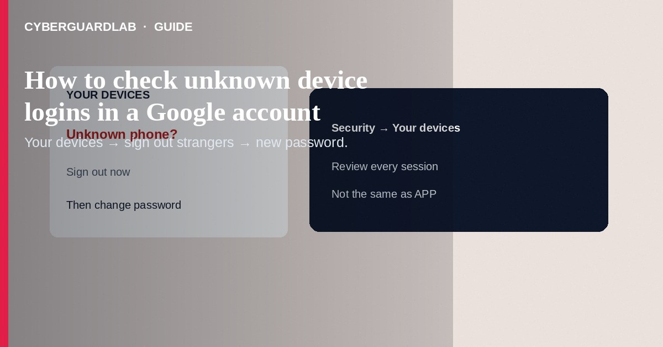
To check unknown device logins on a Google account, open myaccount.google.com → Security → Your devices (wording may say “devices” or “manage all devices”), review each phone, tablet, and computer, and sign out anything you do not recognize. Then change the password from a device you trust and review recent security activity. This how-to is session hygiene—not enrolling in Advanced Protection, not third-party app OAuth review alone, and not Find My Device setup.

1. Why this matters
A password leak or reused credential can leave an attacker signed in on a spare browser profile. APP raises future sign-in difficulty; device review removes sessions that are already there.
Paid link
Norton 360 | See the Norton first-year offer

See the Norton first-year offer
Offer page: https://cyberguardlab.com/norton
Shared Android tablets often stay signed into a parent Google account for years. After any password scare, remove old tablets from the device list even if “nobody hacks”—stale sessions are still sessions.

2. Legitimate vs suspicious cues
Cue | Likely fine | Investigate
Device name | Your current phone model / home PC | City or model you never owned
Timing | Matches when you traveled or used a hotel PC briefly | Sign-in while you slept, no travel
Duplicate browsers | Chrome on laptop + phone you use daily | Many “Windows” or “Linux” entries you never set up
Recovery changes | None, or ones you remember | New recovery email/phone you did not add

3. Steps: review devices and activity
- On a computer or phone you control, go to https://myaccount.google.com (type it; do not use an email link).
- Open Security.
- Under Your devices / Devices, select Manage all devices (labels vary).
- For each entry, check device name, location approximate, and last activity. Sign out / remove anything unknown.
- Open Recent security activity (or similar) and expand unfamiliar events—new sign-ins, password changes, recovery edits.
- If anything looks wrong: change password, turn on or strengthen 2-Step Verification, and review recovery phone/email.
- Review third-party apps with account access and revoke strangers.
- On Android, also check Settings → Google → Manage your Google Account → Security for the same device list when convenient.

4. If you find an unknown device
- Sign it out immediately from the devices page.
- Change the Google password on a clean device.
- Check Gmail filters, forwarding, and “less secure” leftovers if any remain.
- Alert banks if you reuse that password elsewhere (you should not).
- Scan personal PCs with Norton or Bitdefender; one primary product is enough (TotalAV, McAfee, Avast on-site).
- Consider Advanced Protection if you are a high-risk target and can manage keys.

FAQ

Google shows a city I visited last month—is that a hack?
Often it is your own session with coarse geolocation. Still sign out old hotel or library machines you forgot.

Is this the same as Advanced Protection?
No. Device review removes current sessions. APP changes how future sign-ins work.

Should I use an email “security alert” button?
Open myaccount.google.com yourself. Phishing emails fake those alerts.

Do I need to wipe my phone?
Not for a remote browser session alone. Wipe only if the phone itself is compromised or stolen—after backing up if you still control it.

If you still want a paid suite
Avoiding how to check unknown device logins in a Google account does not require paid antivirus. Careful habits and official support paths are a valid buy-nothing stack. If you want multi-device paid protection later, use only these on-site paid links: TotalAV (paid link), Norton (paid link), Bitdefender (paid link), McAfee (paid link), Avast (paid link).

Sources
- Google Account Help: Manage devices
- Google Account Help: Security checkup
- CISA: Compromised accounts guidance (general)
- FTC: IdentityTheft.gov

Also read
- How to turn on Google Advanced Protection Program
- How to review Google account third-party app access
- How to spot a fake Google Play billing phishing email
- How to turn on enhanced Safe Browsing in Chrome
- How to check if your email was in a data breach

