
How to turn on Google Prompt instead of SMS codes
https://cyberguardlab.com/blog/google-prompt-instead-of-sms
Independent US household comparison site. Not the vendor. Paid links below may earn a commission. Confirm first-year price, renewal, device limit, and refund terms at checkout.
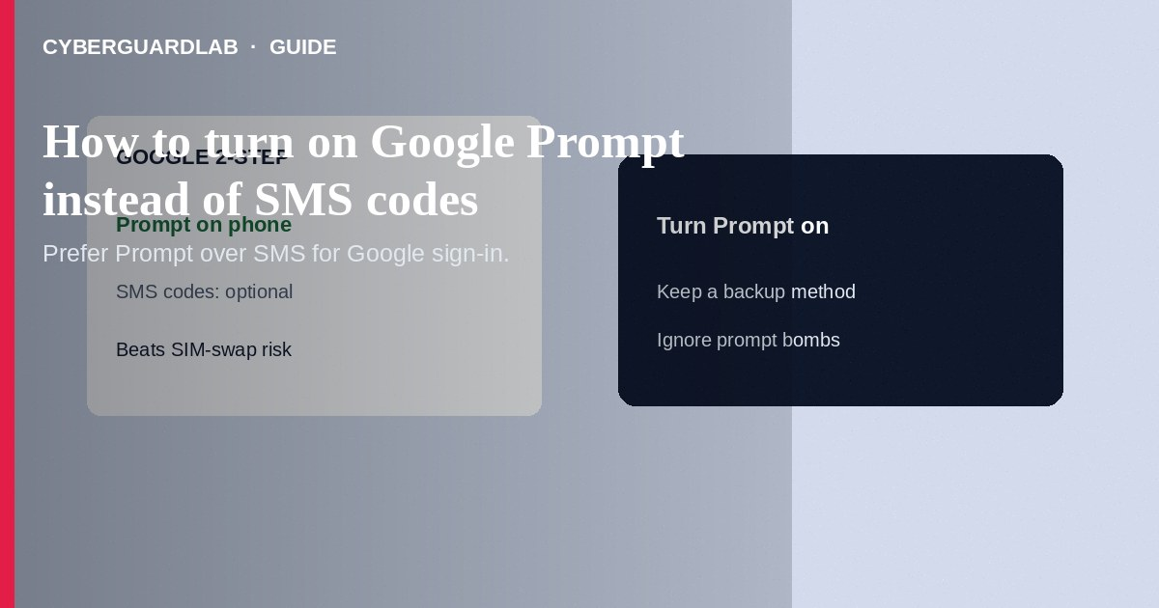
Google Prompt (phone prompts in 2-Step Verification) asks you to approve a Google sign-in on a trusted phone instead of typing an SMS code—cutting off many SIM-swap and fake-text attacks that target SMS. Turn on 2-Step Verification in your Google Account, add a phone for prompts, then remove SMS as a primary second step when Google’s settings allow stronger options. Keep backup codes offline. This how-to is about Google Prompt vs SMS—not migrating third-party authenticator apps, not spotting fake 2FA texts in general, and not carrier number lock setup (still recommended as a parallel control).

1. Why Prompt beats SMS for Google
SMS codes can be stolen via SIM swap, SS7-style interception, or by tricking you into reading a code. A prompt appears on a device already signed into your Google Account and shows sign-in context you can deny. You should still deny unexpected prompts and pair Prompt with a strong password plus backup codes or a security key when possible.
Paid link
Norton 360 | See the Norton first-year offer

See the Norton first-year offer
Offer page: https://cyberguardlab.com/norton
Attackers who know your password may send repeated prompts hoping you tap Yes out of annoyance. Always choose No for prompts you did not initiate, then change the password from a known-good device.

2. Prompt vs SMS vs authenticator
Method | Strength vs SMS phishing | Typical failure mode
SMS code | Weakest common option | SIM swap; you read the code to a scammer
Google Prompt | Stronger—tied to a trusted device | You tap Yes on a prompt you did not start
Authenticator app (TOTP) | Strong vs SMS interception | Phone loss without backup codes
Security key / passkey | Among the strongest | Lost key without a spare enrollment

3. Steps: turn on Google Prompt
- On a browser you trust, open myaccount.google.com (type it yourself).
- Go to Security → 2-Step Verification. Sign in again if asked. Turn on 2-Step Verification if it is off, following Google’s enrollment flow.
- Add or confirm a phone that can receive Google prompts (Google Account Help documents Prompt / Google phone prompts under 2-Step Verification). Use a device you control, with a screen lock.
- Under 2-Step Verification, review second steps: prefer Prompt, authenticator app, passkeys, or security keys over Text message when Google offers the choice for your account.
- Generate and print backup codes; store them offline. Do not keep the only copy in SMS.
- Optionally add an authenticator app as another second step before you remove weaker options—see moving authenticators if you are changing phones.
- Test: sign out and sign in once; approve the prompt on your phone. Practice tapping No / Don’t allow on a prompt you did not start (then cancel).
- Harden the phone: OS updates, carrier number lock, and malware scanning with a trusted tool such as Norton or Bitdefender if the device was phished. Keep one primary real-time antivirus—avoid stacking full suites. TotalAV, McAfee, and Avast are other on-site comparison options.

4. If something goes wrong
- Unexpected prompt: tap No, change your Google password, review recent security activity in the Google Account, and sign out unknown devices.
- New phone: add Prompt on the new device before wiping the old one; keep backup codes handy.
- Locked out: use backup codes or Google’s official account recovery—not paid “unlock Google” services.
- Only SMS still available: add Prompt or authenticator as soon as Google’s UI offers it for your account type.

FAQ

Is Google Prompt the same as an authenticator app?
No. Prompt pushes an approve/deny challenge to a Google-signed-in phone. Authenticator apps show rotating numeric codes for many sites.

Will Prompt stop all account takeovers?
No method is perfect. Prompt removes a large SMS attack path; you must still deny surprise approvals and protect recovery email and backup codes.

Should I delete my phone number from Google entirely?
Follow Google Account Help for recovery options. Many people keep a number for recovery while turning off SMS as the day-to-day second step—choose what Google documents for your account.

Do I still need carrier number lock?
Yes. Protecting the number helps other accounts that still use SMS and reduces takeover of the phone itself.

If you still want a paid suite
Avoiding how to turn on Google Prompt instead of SMS codes does not require paid antivirus. Careful habits and official support paths are a valid buy-nothing stack. If you want multi-device paid protection later, use only these on-site paid links: TotalAV (paid link), Norton (paid link), Bitdefender (paid link), McAfee (paid link), Avast (paid link).

Sources
- Google Account Help: 2-Step Verification
- Google Account Help: Sign in with Google phone prompts
- Google Account Help: Backup codes
- FTC: Recognize phishing
- IdentityTheft.gov

Also read
- How to spot a fake two-factor authentication text
- How to move authenticator apps to a new phone safely
- How to set a carrier account PIN to stop SIM swap
- How to turn on number lock at T-Mobile, Verizon, or AT&T
- How to run a Google Account Security Checkup

