
How to turn on Google Find My Device before you lose a phone
https://cyberguardlab.com/blog/google-find-my-device-setup
Independent US household comparison site. Not the vendor. Paid links below may earn a commission. Confirm first-year price, renewal, device limit, and refund terms at checkout.
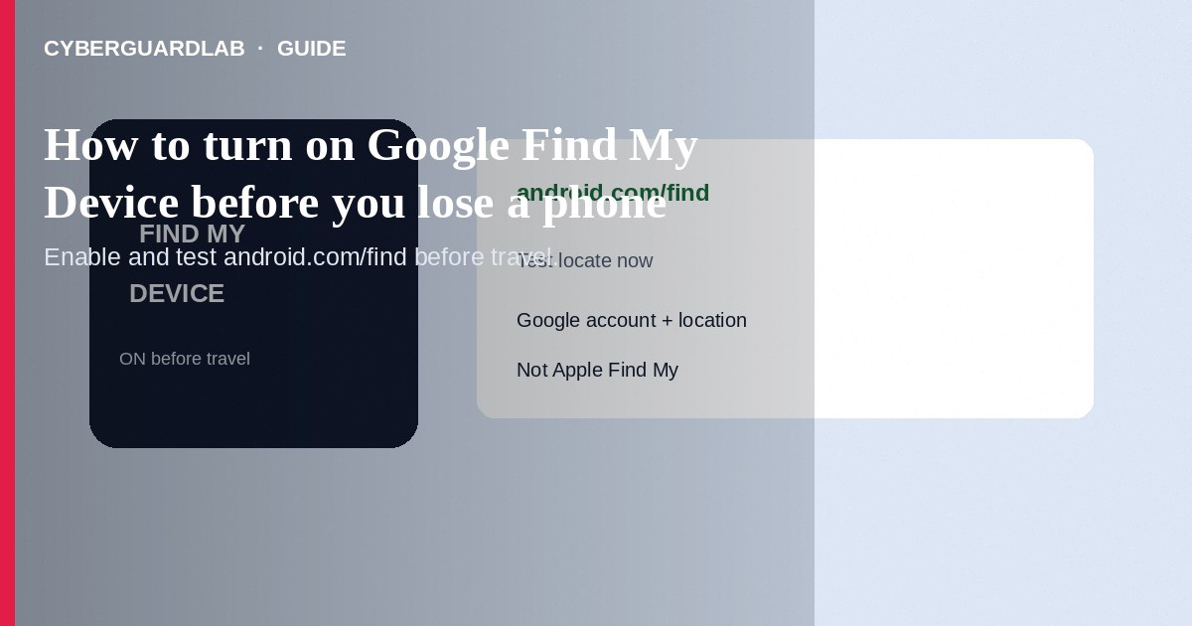
Turn on Google’s lost-device tools (Find My Device, also labeled Find Hub on newer Android builds) *before* you lose the phone: sign in with a Google Account, set a screen lock, allow the device to be located, and practice opening android.com/find from another computer. That lets you ring, lock, or erase later. This how-to is Android/Google prep—not Apple Find My / Activation Lock, not erasing a lost Apple Watch, and not Chrome Enhanced Safe Browsing.

1. Why set this up early
Remote locate/lock/erase only works if the account, Find setting, and (for strong offline finding) a screen lock were already in place. After a theft is the wrong time to discover location sharing was off.
Paid link
Norton 360 | See the Norton first-year offer

See the Norton first-year offer
Offer page: https://cyberguardlab.com/norton
If your only 2SV method is the phone you just lost, backup codes or a security key are what let you into android.com/find. Print or store backup codes offline when you first enable Find My Device—not after the bag is gone.

2. Find My Device vs Apple Find My
Topic | Google / Android | Apple
Setup place | Android Settings + Google Account | Settings → [Your Name] → Find My
Web console | android.com/find | icloud.com/find
Activation-style lock | Factory reset protection / account locks (varies) | Activation Lock with Apple Account
This guide | Yes—enable before loss | See travel Find My guide

3. Steps: enable before you need it
- Update Android. Add the Google Account you will use for recovery.
- Set a PIN, pattern, or password screen lock (biometrics alone are not enough for all Find network features).
- Open Settings and find Find My Device / Find Hub (paths vary): commonly Settings → Google → Find My Device / All services → Find Hub, or Settings → Security → Find My Device.
- Turn on Find My Device / Allow device to be located (wording varies by version).
- Review offline finding / Find network options if shown—understand that participating networks help locate powered devices even without your own data connection.
- On a second device or computer, open https://android.com/find, sign in with the same Google Account, and confirm this phone appears.
- Optionally install Google’s Find Hub / Find My Device app from Play Store on a spare Android for easier guest/help flows.
- Turn on 2-Step Verification for the Google Account and save backup codes or a hardware security key so you can still reach android.com/find if the phone was your only second factor.

4. If the phone goes missing later
- From another browser: android.com/find → select device → Play sound, Secure device, or Erase as appropriate.
- Change the Google password; review third-party app access.
- Call your carrier to suspend service; file local reports as needed.
- Ignore “Google Support” texts that ask for remote access—open only official URLs you type.

FAQ

Is Find Hub different from Find My Device?
Google has been renaming and expanding the experience; Settings labels differ by Android version. Functionally you still need locate permission on and the same Google Account on android.com/find.

Does this work without mobile data?
Online locate needs connectivity on the lost device for classic ringing/erasing. Offline network features depend on settings, screen lock, and nearby Android devices—enable them before travel.

Will erase remove the Google Account FRP lock?
Factory Reset Protection is meant to keep thieves from freely using a reset phone with your account. Do not share account passwords to “help unlock” a phone you do not own.

Can I use this for iPhone?
No. Use Apple Find My for iPhone and Watch.

If you still want a paid suite
Avoiding how to turn on Google Find My Device before you lose a phone does not require paid antivirus. Careful habits and official support paths are a valid buy-nothing stack. If you want multi-device paid protection later, use only these on-site paid links: TotalAV (paid link), Norton (paid link), Bitdefender (paid link), McAfee (paid link), Avast (paid link).

Sources
- Google Account Help: Be ready to find a lost Android device
- Android Help: Find, secure, or erase a lost device
- Find Hub web
- FTC: Secure your phone

Also read
- How to erase an Apple Watch after it is lost
- How to turn on Find My and Activation Lock before travel
- How to lock a lost phone on Apple or Google
- How to use a work profile to isolate risky Android apps
- How to review Google account third-party app access

