
How to review who can access your Google Drive files
https://cyberguardlab.com/blog/google-drive-sharing-permissions-review
Independent US household comparison site. Not the vendor. Paid links below may earn a commission. Confirm first-year price, renewal, device limit, and refund terms at checkout.
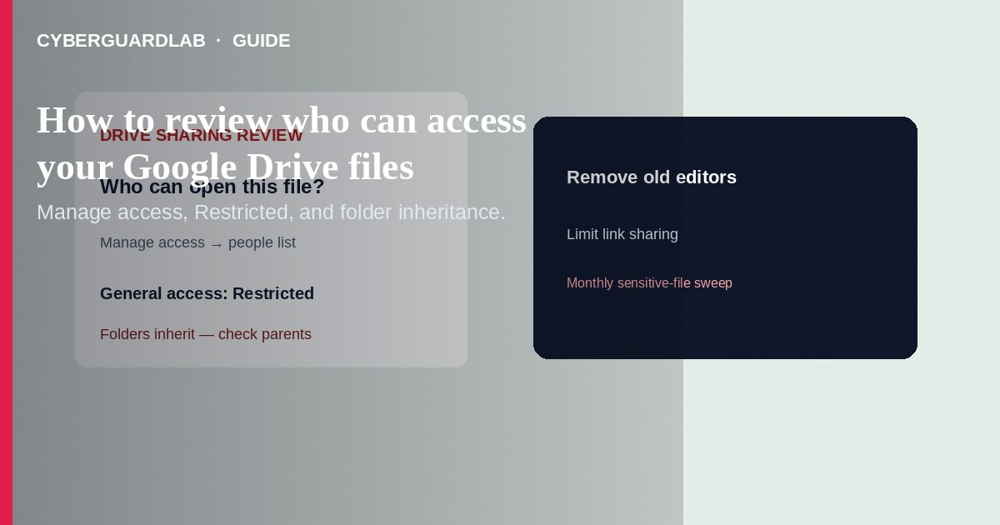
A Google Drive sharing permissions review is when you check who can open, comment on, or edit your files and folders—and whether “anyone with the link” is wider than you intended. Google Support explains how to see owners and people with access, use Manage access, set general access to Restricted, remove people, and understand that folder permissions inherit to files inside. This guide is a household how-to for reviewing Drive sharing. It is not a third-party Google app OAuth audit and not a full Google Account Security Checkup walkthrough (those are related but separate).

Why review Drive sharing
- Old school projects, tax PDFs, and kid photos often stay shared long after the need ends.
- Editors can usually change sharing unless you turn that off as the owner.
- Parent-folder access can keep people in even when you try to lock one file—Google documents inheritance clearly.
- Link sharing set to “Anyone with the link” can spread farther than a closed family circle.

Step-by-step: review one file or folder
- On a computer, open Google Drive and find the file or folder.
- Right-click → File information → Details (or use Share / the info panel). Google Support: the panel shows who owns the item and who has access.
- If you can change permissions, click Manage access.
- Review People with access — remove anyone who no longer needs Viewer / Commenter / Editor.
- Review General access — for private household files, set it to Restricted so only people you named can open the file (this overrides inherited parent-folder link openness for that item, per Google).
- Click Done / Save after changes.

Folder inheritance (do not skip)
Situation | What Google says happens | Household tip
Paid link
Norton 360 | See the Norton first-year offer

See the Norton first-year offer
Offer page: https://cyberguardlab.com/norton
You share a folder | Files and subfolders inside get the same sharing update; later files inherit too | Treat a shared folder as a shared box—everything inside is in scope
You try to give someone less access to one file than the parent folder | Drive may prompt you to change the parent folder instead | Move the sensitive file into its own limited-access folder if you need tighter control
You remove someone from a folder | Removal applies to files/subfolders inside (unless they have higher access on a specific file) | Re-check important files after big folder cleanups
Need a tighter pocket inside a shared folder | Use a limited access subfolder and add only the people who should see it | Good for “taxes 2025” inside a broader family Drive folder

Extra owner controls worth checking
- Stop sharing with one person — Share → find the person → Down arrow → Remove access → Save.
- Editors cannot reshare — As owner: Share → Settings (gear) → uncheck Editors can change permissions and share. Note: folder-level shares can still widen access to files inside that folder.
- Limit download/print/copy for viewers/commenters where Google offers those checkboxes (owner setting).
- Expiration (eligible work/school accounts) — temporary access dates where available; personal accounts may not see every Workspace option.

A practical monthly checklist
- Search Drive for files you know are sensitive (tax, ID scans, medical, passwords notes).
- Open Share / Manage access on each; confirm people + Restricted.
- Review top-level shared folders you own; remove old classmates, contractors, or ex-roommates.
- Check Shared with me for folders you no longer need—remove them from your view if appropriate (does not always revoke others’ access).
- Pair this with a Google Account security pass when you have time (separate guide).

FAQ

How do I see who has access to a Drive file?
On computer: right-click → File information → Details, then Manage access if you can edit permissions (Google Drive Help).

What does “Restricted” mean under General access?
Only people with access can open the file. Google notes Restricted can override inherited parent-folder openness for that item.

Why can’t I make one file more private than its folder?
Folder permissions are the primary source of truth for items inside. Move the file to a folder you control or use limited access, per Google’s folder-sharing help.

Does reviewing Drive sharing replace reviewing third-party apps?
No. Drive sharing is about file/folder people and links. App access (OAuth) is a different review—see the related third-party app guide.

Do I need paid antivirus to review Drive permissions?
No. This is an account/settings habit. Microsoft Defender or built-in protections are fine for everyday browsing; buy-nothing is valid.

If you still want a paid suite
Reviewing Drive permissions does not require paid antivirus. If you still want multi-device paid protection, use only these on-site links: Norton (paid link), Bitdefender (paid link), TotalAV (paid link), McAfee (paid link), Avast (paid link).

Extra caution
After you change sharing, open the file in a private window or ask a trusted household member whether they can still open an old link—confirm Restricted really stuck.

Sources
- Google Drive Help: Stop, limit, or change sharing
- Google Drive Help: Share folders in Google Drive
- Google Drive Help: Limited access to files and folders

Also read
- Review Google third-party app access
- Google Account Security Checkup
- Sign in with Apple permissions review
- Is Microsoft Defender enough?
- Password manager setup for households
- Clear saved passwords on a shared PC

