
How to get a free annual credit report and read it
https://cyberguardlab.com/blog/free-annual-credit-report-how-to
Independent US household comparison site. Not the vendor. Paid links below may earn a commission. Confirm first-year price, renewal, device limit, and refund terms at checkout.
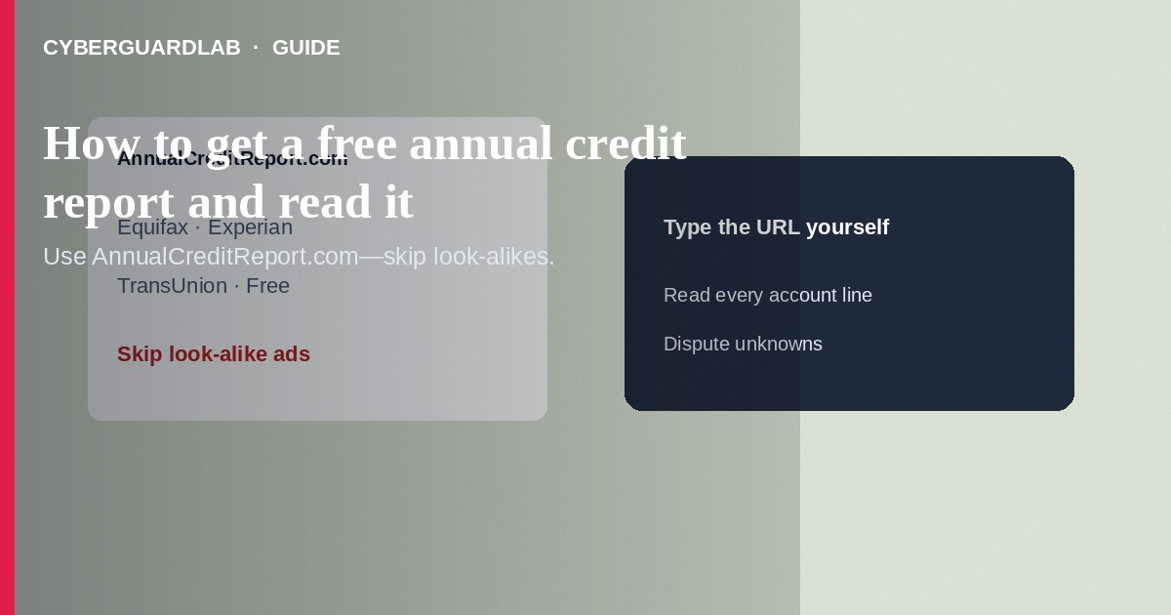
Your free annual credit reports from Equifax, Experian, and TransUnion are available through AnnualCreditReport.com—the only federally authorized centralized source for free weekly online reports under current FTC guidance periods, and for your statutory free annual reports. Order reports yourself, read every section for accounts, inquiries, and personal data errors, then dispute problems with the bureaus and furnishers. This how-to is about getting and reading free reports—not placing a credit freeze, not diagnosing synthetic identity theft in depth, and not disputing a single card charge with your issuer.

1. Why pull reports regularly
Credit reports list loans, cards, collections, public records (where applicable), and who inquired about your credit. Errors and fraud show up here before you notice a collection call. You do not need a paid “credit monitoring upsell” to obtain the free statutory reports—start at AnnualCreditReport.com, which you type yourself.
Paid link
Norton 360 | See the Norton first-year offer

See the Norton first-year offer
Offer page: https://cyberguardlab.com/norton
Ads that promise free reports but funnel you into recurring trials often bury cancellation. Bookmark AnnualCreditReport.com. Teach family members that a free score widget is not a substitute for reading full bureau reports.

2. Legitimate vs look-alike sites
Cue | Likely legitimate | Likely scam / upsell trap
URL | AnnualCreditReport.com you typed | Look-alike domains, ad redirects, or “freeScore” clones
Cost for the report itself | Free statutory report | Must buy a membership to “unlock” the free report
Contact origin | You initiated the visit | Cold email “Your free report is ready—click here”
Data asked | Identity questions consistent with bureau verification | Gift cards, crypto, or remote-access apps to “verify”

3. Steps: get and read your reports
- Open https://www.annualcreditreport.com/ yourself in a browser. Do not follow ads that say “free credit report” and push paid memberships first.
- Start a request for Equifax, Experian, and TransUnion. Online is fastest when available; phone and mail options exist if you prefer.
- Complete identity verification questions. If you fail automated questions, use the site’s alternate paths—do not call numbers from a random email.
- Download or save PDFs for each bureau. Label files with the bureau name and date; store them securely.
- Repeat on a schedule (for example, staggered monthly checks or weekly online checks while free weekly online reports remain available per FTC announcements). Mark your calendar.
- If identity theft is already confirmed, use IdentityTheft.gov for extra free report rights tied to your case.
- Personal information: Confirm name spellings, addresses, employer data, and SSN truncated digits. Strange addresses can signal fraud or mixed files.
- Accounts: Check every credit card, loan, and collection. Flag accounts you never opened, wrong balances, or accounts still open after you closed them.
- Inquiries: Hard inquiries you do not recognize deserve follow-up—especially clusters before new fraudulent accounts.
- Negative items: Note late payments, charge-offs, and collections. Decide whether they are accurate, outdated beyond reporting limits, or fraudulent.
- Cross-bureau differences: One bureau may show an account another lacks. Review all three before assuming you are clean.
- Next actions: Dispute errors with the bureau and the creditor; freeze credit if fraud appears; see synthetic identity cues if the file mixes strangers’ data with yours.

4. If you find problems
- Dispute inaccurate items online or by mail with the bureau that shows them; also notify the furnisher (creditor).
- Place freezes at all three bureaus if you see accounts you did not open.
- Report identity theft at IdentityTheft.gov and follow the recovery plan.
- For a single unauthorized card purchase, contact the issuer’s fraud line—see dispute fraudulent credit card charges.
- If a fake report site stole your login, change passwords and scan with a trusted tool such as Norton or Bitdefender. Keep one primary real-time antivirus—avoid stacking full suites. TotalAV, McAfee, and Avast are other on-site comparison options.

FAQ

Is AnnualCreditReport.com the same as a free FICO score app?
No. The site provides free credit reports. Scores may be offered elsewhere and are not the same product as your full bureau reports.

How often can I get free reports?
You are entitled to a free report from each nationwide bureau every 12 months under the Fair Credit Reporting Act. Online weekly free reports have also been available through AnnualCreditReport.com during FTC-supported periods—check the site’s current notice when you visit.

Do I need to buy monitoring to see my report?
No. Paid monitoring is optional. Free reports do not require a subscription.

Will checking my own report hurt my score?
Requesting your own report is a soft process and does not harm your score the way a lender’s hard pull can.

If you still want a paid suite
Avoiding how to get a free annual credit report and read it does not require paid antivirus. Careful habits and official support paths are a valid buy-nothing stack. If you want multi-device paid protection later, use only these on-site paid links: TotalAV (paid link), Norton (paid link), Bitdefender (paid link), McAfee (paid link), Avast (paid link).

Sources
- AnnualCreditReport.com
- FTC: Free credit reports
- FTC: Credit freezes and fraud alerts
- IdentityTheft.gov
- FTC ReportFraud

Also read
- How to place a credit freeze at all three bureaus
- How to spot synthetic identity theft on a credit file
- How to dispute a fraudulent credit card charge
- Credit freeze vs identity monitoring
- How to replace a stolen Social Security card safely

