
How to turn on Find My and Activation Lock before travel
https://cyberguardlab.com/blog/find-my-activation-lock-before-travel
Independent US household comparison site. Not the vendor. Paid links below may earn a commission. Confirm first-year price, renewal, device limit, and refund terms at checkout.
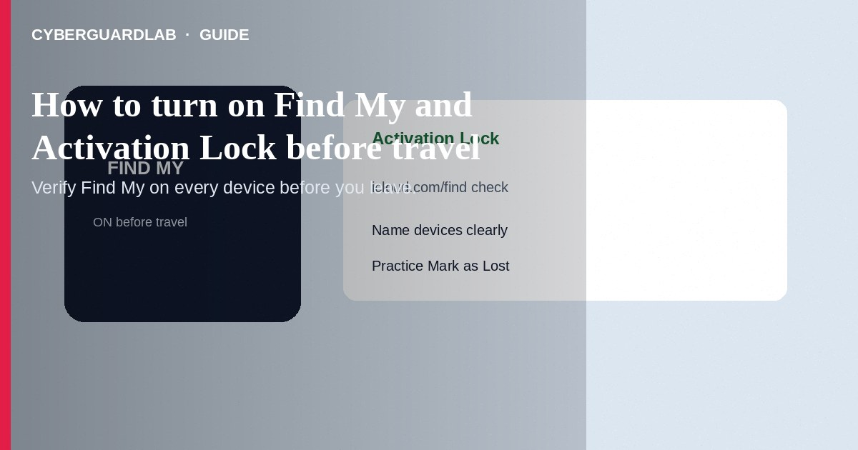
Before you travel, turn on Find My for iPhone, iPad, Mac, and AirTags you carry, and confirm Activation Lock is active via your Apple Account so a thief cannot easily reactivate the device with another account. Also note your device names in iCloud.com/find and practice Mark as Lost. This how-to is about Find My + Activation Lock readiness for trips—not Sign in with Apple permission review, not Advanced Data Protection, and not Hide My Email.

1. Why this matters before travel
Hotels, transit, and rental cars raise loss/theft risk. Find My helps locate or play a sound; Activation Lock ties activation to your Apple Account password after erase. These features do not replace travel insurance or a strong device passcode.
Paid link
Norton 360 | See the Norton first-year offer

See the Norton first-year offer
Offer page: https://cyberguardlab.com/norton
Anyone who offers to “unlock Find My” for a fee or asks for your Apple Account password/codes is not Apple. Use support.apple.com or the Apple Support app yourself. Activation Lock exists to frustrate thieves—do not disable it for strangers.

2. Find My vs related Apple privacy features
Feature | Purpose | Travel note
Find My + Activation Lock | Locate/lock/erase; block reactivation | Turn on before you leave home
Advanced Data Protection | End-to-end encrypt more iCloud categories | Useful long-term; set up with recovery contact/key before trips—see ADP guide
Sign in with Apple | App login permissions | Review apps separately; not a theft deterrent
Hide My Email | Relay addresses for sign-ups | Handy for hotel/Wi-Fi portals; not Find My

3. Steps: turn on Find My and verify Activation Lock
- Update iOS/iPadOS/macOS. Use a strong device passcode and keep the Apple Account password only you know.
- On iPhone/iPad: Settings → [Your Name] → Find My → Find My iPhone/iPad → turn on. Enable Find My network and Send Last Location when offered.
- On Mac: System Settings → [Your Name] → Find My → Find My Mac → turn on.
- Confirm you are signed into the same Apple Account you will use on the road. Activation Lock turns on automatically when Find My is enabled with that account.
- Visit icloud.com/find (or the Find My app on another Apple device) and verify each device appears with a sensible name (e.g., “Travel iPhone”).
- Optionally enable Lost Mode features awareness: know how to Mark as Lost, erase remotely, and view Activation Lock status after erase.
- Pack a backup charging cable; low battery kills tracking usefulness. Do not share Apple Account codes with anyone who “helps” at the airport—that pattern matches support scams.
- Antivirus on accompanying Windows laptops is separate—use Norton, Bitdefender, or other on-site options (TotalAV, McAfee, Avast) as your chosen primary suite.

4. If a device goes missing on the trip
- Use Find My ASAP: play sound, Mark as Lost with a phone number you can answer, watch the map.
- Change the Apple Account password from a trusted device if theft is likely.
- Report to local police and your carrier for IMEI/service as needed; erase only when you accept you may not recover the hardware.
- Watch for fake iCloud storage phishing emails that appear after a loss—open iCloud only via appleid.apple.com / account.apple.com you type yourself.

FAQ

Is Activation Lock separate from Find My?
Activation Lock is enabled when Find My is on with your Apple Account. Turning Find My off (and completing sign-out properly) is required before you sell a device.

Does Find My work without cellular data?
It can use Wi-Fi and the Find My network of nearby Apple devices. Offline devices may show last known location.

Should I enable ADP the night before a flight?
Only if you already understand recovery contacts/keys. Last-minute ADP setup without a recovery plan risks lockout—see Advanced Data Protection.

Will Find My stop someone from reading an unlocked phone?
No. Use a passcode/Face ID/Touch ID and auto-lock. Find My helps after loss; it does not replace screen lock.

If you still want a paid suite
Avoiding how to turn on Find My and Activation Lock before travel does not require paid antivirus. Careful habits and official support paths are a valid buy-nothing stack. If you want multi-device paid protection later, use only these on-site paid links: TotalAV (paid link), Norton (paid link), Bitdefender (paid link), McAfee (paid link), Avast (paid link).

Sources
- Apple Support: Set up Find My on iPhone
- Apple Support: Activation Lock
- Apple Support: If your iPhone is lost or stolen
- FTC: Laptop and phone security tips

Also read
- How to turn on Advanced Data Protection for iCloud
- How to spot a fake iCloud storage full phishing email
- How to review Sign in with Apple app permissions
- How to use Hide My Email for new sign-ups
- How to lock a lost phone on Apple or Google

