
How to spot a fake Zoom meeting invite phishing email
Read online: https://cyberguardlab.com/blog/fake-zoom-meeting-invite-phishing
Published September 27, 2026 · Updated September 27, 2026
Short answer
Ignore Join links in unexpected Zoom invites from unknown senders; confirm the meeting with the host through a channel you already trust; join only inside the official Zoom app or zoom.us you open yourself — never type work or personal passwords on a cold invite page.
Advertising disclosure: CyberGuardLab is an independent comparison site. We are not TotalAV, Norton, Bitdefender, McAfee, or Avast. If you buy through our links, we may earn a commission, which can affect ranking and placement.
Independent US household comparison site. Not the vendor. Paid links below may earn a commission. Confirm first-year price, renewal, device limit, and refund terms at checkout.
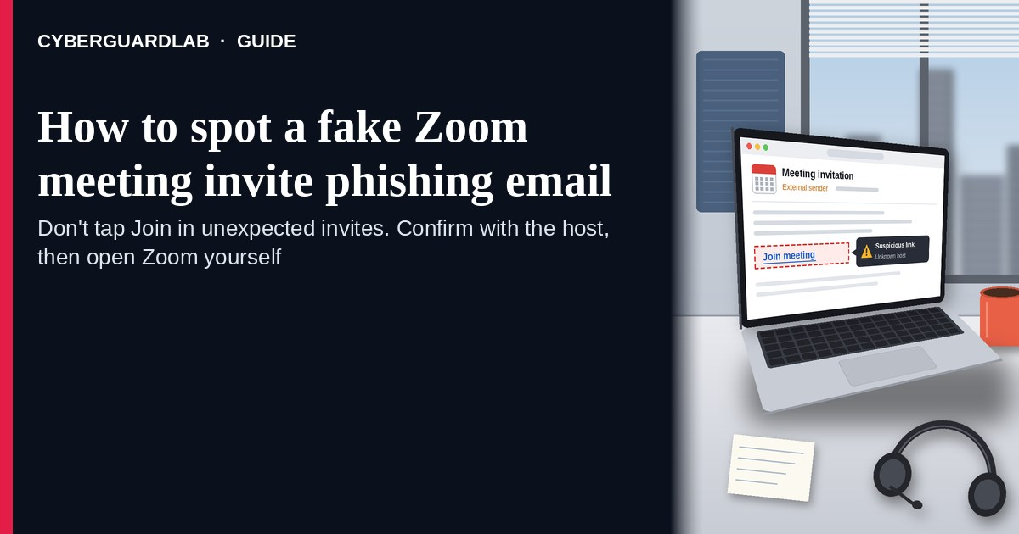
A fake Zoom meeting invite phishing email (or calendar invite) is designed to look like a normal “Join Zoom Meeting” notice so you tap a link that harvests work or personal passwords — or drops malware. Real Zoom meetings are joined from the official Zoom app or zoom.us session you open yourself, or from an invite you already expected from a known host. The FTC’s phishing guidance is clear: do not click links or open attachments in unexpected messages; if you think a meeting might be real, confirm with the host through a channel you already trust, then join only inside Zoom you started yourself. Never enter your work or personal password on a cold invite page. This lure is a cousin of LinkedIn recruiter phishing and other credential-harvest emails such as fake Microsoft 365 renewal. CyberGuardLab is independent. Referral fees may affect product placement on other pages. Buying nothing and sticking to free verification habits is a valid outcome.

The short answer
Ignore Join links in unexpected Zoom invites from unknown senders; confirm the meeting with the host through a channel you already trust; join only inside the official Zoom app or zoom.us you open yourself — never type work or personal passwords on a cold invite page.
Paid link
Norton 360 | See the Norton first-year offer

See the Norton first-year offer
Offer page: https://cyberguardlab.com/norton
Ad link: https://trysecurities.com/offer/norton?dtm=gg&cid=

What a fake Zoom invite usually looks like
Scammers copy Zoom calendar language: “You are invited to a Zoom meeting,” “Passcode,” “Join from PC, Mac, iOS,” or “Waiting room.” The job is a look-alike login page, a malware download dressed as a “Zoom client update,” or both.
Common shapes US households report:
- Unexpected calendar invite or email from a stranger, a misspelled coworker name, or a “HR / IT / vendor” address you do not recognize.
- Join URL that is not zoom.us / zoom.com — shortener, random form host, or look-alike domain that opens a fake Microsoft / Google / Zoom login.
- Attachment labeled “agenda,” “Zoom_Meeting,” or “client update” that asks you to enable macros or install software.
- Urgent “join in 5 minutes — board / interview / school meeting” pressure so you skip checking the host.
- Password harvest after the tap — the page asks for the same email password you use at work or for personal mail, then may prompt for a second “Zoom” password. Similar cold credential ask: School parent portal phishing.
FTC phishing guidance: do not click links or open unexpected attachments; if you think it might be real, contact the person or company with a channel you know is real; report at ReportFraud.ftc.gov.
We do not claim Zoom “never sends email invites.” Zoom and calendar tools send real invites every day. The safe habit is always the same: unexpected invite from an unknown sender → confirm the host first → join only inside the official Zoom app or a zoom.us session you start yourself.

Fake Zoom invite vs real invite vs related phishing
Signal | Fake Zoom meeting invite | Real Zoom / calendar invite (typical) | Related credential phishing
Opening hook | “Join Zoom Meeting” from a stranger or odd look-alike name. | Meeting you already expected from a known host / school / workplace. | “Renew Microsoft 365” or “recruiter job link” password harvest.
Ask | Cold Join link to a non-Zoom domain, fake login, or odd attachment. | Join inside Zoom app / zoom.us; host details match someone you know. | Sign-in on a look-alike Microsoft, Google, or LinkedIn page.
Pressure | “Starts in 5 minutes,” interview, payroll, or school urgency. | Normal calendar timing; you can confirm the host first. | Account lock, job deadline, or renewal countdown.
Safe next step | Do not Join. Confirm host on a known channel; open Zoom yourself. | Join only from official Zoom after host check if anything feels off. | See related phishing guides; never reuse passwords on cold pages.
Related guide | This page | Official Zoom app / zoom.us typed by you | LinkedIn recruiter phishing · Fake Microsoft 365 renewal
If the page after Join asks for your work email password, Microsoft / Google password, or a “Zoom account password” you do not normally use that way, stop — that is credential theft dressed as a meeting.

How to verify a Zoom meeting invite (US household steps)
Do this when any unexpected Zoom invite or Join email appears. You do not need a paid product to finish these steps.
- Do not tap Join, open the attachment, or enter a password on a page that arrived from the invite. Close the email or calendar item if the sender is unknown or the topic is surprising.
- Confirm the meeting with the host through a channel you already trust. Call, text, or message the person using a number or chat thread you already have — not a Reply-All on the suspicious invite.
- Join only inside the official Zoom app or a zoom.us session you start yourself. Open Zoom from your home screen or type zoom.us; find the meeting under your normal signed-in account or enter a meeting ID the confirmed host gave you.
- Never enter work or personal passwords on a cold invite page. Real Zoom joins do not need your Microsoft, Google, or email password on a random form that appeared from an unexpected invite. Watch for look-alike domains and “Sign in with Microsoft / Google” traps.
- If you already tapped, typed a password, or installed something from the invite, treat the first hour as incident response. Change the password you typed from a device and site you trust; turn on 2FA if it was off; tell work IT if it was a work account. Follow Clicked a phishing link — first hour. Report at ReportFraud.ftc.gov; if identity data was stolen, use IdentityTheft.gov.
- Report the invite and tell the household / team. Mark the email as phishing / junk; delete the calendar item if it is fake; file at ReportFraud.ftc.gov. Agree that nobody joins unexpected Zoom links from strangers without a host check. Checklist: How to report a scam to the FTC.

Signs the invite is fake or unsafe (scan table)
Use this as a quick pass before you Join or type a password.
Sign | Why it matters | What to do
Sender is unknown, misspelled, or a random free-mail address | Easy to spoof display names | Confirm host on a known channel first
Join URL is not zoom.us / zoom.com (shortener, .xyz, form host) | Phishing or malware page | Never tap; open official Zoom yourself
Page asks for Microsoft / Google / email password to “enter the meeting” | Credential harvest | Stop; change that password if you typed it
Attachment demands macros, a “Zoom update,” or a random installer | Malware risk | Do not open; delete; scan if already opened
Urgent interview / payroll / school meeting you never scheduled | Fear used to skip verification | Slow down; confirm with the real host
You already Joined once and typed a password | Account takeover and follow-up phishing | Run first-hour steps; tell IT if work-related

Free habits that reduce the blast radius
You do not need a new subscription to lower damage if a fake Zoom invite gets through.
- Install Zoom only from the official site or your device’s official app store; join from that app.
- Household / team rule: unexpected Join link → confirm host first → never password-paste on cold pages.
- Strong unique passwords + 2FA on email and work accounts limit what a stolen invite password can unlock.
- Mark phishing in your mailbox; enable spam filtering when available.
- Optional antivirus / web filtering is a separate layer after a bad tap; it does not replace host confirmation and official-app joins.

What this page is not
This page is not a Zoom product review, not IT policy for a specific employer, and not legal advice about a workplace incident.
It does not claim CyberGuardLab lab scores or “#1 anti-phishing” ranks. It does not tell you to skip real meetings you already scheduled with known hosts — it tells you to verify unexpected invites and join only inside official Zoom. Official recovery and reporting stay with your IT team (for work accounts), your email provider, ReportFraud.ftc.gov, and IdentityTheft.gov if personal data was stolen.

If you decide a paid extra is a real job
Most households can handle fake Zoom invites with the free steps above. Open a paid page only if you already named a job — for example broader web filtering, cross-device AV, or identity alerts after you gave a scammer personal data — and you will actually use it.
- PC / Mac suite with phishing and web protections many households already compare: Norton plans (paid link; confirm renewal price).
- Independent-test–oriented suite option: Bitdefender plans (paid link).
- Household suite shopping starting point: TotalAV plans (paid link; confirm renewal).
- Multi-device bill under one vendor: McAfee plans (paid link; confirm device limit).
- Another suite path some homes already use: Avast plans (paid link).
Buying nothing beyond free official-app verification habits is still valid. Paid links above are on-site only.

FAQ

Does Zoom really send meeting invite emails?
Yes. Zoom and calendar tools send real invites. That is why the safe test is not “Zoom never emails,” but “I only join unexpected meetings after I confirm the host and open official Zoom myself.”

The invite has a passcode and meeting ID. Is that enough?
No. Meeting IDs and passcodes are easy to invent or reuse. Trust a host you can confirm on a known channel, then join inside the official Zoom app or zoom.us.

I already entered my work password on the Join page. What should I do first?
Change that password from a trusted device and official site. Tell work IT if it was a work account. Turn on 2FA if it was off. Follow Clicked a phishing link — first hour. Report at ReportFraud.ftc.gov.

How is this different from general phishing?
Same cold-link credential trick, Zoom costume. Recruiter and Microsoft renewal pages use different brands for the same password steal. Related: LinkedIn recruiter phishing and Fake Microsoft 365 renewal.

How do I report a fake Zoom invite?
Mark the email as phishing / junk, delete the fake calendar item, and file at ReportFraud.ftc.gov. Steps for the FTC side are in How to report a scam to the FTC.

Do I need paid antivirus to spot these invites?
No. Spotting is a verification habit: confirm the host, join only inside official Zoom, never type passwords on a cold invite page. Antivirus can be a separate optional layer for malware after a bad attachment; it does not replace that habit.

Sources
- How To Recognize and Avoid Phishing Scams (FTC)
- ReportFraud.ftc.gov
- IdentityTheft.gov
- Avoiding Social Engineering and Phishing Attacks (CISA)
- Protecting Against Malicious Code (CISA)

Also read
- LinkedIn recruiter phishing scam
- Fake Microsoft 365 renewal scam
- School parent portal phishing
- Clicked a phishing link — first hour

