
How to spot a fake Walmart gift card balance scam
Read online: https://cyberguardlab.com/blog/fake-walmart-gift-card-balance
Published October 2, 2026 · Updated October 2, 2026
Short answer
Ignore unexpected “Walmart gift card balance / reload / redeem / verify card” messages; check balance only at walmart.com, the Walmart app, or a store you start yourself; never read full card numbers to a cold caller or enter a PIN on a cold page.
Advertising disclosure: CyberGuardLab is an independent comparison site. We are not TotalAV, Norton, Bitdefender, McAfee, or Avast. If you buy through our links, we may earn a commission, which can affect ranking and placement.
Independent US household comparison site. Not the vendor. Paid links below may earn a commission. Confirm first-year price, renewal, device limit, and refund terms at checkout.
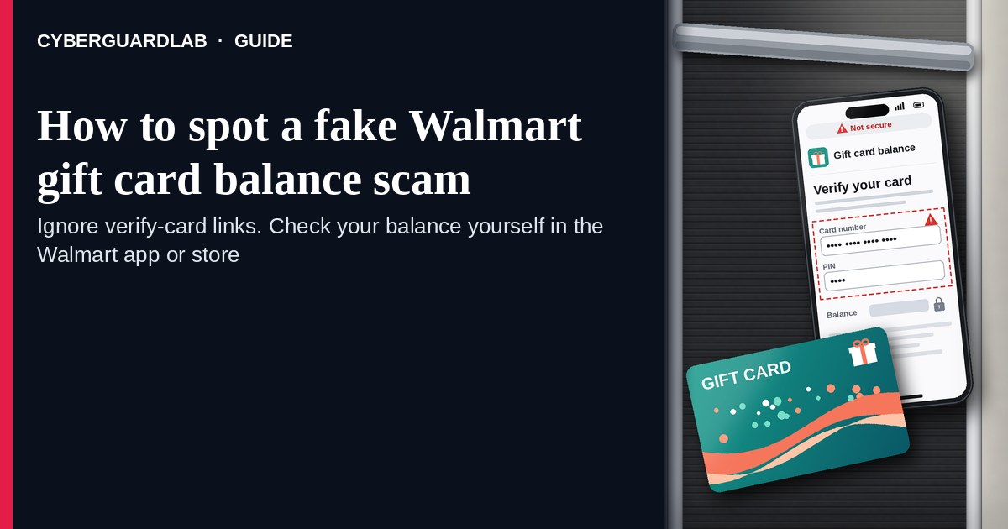
A fake Walmart gift card balance scam is an unexpected email, SMS, call, or buyer message that claims you have a Walmart gift card balance to “check,” “reload,” or “redeem,” or that asks you to “verify” a card number / PIN for a purchase, refund, or reward. Real Walmart gift card balance checks live inside the Walmart experience you start yourself — walmart.com, the Walmart app, or a store path you already trust — not inside a cold “check balance / redeem reward” link or a stranger who wants the full card number read aloud. Walmart publishes gift card help; the safe habit is to check balance only after you open Walmart yourself, and never read full card numbers or enter a PIN on a cold page or to a cold caller. This page is about Walmart gift card balance / reload / redeem / “verify card” harvest and cash-out only. Broader gift-card payment pressure is covered in Gift card scam. Related first-hour steps: Clicked a phishing link — first hour. CyberGuardLab is independent. Referral fees may affect product placement on other pages. Buying nothing and sticking to free verification habits is a valid outcome.

The short answer
Ignore unexpected “Walmart gift card balance / reload / redeem / verify card” messages; check balance only at walmart.com, the Walmart app, or a store you start yourself; never read full card numbers to a cold caller or enter a PIN on a cold page.
Paid link
Norton 360 | See the Norton first-year offer

See the Norton first-year offer
Offer page: https://cyberguardlab.com/norton
Ad link: https://trysecurities.com/offer/norton?dtm=gg&cid=

What a fake Walmart gift card balance scam usually looks like
Scammers copy Walmart gift card language: “check your balance,” “reload your card,” “redeem a reward,” “verify this gift card for your purchase,” or “your Walmart eGift has a problem.” The job is stealing the card number + PIN (cash-out) or harvesting credentials on a look-alike page.
Common shapes US households report:
- Email or SMS claiming a Walmart gift card balance, reward, or “unused funds” with a short link to “check balance,” “reload,” or “redeem now.”
- Cold call or voicemail about a Walmart gift card “problem” or “verification” that asks you to read the full number and PIN from a card you already own.
- Buyer / marketplace / “friend” asking you to “verify” or “test” a Walmart gift card by reading numbers or pasting them into a cold form — a cash-out pattern related to broader gift-card scam pressure.
- Look-alike Walmart balance or account page after you tap — then card number, PIN, email, password, and often a payment method harvest.
- Follow-up after any reply or tap — once you engage, expect more “support” emails or a scripted call. Related Apple Store-branded gift card lure: Fake Apple Store gift card scam. Related first-hour steps: Clicked a phishing link — first hour.
FTC gift-card and phishing guidance: treat unexpected requests for gift card numbers as a red flag; do not click links in unexpected messages; if you think it might be real, contact the company with a website or phone number you know is real; report at ReportFraud.ftc.gov.
We do not claim Walmart “never emails about gift cards.” Walmart may send real order and account notices. The safe habit is always the same: leave the unexpected message, open walmart.com or the Walmart app yourself (or ask in-store), and manage gift card balance only inside a session or channel you started.

Fake Walmart balance lure vs real Walmart help vs general gift-card scam
Signal | Fake Walmart gift card balance / verify message | Real Walmart gift card path (typical) | Related lure (general gift-card pressure)
Opening hook | “Check Walmart gift card balance / reload / redeem reward / verify card.” | Balance tools you open yourself on walmart.com, the Walmart app, or in store. | “Pay / refund / tax / prize only with gift cards” (see Gift card scam).
Ask | Cold link, full card number + PIN to a stranger, password on a look-alike page. | Usually you enter the number only inside Walmart channels you start. | Buy cards and read codes to a caller / form outside the brand.
Pressure | “Balance expires today,” “reward voids in 1 hour,” “verify before shipping.” | Normal shopping pace; you check balance on your schedule. | Government / romance / tech-support urgency to drain cards fast.
Safe next step | Ignore link / hang up. Type walmart.com or open the Walmart app / store. | Confirm balance only inside Walmart channels you start. | See Gift card scam guide.
Related guide | This page | walmart.com / Walmart app / store typed or visited by you | Gift card scam
If anyone asks you to read a full Walmart gift card number and PIN over the phone or into a cold form, stop — that is cash-out, not customer service.

How to verify a Walmart gift card balance message (US household steps)
Do this when any unexpected Walmart balance / reload / redeem / “verify card” message or call appears. You do not need a paid product to finish these steps.
- Do not tap the link, reply with card digits, or call a number that lives only inside the message. Hang up on cold callers who ask for gift card numbers. Close the email or text.
- Open Walmart the way you already trust. Type walmart.com yourself, open the Walmart app you installed earlier, use a bookmark you saved, or ask at a Walmart store — not the check-balance / reload / redeem link from the unexpected message.
- Check gift card balance only inside a session or channel you started. Use Walmart’s own gift card / help tools after you arrive yourself. If you were not expecting a reward or balance alert, treat the message as spam.
- Never read the full gift card number and PIN to a cold caller, buyer, or “support agent,” and never enter a PIN on a page that arrived from a cold email or text. Legitimate Walmart gift card checks do not require you to trust an unexpected shortener or a stranger who contacted you first.
- If you already tapped, typed a password, entered a PIN, or read card numbers aloud, treat the first hour as incident response. Assume the card value may be drained; keep the card and any receipts. Change passwords from sessions you started if you typed any. Follow Clicked a phishing link — first hour. Report at ReportFraud.ftc.gov; if identity data was stolen, use IdentityTheft.gov.
- Report the message and tell the household. Mark the email as phishing / junk; forward scam texts to 7726 (SPAM); file at ReportFraud.ftc.gov. Agree that nobody “verifies,” reloads, or redeems Walmart gift cards from unexpected links or cold callers — only via walmart.com, the Walmart app, or the store you start. Checklist: How to report a scam to the FTC.

Signs the message is fake or unsafe (scan table)
Use this as a quick pass before you spend money or time.
Sign | Why it matters | What to do
Check balance / reload / redeem / verify link lives only inside the unexpected message | Card and credential theft | Ignore; open walmart.com, app, or store yourself
Caller or buyer asks you to read the full gift card number + PIN | Immediate cash-out | Hang up; never read numbers to a cold contact
URL is a shortener, misspelled Walmart name, or random form host | Phishing page | Never tap; type walmart.com
Urgent “reward expires in 15 minutes” or “verify before we ship” | Fear used to skip verification | Slow down; check only inside Walmart you start
Page asks for gift card PIN plus Walmart password / payment card on the same cold form | Credential + payment harvest | Stop; change password from official Walmart if you typed anything
You already replied, tapped, or spoke to a “gift card agent” | Follow-up spam, drained card, or account takeover risk | Stop engaging; verify on walmart.com; run first-hour steps if you entered secrets

Free habits that reduce the blast radius
You do not need a new subscription to lower damage if a fake Walmart gift card balance lure gets through.
- Bookmark walmart.com / the Walmart app; check gift card balance only there or in store — never from a cold balance link.
- Household rule: never read gift card numbers or PINs to unexpected callers, buyers, or “support,” and never use reload / redeem links inside unexpected Walmart emails or texts.
- Treat any pressure to pay taxes, fees, or refunds with gift cards as a separate pattern — see the Gift card scam guide. Apple Store-branded gift card phishing is covered in Fake Apple Store gift card scam.
- Forward obvious scam texts to 7726; enable carrier and mailbox spam filtering when available.
- Optional antivirus / web filtering is a separate layer after a bad tap; it does not replace the verify-on-walmart.com habit. Built-in Microsoft Defender plus those habits is enough for many households.

What this page is not
This page is not a guide to buying Walmart gift cards for holidays, not a review of Walmart+ membership, and not legal advice about a specific drained card.
It does not claim CyberGuardLab lab scores or “#1 anti-phishing” ranks. It does not tell you to ignore a real Walmart order or account notice you can also see inside a Walmart session you start yourself — it tells you to verify there, not in the cold message. It is not the general “pay with gift cards” encyclopedia; for that pressure, read Gift card scam. Official recovery and reporting stay with Walmart Help / gift card support paths you open yourself, your card issuer if a payment card was stolen, ReportFraud.ftc.gov, and IdentityTheft.gov if personal data was stolen.

If you decide a paid extra is a real job
Most households can handle fake Walmart gift card balance scams with the free steps above. Open a paid page only if you already named a job — for example broader web filtering, cross-device AV, or identity alerts after you gave a scammer personal data — and you will actually use it.
- PC / Mac suite with phishing and web protections many households already compare: Norton plans (paid link; confirm renewal price).
- Independent-test–oriented suite option: Bitdefender plans (paid link).
- Household suite shopping starting point: TotalAV plans (paid link; confirm renewal).
- Multi-device bill under one vendor: McAfee plans (paid link; confirm device limit).
- Another suite path some homes already use: Avast plans (paid link).
Buying nothing beyond free official-site / app / store verification habits is still valid. Paid links above are on-site only.

FAQ

Does Walmart really email or text about gift card balances?
Walmart may send real order and account notices. That is why the safe test is not “Walmart never messages,” but “I only check gift card balance inside walmart.com, the Walmart app, or a store I start myself — never from a cold link, and I never read full card numbers to a cold caller.”

The message shows my name or a partial card number. Is that enough?
No. Names and partial card-like strings are easy to reuse from breaches, prior purchases, or guesswork. Trust the Walmart session, app, or store channel you start yourself, not the message chrome.

I already entered my gift card PIN or read the numbers to a caller. What should I do first?
Assume the balance may be drained; keep the physical card and any proof of purchase. Change any password you typed from walmart.com you open. Follow Clicked a phishing link — first hour. Report at ReportFraud.ftc.gov and contact Walmart Help through a path you start yourself.

How is this different from a general gift card scam?
This page is Walmart-branded gift card balance / reload / redeem / “verify card” harvest only. Gift card scam covers broader pressure to buy or send gift cards as “payment.” Same habit (never hand card codes to cold contacts), different brand costume. Apple Store-branded gift card phishing is a separate guide.

How do I report a fake Walmart gift card balance scam?
Mark the email as phishing / junk, forward scam texts to 7726 (SPAM), and file at ReportFraud.ftc.gov. Steps for the FTC side are in How to report a scam to the FTC.

Do I need paid antivirus to spot these messages?
No. Spotting is a verification habit: ignore the link, open walmart.com / the Walmart app / the store, never enter PINs or read full numbers on a cold path. Microsoft Defender plus those habits is enough for many households. Antivirus can be a separate optional layer for malware after a bad tap; it does not replace that habit.

Sources
- Walmart Help
- Check gift card balance — Walmart
- Gift Card Scams (FTC)
- How To Recognize and Avoid Phishing Scams (FTC)
- How to Recognize and Report Spam Text Messages (FTC)
- ReportFraud.ftc.gov
- IdentityTheft.gov
- Avoiding Social Engineering and Phishing Attacks (CISA)

Also read
- Gift card scams
- Fake Apple Store gift card scam
- Clicked a phishing link: the first hour
- How to report a scam to the FTC

