
How to spot a fake Uber receipt phishing email
Read online: https://cyberguardlab.com/blog/fake-uber-receipt-phishing
Published September 30, 2026 · Updated September 30, 2026
Short answer
Ignore the view-receipt / dispute-charge link in an unexpected “Uber receipt” or “trip charge” message; verify only in the official Uber app you open yourself; never enter your Uber password, card, or one-time code on a cold page.
Advertising disclosure: CyberGuardLab is an independent comparison site. We are not TotalAV, Norton, Bitdefender, McAfee, or Avast. If you buy through our links, we may earn a commission, which can affect ranking and placement.
Independent US household comparison site. Not the vendor. Paid links below may earn a commission. Confirm first-year price, renewal, device limit, and refund terms at checkout.
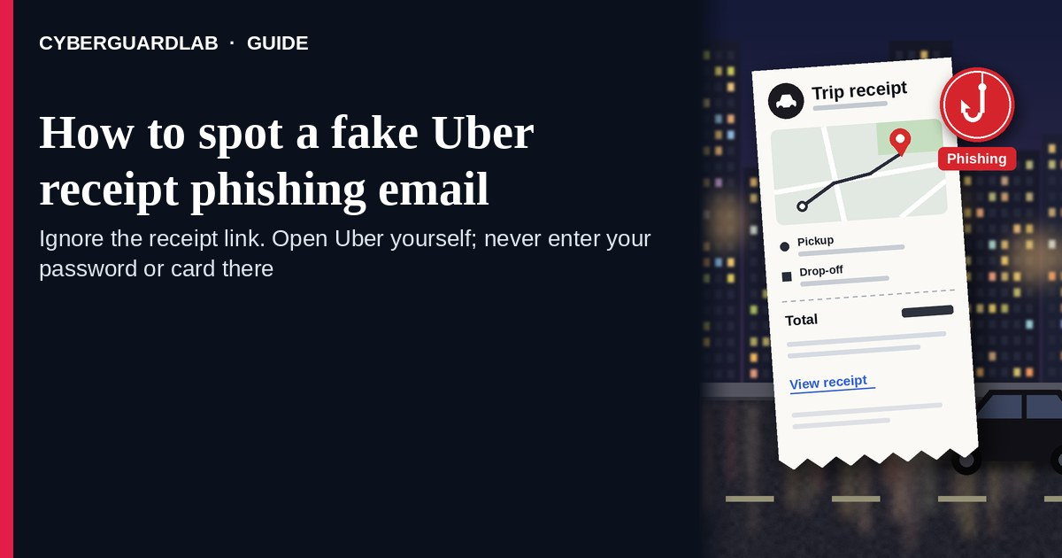
A fake Uber receipt phishing email (or text) is an unexpected “Uber receipt,” “trip charge,” or “dispute this ride” message with a cold link to “view receipt,” “dispute charge,” or “manage payment.” Real Uber trip history, receipts, and unrecognized-charge help live inside the Uber account you open yourself in the official app — not inside a cold “view receipt” button in an unexpected message. Uber Help covers unrecognized charges and what to do if someone else may have used your account. This page is about Uber-branded receipt / trip-charge phishing. It is different from a general fake bank fraud alert text and from a fake PayPal purchase alert. CyberGuardLab is independent. Referral fees may affect product placement on other pages. Buying nothing and sticking to free verification habits is a valid outcome.

The short answer
Ignore the view-receipt / dispute-charge link in an unexpected “Uber receipt” or “trip charge” message; verify only in the official Uber app you open yourself; never enter your Uber password, card, or one-time code on a cold page.
Paid link
Norton 360 | See the Norton first-year offer

See the Norton first-year offer
Offer page: https://cyberguardlab.com/norton
Ad link: https://trysecurities.com/offer/norton?dtm=gg&cid=

What a fake Uber receipt usually looks like
Scammers copy rideshare receipt language: “Your trip receipt is ready,” “You were charged $87.40,” “Dispute this ride,” or “Payment method failed — update now.” The job is credential theft, card theft, or both.
Common shapes US households report:
- Email claiming an Uber trip you did not take with a bright “View receipt,” “Dispute charge,” or “Get help” button that does not land in the official Uber app or on uber.com you typed yourself.
- SMS or iMessage about an “Uber charge” or “receipt ready” with a short link to “review trip” or “cancel unauthorized ride.”
- Look-alike Uber login or payment page after you tap — then email, password, card, and often a one-time code harvest.
- Fake receipt PDF or HTML attachment mixed with a “manage payment” link outside Uber.
- Follow-up after any reply or tap — once you engage, expect more “support” emails or a scripted call. Related first-hour steps: Clicked a phishing link — first hour.
FTC phishing guidance: do not click links in unexpected messages; if you think it might be real, contact the company with a website or app you know is real; report at ReportFraud.ftc.gov.
We do not claim Uber “never emails about receipts.” Uber may send real trip receipts and account notices. The safe habit is always the same: leave the unexpected message, open the official Uber app yourself, and review trip history / payment methods only inside a session you started.

Fake Uber receipt vs real Uber notice vs bank / PayPal charge alerts
Signal | Fake Uber receipt / dispute-charge message | Real Uber receipt or account notice (typical) | Bank fraud text or PayPal purchase alert scam
Opening hook | “View Uber receipt / dispute this $… trip / update payment now.” | Trip or receipt details you can also see after you open the official Uber app yourself. | “Unusual bank charge — reply YES,” or “PayPal purchase you didn’t make.”
Ask | Cold view / dispute link, Uber password, card, OTP. | Usually none inside the message — review trips and unrecognized charges inside the signed-in Uber app. | Cold bank / PayPal link, reply codes, or card “verification.”
Pressure | Same-day dispute deadline, “unauthorized ride now.” | Normal trip timeline; you verify on your schedule. | Account freeze countdown or “confirm within minutes.”
Safe next step | Ignore link. Open the official Uber app yourself. | Confirm trip history and payment methods only inside Uber. | Check the charge in your card or bank app you open yourself.
Related guide | This page | Official Uber app typed / opened by you | Fake App Store receipt phishing
If the page after the tap asks for your Uber password plus a card or one-time code, stop — that is credential and payment theft dressed as a receipt. Uber Help for unrecognized charges starts from reviewing trip / order history in your account — not from a cold shortener.

How to verify an Uber receipt message (US household steps)
Do this when any unexpected Uber receipt / trip-charge / dispute-ride message appears. You do not need a paid product to finish these steps.
- Do not tap the link, reply YES/NO, or call a number that lives only inside the message. Close the email or text. Do not discuss the “charge” with a caller who contacted you first.
- Open Uber the way you already trust. Open the official Uber app already on your phone — not the view-receipt / dispute link. If you must use the web, type the Uber site yourself rather than following the cold link.
- Check trip history and payment methods only inside a signed-in session you started. Look for trips, receipts, and payment methods you recognize. Uber Help for unrecognized charges starts with pending holds, family/friend use, and trip history inside the account. If nothing unexpected appears, treat the cold message as spam.
- Never enter your Uber password, card, or one-time code on a page that arrived from a cold email or text. Legitimate Uber account work does not require you to trust an unexpected shortener or look-alike domain.
- If you already tapped, typed a password, or entered a card, treat the first hour as incident response. Change your Uber password from the official app you open if you still can; review trip history and payment methods; call the number on the back of your card to watch for fraud. Follow Clicked a phishing link — first hour. Report at ReportFraud.ftc.gov; if identity data was stolen, use IdentityTheft.gov.
- Report the message and tell the household. Mark the email as phishing / junk; forward scam texts to 7726 (SPAM); file at ReportFraud.ftc.gov. Agree that nobody “views Uber receipts” or “disputes rides” from unexpected links. Checklist: How to report a scam to the FTC. Turn on 2FA on the email / phone account that owns Uber.

Signs the message is fake or unsafe (scan table)
Use this as a quick pass before you spend money or time.
Sign | Why it matters | What to do
View-receipt / dispute-charge link lives only inside the unexpected message | Password and card theft | Ignore; open the official Uber app
URL is a shortener, misspelled Uber name, or random form host | Phishing page | Never tap; open the official app
Urgent “dispute in 15 minutes” or “unauthorized ride charged tonight” | Fear used to skip verification | Slow down; check trip history inside Uber
Sender address is not an Uber domain you recognize, or reply-to looks odd | Easy to spoof display names | Verify only inside a session you start
Page asks for Uber password plus card / OTP on the same cold form | Credential + payment harvest | Stop; change password from official Uber if you typed anything
You already replied, tapped, or spoke to a “billing agent” | Follow-up spam, malware, or account takeover risk | Stop engaging; verify in the official app; run first-hour steps if you entered secrets

Free habits that reduce the blast radius
You do not need a new subscription to lower damage if a fake Uber receipt gets through.
- Keep only the official Uber app; manage trip history and payment methods only there.
- Household rule: never use view-receipt / dispute links inside unexpected Uber emails or texts.
- Strong unique passwords + 2FA on email and Uber limit what a stolen password can unlock.
- Forward obvious scam texts to 7726; enable carrier and mailbox spam filtering when available.
- Optional antivirus / web filtering is a separate layer after a bad tap; it does not replace the verify-in-official-app habit.

What this page is not
This page is not a full Uber billing dispute walkthrough for every fare question, not a driver / delivery partner guide, and not legal advice about a specific charge.
It does not claim CyberGuardLab lab scores or “#1 anti-phishing” ranks. It does not tell you to ignore a real trip you can also see inside the official Uber app — it tells you to verify there, not in the cold message. It is not a bank fraud-text guide or a PayPal purchase-alert guide; for those, read Fake bank fraud alert text and Fake PayPal purchase alert. It is also not the Apple receipt guide: Fake App Store receipt phishing covers fake App Store or iTunes receipts, while this page covers fake Uber trip receipts. Official recovery and reporting stay with Uber Help, your card issuer, ReportFraud.ftc.gov, and IdentityTheft.gov if personal data was stolen.

If you decide a paid extra is a real job
Most households can handle fake Uber receipt messages with the free steps above. Open a paid page only if you already named a job — for example broader web filtering, cross-device AV, or identity alerts after you gave a scammer personal data — and you will actually use it.
- PC / Mac suite with phishing and web protections many households already compare: Norton plans (paid link; confirm renewal price).
- Independent-test–oriented suite option: Bitdefender plans (paid link).
- Household suite shopping starting point: TotalAV plans (paid link; confirm renewal).
- Multi-device bill under one vendor: McAfee plans (paid link; confirm device limit).
- Another suite path some homes already use: Avast plans (paid link).
Buying nothing beyond free official-app verification habits is still valid. Paid links above are on-site only.

FAQ

Does Uber really email or text about receipts?
Uber may send real trip receipts and account notices. That is why the safe test is not “Uber never messages,” but “I only review trips and payments inside the official Uber app I open myself.”

The message shows a dollar amount, city, or map-like trip detail. Is that enough?
No. Dollar amounts, city names, and trip-like strings are easy to reuse from guesswork or prior data. Trust trip history in the session you start yourself, not the message chrome.

I already entered my Uber password on the receipt page. What should I do first?
Change your Uber password from the official app you open. Review trip history and payment methods. Call the number on the back of your card if you also entered card details. Follow Clicked a phishing link — first hour. Report at ReportFraud.ftc.gov.

How is this different from a fake bank fraud alert or PayPal purchase alert?
This page is about unexpected Uber receipt / trip-charge links. Fake bank fraud alert text covers bank “unusual charge — reply YES” texts. Fake PayPal purchase alert covers PayPal purchase / dispute lures. Same “ignore cold link; open the official app” habit, different brand costume.

How do I report a fake Uber receipt phishing email?
Mark the email as phishing / junk, forward scam texts to 7726 (SPAM), and file at ReportFraud.ftc.gov. Steps for the FTC side are in How to report a scam to the FTC.

Do I need paid antivirus to spot these messages?
No. Spotting is a verification habit: ignore the link, open the official Uber app, never enter secrets on a cold page. Antivirus can be a separate optional layer for malware after a bad tap; it does not replace that habit.

Sources
- My account has an unrecognized charge (Uber Help)
- My account has a charge from someone else (Uber Help)
- Uber Help
- Uber Safety
- How To Recognize and Avoid Phishing Scams (FTC)
- How to Recognize and Report Spam Text Messages (FTC)
- ReportFraud.ftc.gov
- IdentityTheft.gov
- Avoiding Social Engineering and Phishing Attacks (CISA)

Also read
- Fake App Store receipt phishing email
- Fake PayPal purchase alert
- Fake bank fraud alert text
- Clicked a phishing link — first hour
- How to report a scam to the FTC

