
How to spot a fake two-factor authentication text
https://cyberguardlab.com/blog/fake-two-factor-authentication-text
Independent US household comparison site. Not the vendor. Paid links below may earn a commission. Confirm first-year price, renewal, device limit, and refund terms at checkout.
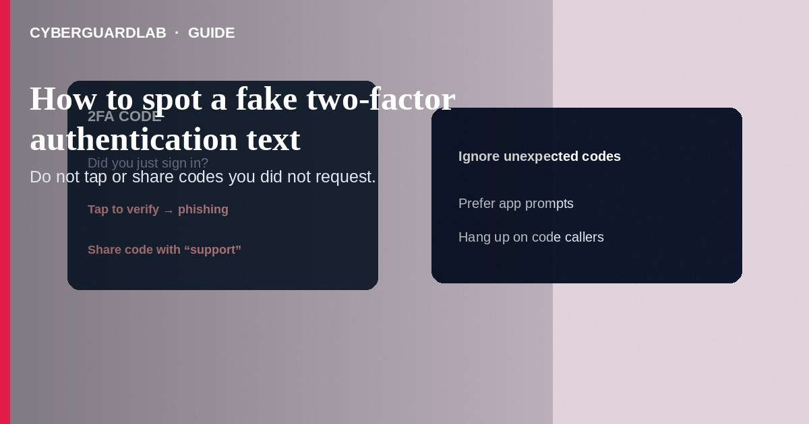
A fake two-factor authentication text impersonates your bank, Apple, Google, or carrier and either pushes a phishing link or tricks you into reading a real one-time code to a scammer who already started a login. If you did not just try to sign in, do not tap the link and do not share the code. Hang up on callers who ask you to “confirm” the SMS. Prefer app prompts and authenticator codes over SMS when available—see Google Prompt instead of SMS. This guide is about fraudulent 2FA messages—not carrier number lock, not moving authenticator apps, and not setting a carrier account PIN.

1. How fake 2FA texts work
You receive: “Unusual sign-in—tap to secure your account,” “Your Apple ID was locked,” or “Your bank code is 482193—call us if this wasn’t you” with a spoofed number. Variant A: the link opens a credential-stealing page. Variant B: a scammer already has your password and calls or texts while the real code arrives—then social-engineers you into reading the digits. Variant C: “forward this code to stop a purchase” instructions that actually approve the thief’s login.
Paid link
Norton 360 | See the Norton first-year offer

See the Norton first-year offer
Offer page: https://cyberguardlab.com/norton
Real 2FA SMS from major services usually arrives only after a login or reset you started—and legitimate support will not ask you to recite the code on an inbound call.
Some scripts claim a $1,000 purchase is pending and that reading the SMS code will cancel it. Reading the code approves the attacker’s login or transfer. Teach teens and older relatives: codes are secrets, not cancel buttons.

2. Red flags before you tap or reply
Cue | Likely legitimate | Likely scam
Timing | You just clicked Sign in or Reset password | Code or link arrives while you were idle
Ask | Enter the code only in the app/site you opened yourself | Caller or chat asks you to read the code aloud
Link | No link required—or you use a bookmark | Shortened “secure your account” URL in the SMS
Grammar / brand | Matches the service’s usual short template | Odd spelling, wrong brand mix, gift-card threats
Channel | In-app push or authenticator after you upgrade | Only SMS forever despite phishing risk
SIM context | Number still on your phone; carrier locks on | Sudden service loss then “codes” on a new SIM

3. Safer habits (buy-nothing)
- Do not tap links inside unexpected security texts.
- Do not read codes to anyone who contacted you first.
- If you were not signing in, open the real app or bookmark and check recent security activity—or change the password from a clean session.
- If a code arrived during a cold call, end the call; the scammer may be mid-login.
- Turn on number lock / SIM protection and a strong carrier PIN; move important accounts off SMS 2FA.
- For Google accounts, switch to Google Prompt or passkeys/authenticator instead of text codes when possible.

4. If you already shared a code
- Assume that account session may be compromised. Change the password from another device if needed; sign out other sessions.
- Change the email password that recovers the account; enable stronger 2FA.
- Call your bank using the number on your card if financial codes were shared.
- Contact your carrier if you suspect SIM swap; enable locks—see number lock guide.
- Report at ReportFraud.ftc.gov; use IdentityTheft.gov if identity data was taken.
- Scan the phone and PCs you used with a trusted tool such as Norton or Bitdefender. Keep one primary real-time antivirus—avoid stacking full suites. TotalAV, McAfee, and Avast are other on-site comparison options.

FAQ

Can scammers send a real-looking bank SMS?
They can spoof sender names or send parallel phishing texts. Treat unexpected codes as hostile until you confirm a login you started.

How is this different from SIM swap?
SIM swap steals the number so real SMS codes arrive on the thief’s SIM. Fake 2FA texts trick you without necessarily swapping the SIM—or combine both.

Is authenticator-app 2FA immune?
App codes are much harder to steal via SMS phishing, but approval-fatigue and malware still exist. Never confirm prompts you did not initiate.

Should I disable all SMS 2FA?
Where a service offers authenticator, security keys, or prompts, prefer those. SMS is better than nothing for some accounts but is the weakest common option.

If you still want a paid suite
Avoiding how to spot a fake two-factor authentication text does not require paid antivirus. Careful habits and official support paths are a valid buy-nothing stack. If you want multi-device paid protection later, use only these on-site paid links: TotalAV (paid link), Norton (paid link), Bitdefender (paid link), McAfee (paid link), Avast (paid link).

Sources
- FTC: How to recognize phishing
- FTC: Online shopping / account security tips hub
- Google Account Help: 2-Step Verification
- IdentityTheft.gov
- FTC ReportFraud

Also read
- How to turn on Google Prompt instead of SMS codes
- How to turn on number lock at T-Mobile, Verizon, or AT&T
- How to set a carrier account PIN to stop SIM swap
- How to move authenticator apps to a new phone safely
- How to spot a phishing email

