
How to spot a fake unpaid toll road text
Read online: https://cyberguardlab.com/blog/fake-toll-road-text-scam
Published September 26, 2026 · Updated September 26, 2026
Short answer
Ignore the pay link in an unexpected “unpaid toll” text; verify only on the official toll agency site or app you open yourself; never enter a card on a cold short link.
Advertising disclosure: CyberGuardLab is an independent comparison site. We are not TotalAV, Norton, Bitdefender, McAfee, or Avast. If you buy through our links, we may earn a commission, which can affect ranking and placement.
Independent US household comparison site. Not the vendor. Paid links below may earn a commission. Confirm first-year price, renewal, device limit, and refund terms at checkout.
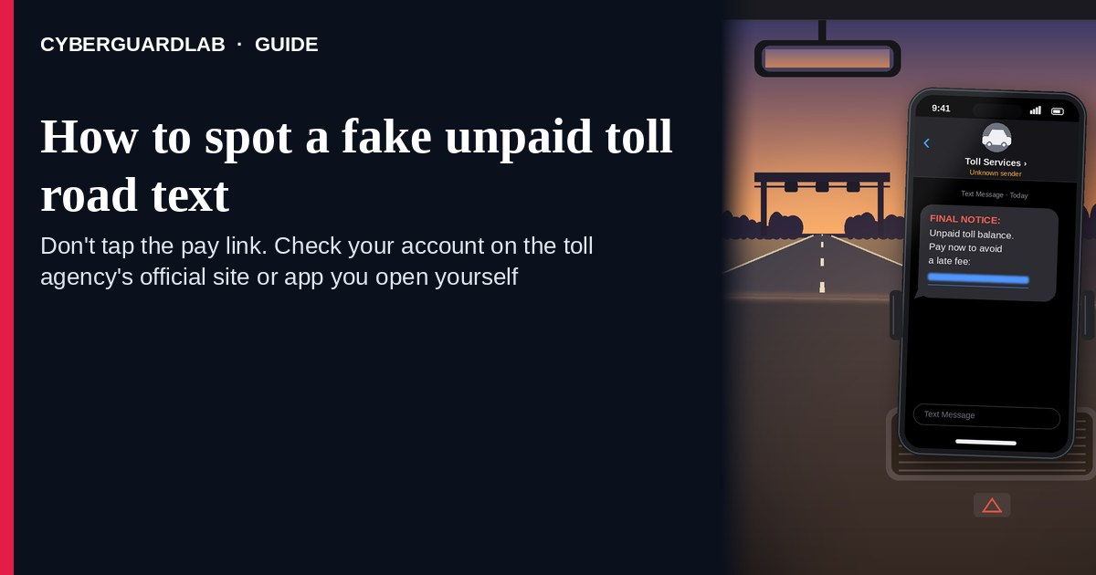
A fake unpaid toll road text (or iMessage) is designed to panic you into paying a “past-due” FasTrak, SunPass, E-ZPass, or turnpike balance through a short link in the message. Real toll agencies do send some billing notices — the problem is the payment path, not the word “toll” itself. The FTC’s spam-text guidance is clear: do not click links or reply to unexpected texts; if you think a bill might be real, contact the company using a phone number or website you know is real. Never pay a cold text link. Open the official toll or DMV account page you typed yourself, or the app already on your phone. This lure is a cousin of the fake delivery text scam and the DMV license renewal text scam. CyberGuardLab is independent. Referral fees may affect product placement on other pages. Buying nothing and sticking to free verification habits is a valid outcome.

The short answer
Ignore the pay link in an unexpected “unpaid toll” text; verify only on the official toll agency site or app you open yourself; never enter a card on a cold short link.
Paid link
Norton 360 | See the Norton first-year offer

See the Norton first-year offer
Offer page: https://cyberguardlab.com/norton
Ad link: https://trysecurities.com/offer/norton?dtm=gg&cid=

What a fake toll text usually looks like
Scammers copy turnpike language: “unpaid toll,” “plate on file,” “account suspended,” or “pay in 24 hours to avoid a fine.” The job is card theft or a phishing page that steals login details for a real toll account.
Common shapes US households report:
- SMS naming E-ZPass / FasTrak / SunPass / “your toll agency” with a short link to “view invoice” or “pay now.”
- Plate or last-four partial match that feels personal — often scraped from public records, prior breaches, or guesswork, not proof the sender is the agency.
- Countdown fine threat — “civil penalty doubles today,” “registration hold,” or “DMV flag” unless you pay immediately.
- Look-alike payment page after you tap — then a card number, CVV, and sometimes a password harvest.
- Follow-up after any reply — replying YES/NO or “STOP” can confirm your number is live and invite more spam (same pattern as other spam text messages).
FTC spam-text guidance: do not click links or respond to unexpected texts; if you think it might be real, contact the company with a phone number or website you know is real; forward scam texts to 7726 (SPAM) and report at ReportFraud.ftc.gov.
We do not claim that every toll agency “never texts.” Some agencies and account vendors send real notices. The safe habit is always the same: leave the text, open the official site or app yourself, and pay only inside a session you started.

Fake toll text vs real agency notice vs delivery / DMV text
Signal | Fake unpaid-toll text | Real toll / agency notice (typical) | Related delivery or DMV text scam
Opening hook | “Unpaid toll — pay now or fine / plate hold.” | Balance, invoice, or statement you can also see after you sign into the official account. | “Package held” or “license expires — renew now” with a short link.
Ask | Cold short link, card on a look-alike page, sometimes a “login to view.” | Usually none inside the text — or a pointer to open the official app / site you already use. | Pay / schedule / renew through the unexpected link.
Pressure | Same-day fine, registration hold, “final notice.” | Normal billing calendar; you verify on your schedule. | Delivery deadline or license suspension countdown.
Safe next step | Ignore link. Type the official agency URL or open the real app. | Confirm balance and pay only inside the signed-in official account. | See delivery / DMV guides; never pay the cold link.
Related guide | This page | Your agency’s official site (typed by you) | Fake delivery text · DMV renewal text
If the page after the tap asks for a card plus a password you use elsewhere, stop — that is credential theft dressed as a toll bill.

How to verify an unpaid toll text (US household steps)
Do this when any unexpected toll or turnpike text appears. You do not need a paid product to finish these steps.
- Do not tap the link, reply YES/NO, or call a number that lives only inside the text. Close the message. Do not discuss the “invoice” with a caller who contacted you first.
- Open the official toll account the way you already trust. Type the agency URL yourself (for example your state’s turnpike, E-ZPass group, FasTrak, or SunPass site), use a bookmark you saved earlier, or open the official app already on your phone — not the short link.
- Pay only inside a signed-in session you started. If a real balance exists, it should appear there. If the official account shows nothing due, treat the text as spam.
- Never enter a card, bank login, or one-time code on a page that arrived from a cold text. Legitimate agencies do not need you to trust an unexpected shortener. If you only drive rarely on toll roads, check whether you even have an account before “renewing” anything.
- If you already tapped, typed a card, or entered a password, treat the first hour as incident response. Call the number on the back of your card to watch for fraud; change any password you reused; review bank and email accounts. Follow Clicked a phishing link — first hour. Report at ReportFraud.ftc.gov; if identity data was stolen, use IdentityTheft.gov.
- Report the text and tell the household. Forward the scam text to 7726 (SPAM), report junk in your messaging app, and file at ReportFraud.ftc.gov. Agree that nobody pays tolls, parking, or “DMV holds” from unexpected text links. Broader spam habits: Spam text messages. Checklist: How to report a scam to the FTC.

Signs the text is fake or unsafe (scan table)
Use this as a quick pass before you spend money or time.
Sign | Why it matters | What to do
Pay / invoice link lives only inside the unexpected text | Card and credential theft | Ignore; open official agency site or app
Sender is a random digit string or odd short code | Easy to spoof; not proof of the toll agency | Verify only on the official site you type
Urgent “fine doubles in 2 hours” or “registration suspended today” | Fear used to skip verification | Slow down; check the real account
URL is a shortener, misspelled agency name, or random .xyz / form host | Phishing page | Never tap; type the real domain
You do not have a toll tag / account and rarely use toll roads | “Past-due balance” for coverage you never opened is a classic lure | Ignore; optional check on official site only
You already replied or tapped once | Follow-up spam or malware / card risk | Stop engaging; verify on official site; run first-hour steps if you entered a card or password

Free habits that reduce the blast radius
You do not need a new subscription to lower damage if a fake toll text gets through.
- Bookmark the real toll / turnpike account URL on your phone; pay only there.
- Household rule: never use payment links inside unexpected texts (tolls, parking, delivery, DMV).
- Forward obvious scam texts to 7726; enable carrier spam filtering when available.
- Strong unique passwords + 2FA on email and banking limit what a stolen card or reused password can unlock.
- Optional antivirus / web filtering is a separate layer after a bad tap; it does not replace the verify-on-official-site habit.

What this page is not
This page is not a ranking of toll agencies, not a list of which states “never text,” and not legal advice about a specific ticket or civil penalty.
It does not claim CyberGuardLab lab scores or “#1 anti-phishing” ranks. It does not tell you to ignore a real balance you can also see inside your signed-in official toll account — it tells you to verify there, not in the cold text. Official recovery and reporting stay with your card issuer, ReportFraud.ftc.gov, and IdentityTheft.gov if personal data was stolen.

If you decide a paid extra is a real job
Most households can handle fake toll texts with the free steps above. Open a paid page only if you already named a job — for example broader web filtering, cross-device AV, or identity alerts after you gave a scammer personal data — and you will actually use it.
- PC / Mac suite with phishing and web protections many households already compare: Norton plans (paid link; confirm renewal price).
- Independent-test–oriented suite option: Bitdefender plans (paid link).
- Household suite shopping starting point: TotalAV plans (paid link; confirm renewal).
- Multi-device bill under one vendor: McAfee plans (paid link; confirm device limit).
- Another suite path some homes already use: Avast plans (paid link).
Buying nothing beyond free official-site verification habits is still valid. Paid links above are on-site only.

FAQ

Do toll agencies really send unpaid-balance texts?
Some account systems send SMS or email notices. That is why the safe test is not “agencies never text,” but “I only pay inside the official site or app I open myself.”

The text has my plate number or city. Is that enough?
No. Plates and locations are easy to guess, scrape, or reuse from other data. Trust the signed-in official account session you start yourself, not the message chrome.

I already paid through the link in the text. What should I do first?
Call the number on the back of your card to report possible fraud and watch for new charges. Change any password you typed. Follow Clicked a phishing link — first hour. Report at ReportFraud.ftc.gov.

How is this different from a fake delivery or DMV text?
Same cold-link payment trick, different costume. Delivery texts push package fees; DMV texts push license “renewal.” Toll texts push unpaid turnpike balances. Related: Fake delivery text scam and DMV license renewal text scam.

How do I report a fake toll text?
Forward it to 7726 (SPAM), report junk in your messaging app, and file at ReportFraud.ftc.gov. Steps for the FTC side are in How to report a scam to the FTC.

Do I need paid antivirus to spot these texts?
No. Spotting is a verification habit: ignore the link, open the official agency site or app, never pay from a cold text. Antivirus can be a separate optional layer for malware after a bad tap; it does not replace that habit.

Sources
- How to Recognize and Report Spam Text Messages (FTC)
- Have you been getting scammy text messages? (FTC)
- How To Recognize and Avoid Phishing Scams (FTC)
- ReportFraud.ftc.gov
- IdentityTheft.gov
- Avoiding Social Engineering and Phishing Attacks (CISA)

Also read
- Fake delivery text scam
- DMV license renewal text scam
- Spam text messages
- USPS Informed Delivery scam

