
How to spot a fake Ticketmaster refund scam
Read online: https://cyberguardlab.com/blog/fake-ticketmaster-refund
Published September 30, 2026 · Updated September 30, 2026
Short answer
Ignore the claim-refund / verify-payment link in an unexpected “Ticketmaster refund” or “event canceled — get your money back” message; verify only at ticketmaster.com or the official Ticketmaster app you open yourself; never pay gift cards, share remote access, or enter your Ticketmaster password or card on a cold page.
Advertising disclosure: CyberGuardLab is an independent comparison site. We are not TotalAV, Norton, Bitdefender, McAfee, or Avast. If you buy through our links, we may earn a commission, which can affect ranking and placement.
Independent US household comparison site. Not the vendor. Paid links below may earn a commission. Confirm first-year price, renewal, device limit, and refund terms at checkout.
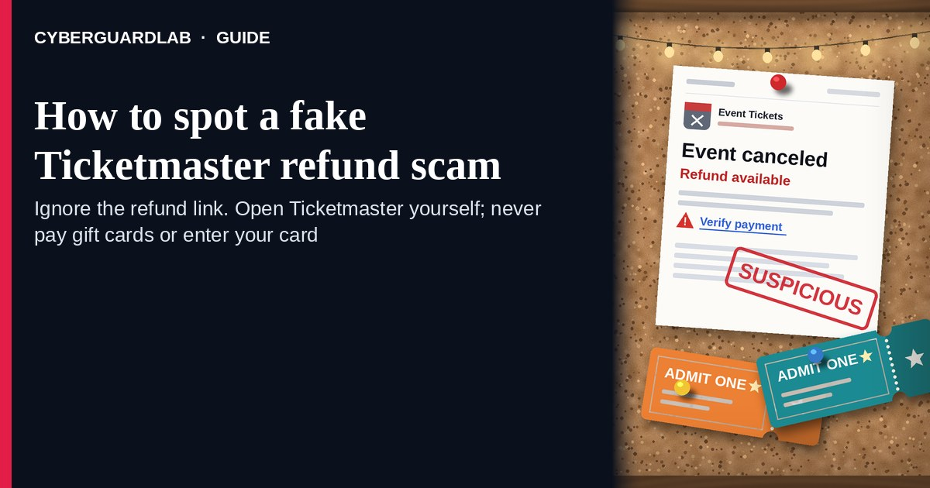
A fake Ticketmaster refund scam is an unexpected email, SMS, or phone call that claims Ticketmaster (or a canceled event) owes you a refund — then pushes a cold “claim refund,” “verify payment,” or “confirm your order” link, asks for gift cards, or steers you into remote-access “support.” Real Ticketmaster refund options, when an event organizer offers them, live inside the Ticketmaster account you open yourself — typically under My Tickets — not inside a cold refund button in an unexpected message. Ticketmaster Help covers how refunds work, eligibility, and how to contact Fan Support. This page is about Ticketmaster-branded refund / canceled-event phishing and social engineering. It is not marketplace advice for buying or selling resale tickets. CyberGuardLab is independent. Referral fees may affect product placement on other pages. Buying nothing and sticking to free verification habits is a valid outcome.

The short answer
Ignore the claim-refund / verify-payment link in an unexpected “Ticketmaster refund” or “event canceled — get your money back” message; verify only at ticketmaster.com or the official Ticketmaster app you open yourself; never pay gift cards, share remote access, or enter your Ticketmaster password or card on a cold page.
Paid link
Norton 360 | See the Norton first-year offer

See the Norton first-year offer
Offer page: https://cyberguardlab.com/norton
Ad link: https://trysecurities.com/offer/norton?dtm=gg&cid=

What a fake Ticketmaster refund usually looks like
Scammers copy event-ticket language: “Your event was canceled,” “refund available today,” “verify your payment method to release funds,” or “confirm order to receive credit.” The job is credential theft, card theft, gift-card cash-out, or remote-access takeover.
Common shapes US households report:
- Email claiming a canceled-event refund with a bright “Claim refund,” “Request refund,” or “Verify payment” button that does not land on ticketmaster.com.
- SMS or iMessage about a “Ticketmaster refund pending” with a short link to “unlock funds” or “confirm your order.”
- Cold call from “Ticketmaster refund support” that asks you to install remote-access software, read aloud a one-time code, or buy gift cards “to receive the refund.” Related call pattern: Tech support scam phone call. Gift-card cash-out pattern: Gift card scam.
- Look-alike Ticketmaster login or refund form after you tap — then email, password, card, and often a one-time code harvest.
- Follow-up after any reply or tap — once you engage, expect more “processing” emails or a scripted agent. Related first-hour steps: Clicked a phishing link — first hour.
FTC phishing guidance: do not click links in unexpected messages; if you think it might be real, contact the company with a website or phone number you know is real; report at ReportFraud.ftc.gov.
We do not claim Ticketmaster “never emails about refunds.” Ticketmaster may send real order and event-update notices, and refund buttons can appear inside a signed-in account when an organizer offers them. The safe habit is always the same: leave the unexpected message, open ticketmaster.com or the official app yourself, and manage refunds only inside a session you started.

Fake Ticketmaster refund vs real Ticketmaster notice vs gift-card / tech-support scam
Signal | Fake Ticketmaster refund / verify-payment message | Real Ticketmaster refund / event notice (typical) | Gift-card or remote-access follow-on
Opening hook | “Event canceled — claim refund / verify payment to release funds today.” | Order or event details you can also see after you sign into Ticketmaster yourself (My Tickets). | “Agent” needs gift cards, wire, crypto, or remote access to “process the refund.”
Ask | Cold claim / verify link, Ticketmaster password, card, OTP. | Usually none inside the unexpected message — request refund only inside signed-in My Tickets when a Request Refund button appears. | Gift-card numbers, remote desktop install, or codes read over the phone.
Pressure | Same-day “funds expire,” verify-before-midnight countdown. | Normal event / organizer timeline; you verify on your schedule. | “Stay on the line,” “buy cards now,” or “do not hang up.”
Safe next step | Ignore link / hang up. Type ticketmaster.com or open the official app. | Confirm My Tickets and refund options only inside Ticketmaster. | Hang up or delete. Check refunds only under My Tickets in an account you open yourself.
Related guide | This page | ticketmaster.com typed by you / official app | Fake refund or overpayment scam · Fake ticket or StubHub listing scam
If the page after the tap asks for your Ticketmaster password plus a card or one-time code, stop — that is credential and payment theft dressed as a refund. Real Ticketmaster Help says refund eligibility is set by the event organizer, and a Request Refund button appears under My Tickets when refunds are offered — not as a cold shortener in an unexpected text.

How to verify a Ticketmaster refund message (US household steps)
Do this when any unexpected Ticketmaster refund / canceled-event / verify-payment message or cold “refund agent” call appears. You do not need a paid product to finish these steps.
- Do not tap the link, reply YES/NO, buy gift cards, or install remote-access software from a cold contact. Close the email or text. Hang up on callers who contacted you first. Do not read aloud codes from your phone or email.
- Open Ticketmaster the way you already trust. Type ticketmaster.com yourself, use a bookmark you saved earlier, or open the official Ticketmaster app already on your phone — not the claim-refund / verify link.
- Check My Tickets and refund options only inside a signed-in session you started. Look for the order and any Request Refund button Ticketmaster Help describes when an organizer offers refunds. If nothing unexpected appears, treat the cold message as spam.
- Never enter your Ticketmaster password, card, or one-time code on a page that arrived from a cold email, text, or call. Legitimate Ticketmaster account work does not require you to trust an unexpected shortener, look-alike domain, gift cards, or remote desktop.
- If you already tapped, typed a password or card, paid with gift cards, or gave remote access, treat the first hour as incident response. Change your Ticketmaster password from a session you started; turn on 2FA on the email that owns the account if it was off; call the number on the back of your card to watch for fraud; stop the remote session and run device security checks. Follow Clicked a phishing link — first hour. For gift-card loss, also read Gift card scam. Report at ReportFraud.ftc.gov; if identity data was stolen, use IdentityTheft.gov.
- Report the message and tell the household. Mark the email as phishing / junk; forward scam texts to 7726 (SPAM); file at ReportFraud.ftc.gov. Agree that nobody claims Ticketmaster refunds, “verifies payment,” or talks to cold “refund agents” from unexpected links or calls. Checklist: How to report a scam to the FTC. Turn on 2FA on the email that owns Ticketmaster.

Signs the message is fake or unsafe (scan table)
Use this as a quick pass before you spend money or time.
Sign | Why it matters | What to do
Claim-refund / verify-payment link lives only inside the unexpected message | Password and card theft | Ignore; open ticketmaster.com or the official app
URL is a shortener, misspelled Ticketmaster / Live Nation name, or random form host | Phishing page | Never tap; type ticketmaster.com
Urgent “refund expires in 2 hours” or “verify today or lose funds” | Fear used to skip verification | Slow down; check My Tickets inside Ticketmaster
Caller asks for gift cards, crypto, wire, or remote-access software | Classic cash-out / takeover | Hang up; see gift-card and tech-support guides
Page asks for Ticketmaster password plus card / OTP on the same cold form | Credential + payment harvest | Stop; change password from official Ticketmaster if you typed anything
You already replied, tapped, paid, or spoke to a “refund agent” | Follow-up spam, malware, or account takeover risk | Stop engaging; verify on ticketmaster.com; run first-hour steps if you entered secrets

Free habits that reduce the blast radius
You do not need a new subscription to lower damage if a fake Ticketmaster refund gets through.
- Bookmark ticketmaster.com (or keep only the official app); manage My Tickets and refunds only there.
- Household rule: never use claim-refund / verify links inside unexpected Ticketmaster emails or texts; never buy gift cards or install remote tools for a “refund.”
- Strong unique passwords + 2FA on email and Ticketmaster limit what a stolen password can unlock.
- Forward obvious scam texts to 7726; enable carrier and mailbox spam filtering when available.
- Optional antivirus / web filtering is a separate layer after a bad tap; it does not replace the verify-on-ticketmaster.com habit.

What this page is not
This page is not a guide to reselling tickets, not a review of Ticketmaster fees, and not legal advice about a specific canceled event or charge dispute. It covers Ticketmaster-branded refund lures only. For refund and overpayment tricks from any company, read Fake refund or overpayment scam. For fake or duplicate tickets bought on resale sites, read Fake ticket or StubHub listing scam.
It does not claim CyberGuardLab lab scores or “#1 anti-phishing” ranks. It does not tell you to ignore a real refund option you can also see under My Tickets in a signed-in Ticketmaster account — it tells you to verify there, not in the cold message. Official recovery and reporting stay with Ticketmaster Help / Fan Support, your card issuer, ReportFraud.ftc.gov, and IdentityTheft.gov if personal data was stolen.

If you decide a paid extra is a real job
Most households can handle fake Ticketmaster refund messages with the free steps above. Open a paid page only if you already named a job — for example broader web filtering, cross-device AV, or identity alerts after you gave a scammer personal data — and you will actually use it.
- PC / Mac suite with phishing and web protections many households already compare: Norton plans (paid link; confirm renewal price).
- Independent-test–oriented suite option: Bitdefender plans (paid link).
- Household suite shopping starting point: TotalAV plans (paid link; confirm renewal).
- Multi-device bill under one vendor: McAfee plans (paid link; confirm device limit).
- Another suite path some homes already use: Avast plans (paid link).
Buying nothing beyond free official-site verification habits is still valid. Paid links above are on-site only.

FAQ

Does Ticketmaster really email or text about refunds?
Ticketmaster may send real order and event-update notices, and refund tools can appear inside a signed-in account when an organizer offers them. That is why the safe test is not “Ticketmaster never messages,” but “I only manage refunds inside ticketmaster.com or the official app I open myself.”

The message shows my name, event, or part of an order number. Is that enough?
No. Names, event titles, and order-like strings are easy to reuse from breaches, prior purchases, public listings, or guesswork. Trust the signed-in Ticketmaster session you start yourself, not the message chrome.

I already entered my Ticketmaster password or card on the refund page. What should I do first?
Change your Ticketmaster password from ticketmaster.com or the official app you open. Watch email and payment methods for changes. Call the number on the back of your card. Follow Clicked a phishing link — first hour. Report at ReportFraud.ftc.gov.

The caller asked me to buy gift cards or install remote access. Is that Ticketmaster?
No legitimate refund needs gift cards or remote desktop from a cold call. Hang up. Read Gift card scam and Tech support scam phone call. Verify only inside Ticketmaster yourself.

How do I report a fake Ticketmaster refund scam?
Mark the email as phishing / junk, forward scam texts to 7726 (SPAM), and file at ReportFraud.ftc.gov. Steps for the FTC side are in How to report a scam to the FTC.

Do I need paid antivirus to spot these messages?
No. Spotting is a verification habit: ignore the link, open ticketmaster.com or the official app, never enter secrets on a cold page, and never pay gift cards to “receive a refund.” Antivirus can be a separate optional layer for malware after a bad tap; it does not replace that habit.

Sources
- How do I request a refund? (Ticketmaster Help)
- How do I know if my order is eligible for refunds? (Ticketmaster Help)
- How to Contact Us (Ticketmaster Help)
- I’m locked out of my Ticketmaster Account (Ticketmaster Help)
- Ticketmaster Help Center
- How To Recognize and Avoid Phishing Scams (FTC)
- How to Recognize and Report Spam Text Messages (FTC)
- ReportFraud.ftc.gov
- IdentityTheft.gov
- Avoiding Social Engineering and Phishing Attacks (CISA)

Also read
- Fake refund or overpayment scam
- Fake ticket or StubHub listing scam
- Gift card scam
- Clicked a phishing link — first hour
- How to report a scam to the FTC

