
How to spot a fake ticket or StubHub listing scam
https://cyberguardlab.com/blog/fake-ticket-stubhub-scam
Independent US household comparison site. Not the vendor. Paid links below may earn a commission. Confirm first-year price, renewal, device limit, and refund terms at checkout.
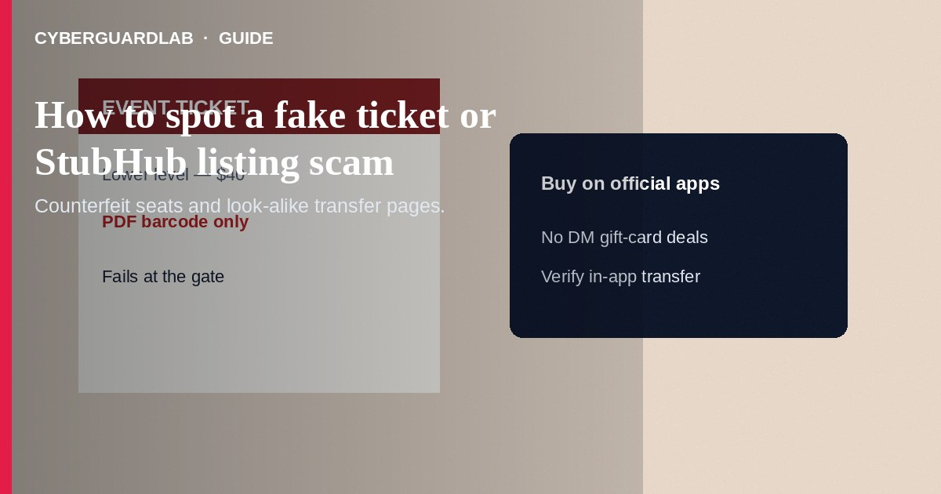
A fake ticket or StubHub listing scam sells seats that do not exist, duplicate barcodes that fail at the gate, or look-alike “ticket transfer” pages that steal logins and payments. Do not buy concert, sports, or theater tickets from cold social DMs. Do not pay with gift cards or wires for “held seats.” If you already paid and the tickets bounce, stop contact, document everything, and report through the platform and the FTC.
This guide covers counterfeit and fraudulent ticket listings—including impersonation of resale marketplaces—not general eBay goods impersonation or rental deposits. Phishing transfers overlap with phishing emails. Off-platform cash-app pressure overlaps with Zelle and Cash App payment scams. No software purchase required.
Paid link
Norton 360 | See the Norton first-year offer

See the Norton first-year offer
Offer page: https://cyberguardlab.com/norton

1. How fake ticket scripts work
Social posts and texts advertise last-minute lower-level seats with a PDF or a link that mimics StubHub, Ticketmaster, or a team site. Some create fake seller profiles on real resale sites using stolen event photos and vanish after payment. Others email a transfer that asks you to log in on a phishing page.
- DM bargain seats — Cold sellers refuse platform checkout and demand Venmo/Zelle.
- Look-alike transfer pages — Links harvest passwords or cards (FTC phishing guidance).
- Duplicate barcodes — Screenshots or PDFs fail at the gate or seats are already taken.
- Fake marketplace support — Cold texts ask for codes after you buy.

2. Red flags before you buy
Cue | Likely legitimate | Likely scam
Where you buy | Official team/venue site or established resale checkout you open yourself | DM sellers, random short links, PDF-only tickets
Price | Within a believable range for the event | Far below face with extreme urgency
Delivery | In-app transfer to your account on a known platform | Screenshot barcodes or Drive folders only
Payment | Card/platform checkout with an order number you can view later | Gift cards, crypto, wire, Friends and Family only
Seller story | Consistent listing history and policies | Flight canceled—need cash today from a new account
Support | Help pages on the real domain | Cold StubHub Support text asking for codes

3. Safer habits (buy-nothing)
- Buy through official box offices or established platforms you navigate to yourself (FTC online shopping tips).
- Be skeptical of DM deals that refuse platform checkout.
- Never pay for tickets with gift cards.
- Confirm transfers inside the official ticketing or resale app—not a PDF alone.
- Ignore unsolicited support texts; open help from the real site.
- For off-platform cash-app pressure, see Zelle and Cash App payment scams.

4. If you already paid
- Stop further payments. Save order emails, chats, PDFs, and payment receipts.
- Contact the platform’s buyer protection or help channel if you used a real marketplace.
- Call your bank or card issuer to dispute unauthorized or non-delivered purchases when eligible (FTC if you were scammed).
- If you used gift cards, contact each issuer’s fraud line with numbers and photos.
- Report at ReportFraud.ftc.gov; report fake social listings to the network.
- If you entered passwords on a fake StubHub-like page, change those credentials and ignore recovery callers.

FAQ

Are PDF tickets always fake?
Not always, but PDFs from strangers are easy to duplicate. Prefer official app transfers when the venue supports them.

StubHub emailed me a problem with my order. Is it real?
Open StubHub by typing the address or using the app. Do not use links inside unexpected messages.

How is this different from a gift card scam?
Gift card scams often involve government or romance pressure to buy cards as payment. Here the product itself—the ticket—is fake or the listing is fraudulent.

Can I get into the show if the barcode worked once online?
Some fakes pass a web preview and fail at the door. Rely on official account delivery when possible.

What if the seats exist but are not mine?
That can still be fraud (double sell or stolen account transfer). Document gate staff notes and pursue platform and bank remedies.

Do I need paid antivirus to avoid a fake ticket scam?
No. Buying through official channels you open yourself is enough. Buy-nothing is valid.

If you still want a paid suite
Avoiding a fake ticket or StubHub listing scam does not require paid antivirus. Careful habits and official support paths are a valid buy-nothing stack. If you want multi-device paid protection later, use only these on-site paid links: TotalAV (paid link), Norton (paid link), Bitdefender (paid link), McAfee (paid link), Avast (paid link).

Sources
- Online Shopping Tips (FTC)
- ReportFraud.ftc.gov
- IdentityTheft.gov
- Phishing Scams (FTC)

Also read
- How to spot a phishing email
- How to spot a Zelle or Cash App payment scam
- How to spot a gift card scam
- How to spot an eBay seller impersonation scam
- How to report a scam to the FTC

