
How to spot a fake Netflix or streaming password-reset email
https://cyberguardlab.com/blog/fake-streaming-password-reset-phishing
Independent US household comparison site. Not the vendor. Paid links below may earn a commission. Confirm first-year price, renewal, device limit, and refund terms at checkout.
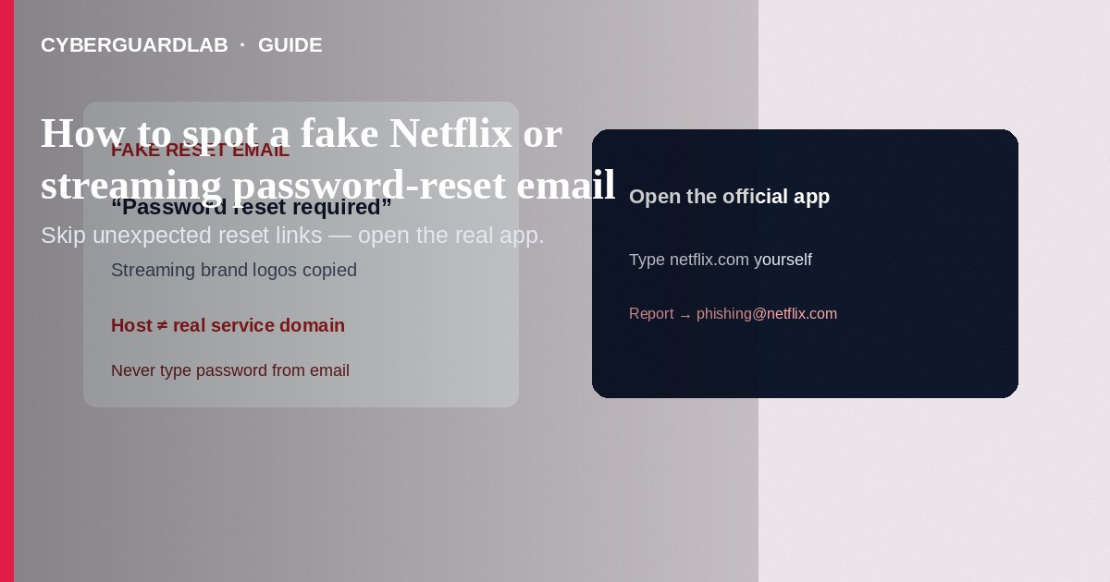
A fake Netflix or streaming password-reset email (or text) is phishing: it imitates a familiar streaming brand to steal your login, payment card, or one-time codes. Real services do not need you to “verify” passwords or cards through an unexpected message. This guide covers streaming reset/phishing cues—not general inbox hygiene alone, not iCloud storage phishing, and not ISP billing scams.

What this scam looks like
Subjects like “Reset your password,” “Password reset required,” “Unusual sign-in,” or “Update payment to keep streaming.” Logos look right; the sender domain does not. Links go to look-alike login pages. Texts may ask for your Netflix email, phone, password, or payment method—Netflix says it will never ask for those in email or text, and will never ask for payment through a third-party vendor or unknown website.
Paid link
Norton 360 | See the Norton first-year offer

See the Norton first-year offer
Offer page: https://cyberguardlab.com/norton

Legitimate vs scam cues
Cue | Likely legitimate | Likely scam
Why you got a reset mail | You just used the official “forgot password” flow on the real site/app | Unexpected “reset required” with a deadline and a big button
What they ask for | Nothing sensitive in the body; you finish reset only on the real domain | Password, card number, bank details, or gift-card “verification”
How you open the site | Type netflix.com (or your service’s real domain) / open the official app | Only via the email/SMS link
Sender / URL | Known brand domains you recognize after hovering | Misspelled domains, free redirects, shortened URLs

What to do if you get a suspicious reset message
- Do not click links or open attachments.
- Ask: Did I just request a reset? If no, treat it as phishing.
- Open the official app or type the real site yourself (for Netflix: start from netflix.com—not the message).
- For Netflix phishing mail/SMS: forward to phishing@netflix.com, then delete. (If a forward is rejected, Netflix may already have a copy—still delete.)
- Report broader phishing to the FTC at ReportFraud.ftc.gov and, for email, APWG at reportphishing@apwg.org; for SMS, forward to 7726 (SPAM) per FTC guidance.
- Tell household members: streaming brands won’t ask for passwords or cards by email/text.

If you already clicked or typed credentials
- Change the streaming password immediately to a strong, unique one (Netflix: unique to Netflix).
- Change that same password anywhere else you reused it.
- Contact your bank/card issuer if you entered payment details.
- If the account email was changed without permission, contact the service’s official support path from the real app/site.
- Run a malware scan on the device you used—Microsoft Defender is enough for many Windows PCs; or compare on-site options: Norton, Bitdefender, TotalAV, McAfee, Avast.
- Turn on multi-factor authentication wherever the streaming service offers it.

Extra caution on “password updated” notices
If you get a “password updated” message you did not cause, assume account takeover risk: change the password from a device/session you trust, review payment methods, and contact official support—never the phone number or chat link inside the suspicious email.

FAQ

I got a Netflix “reset your password” email I didn’t request. What now?
Don’t use the link. Open the real app/site, review recent activity, and follow Netflix’s account-security steps. Forward the message to phishing@netflix.com if it looks fake.

How is this different from a generic password-reset phish?
Same playbook—brand urgency + fake login—but streaming themes often add “payment failed” or “shared password” stories. Still never trust the message link. See also fake password-reset email.

Will spam filters catch all of these?
No. CISA and the FTC both stress recognizing urgency, odd domains, and unexpected asks even when grammar looks perfect.

Can antivirus stop the email from arriving?
Not reliably. Antivirus helps after a malicious download or site; spotting and reporting the message is the primary defense.

Where else should I read on CyberGuardLab?
How to spot a phishing email, fake password-reset email, and fake iCloud storage phishing.

If you still want a paid suite
Spotting streaming password-reset phishing does not require a purchase. Open official apps/sites yourself and buy nothing if Defender habits are solid. If you want multi-device paid protection, use only these on-site paid links: Norton (paid link), Bitdefender (paid link), TotalAV (paid link), McAfee (paid link), Avast (paid link).

Sources
- FTC: How to recognize and avoid phishing scams
- CISA: Recognize and report phishing
- Netflix Help: Phishing or suspicious emails/texts
- Netflix Help: ‘Password reset’ emails from Netflix
- FTC: ReportFraud.ftc.gov

Also read
- How to spot a phishing email
- How to spot a fake password-reset email
- How to spot fake iCloud storage phishing
- Clicked a phishing link: first hour
- How to report a scam to the FTC
- Is Microsoft Defender enough?

