
How to spot a fake Spotify password reset
Read online: https://cyberguardlab.com/blog/fake-spotify-password-reset
Published September 30, 2026 · Updated September 30, 2026
Short answer
Ignore the reset / secure / confirm link in an unexpected “Spotify password reset” or “secure your Spotify account” message; verify only in the official Spotify app or on spotify.com you open yourself; never enter your Spotify password or one-time code on a cold page.
Advertising disclosure: CyberGuardLab is an independent comparison site. We are not TotalAV, Norton, Bitdefender, McAfee, or Avast. If you buy through our links, we may earn a commission, which can affect ranking and placement.
Independent US household comparison site. Not the vendor. Paid links below may earn a commission. Confirm first-year price, renewal, device limit, and refund terms at checkout.
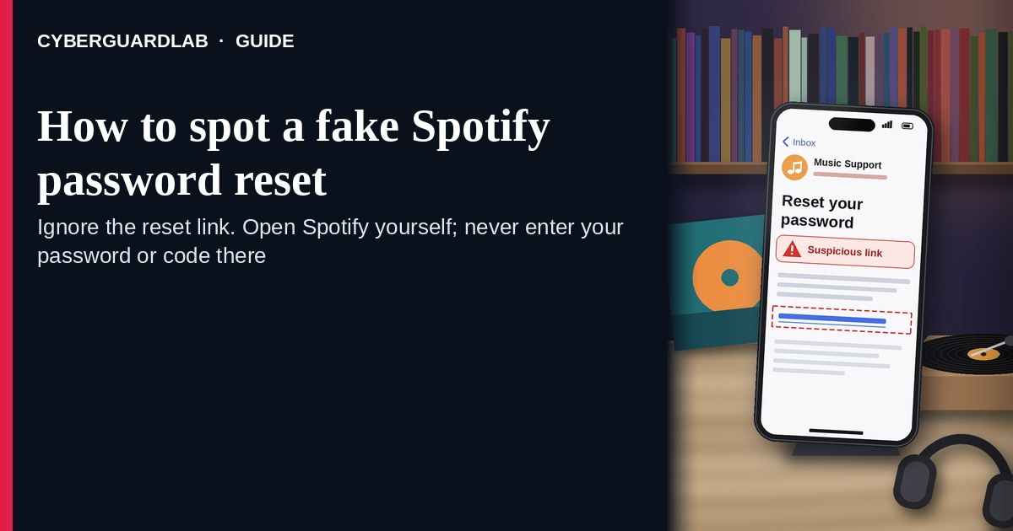
A fake Spotify password reset is an unexpected email, SMS, or DM that claims Spotify needs you to “reset your password,” “secure your account,” or “confirm this login” through a cold link. Real Spotify password and security controls live inside the Spotify account you open yourself in the official app or on spotify.com — not inside a cold “reset password” button in an unexpected message. Spotify Support covers password reset, account protection, and what to do if you think an account was hacked. This page is about Spotify-branded password-reset / secure-account phishing only. Fake reset emails that copy any brand, not just Spotify, are covered in Fake password-reset email. Broader Netflix / streaming password-reset lures are covered in Fake streaming password-reset phishing. Related billing / suspension angles live under Fake Netflix account suspension and Disney Plus billing scam. CyberGuardLab is independent. Referral fees may affect product placement on other pages. Buying nothing and sticking to free verification habits is a valid outcome.

The short answer
Ignore the reset / secure / confirm link in an unexpected “Spotify password reset” or “secure your Spotify account” message; verify only in the official Spotify app or on spotify.com you open yourself; never enter your Spotify password or one-time code on a cold page.
Paid link
Norton 360 | See the Norton first-year offer

See the Norton first-year offer
Offer page: https://cyberguardlab.com/norton
Ad link: https://trysecurities.com/offer/norton?dtm=gg&cid=

What a fake Spotify password reset usually looks like
Scammers copy Spotify security language: “Reset your password,” “We noticed a new login,” “Secure your account now,” or “Confirm it’s you — password reset required.” The job is credential theft and account takeover (and sometimes a card harvest on the fake billing follow-up).
Common shapes US households report:
- Email claiming a Spotify password reset you did not request with a bright “Reset password,” “Secure account,” or “This wasn’t me” button that does not land on spotify.com.
- SMS or iMessage about a “Spotify login attempt” or “password change” with a short link to “review activity” or “unlock your Premium.”
- DM or look-alike “Spotify Support” message that pastes a cold reset / confirm link.
- Look-alike Spotify login or reset page after you tap — then username / email, password, and often a one-time code harvest.
- Follow-up after any reply or tap — once you engage, expect more “support” emails or a scripted call asking for codes. Related first-hour steps: Clicked a phishing link — first hour.
FTC phishing guidance: do not click links in unexpected messages; if you think it might be real, contact the company with a website or app you know is real; report at ReportFraud.ftc.gov.
We do not claim Spotify “never emails about passwords.” Spotify may send real reset and security notices when you start a reset, or when account activity triggers a notice. The safe habit is always the same: leave the unexpected message, open the official Spotify app or spotify.com yourself, and manage password / security only inside a session you started.

Fake Spotify password reset vs real Spotify notice vs other streaming scams
Signal | Fake Spotify password-reset / secure-account message | Real Spotify security / reset notice (typical) | Other streaming password / billing scams
Opening hook | “Reset Spotify password / secure your account / confirm this login today.” | Reset or security details you can also manage after you open Spotify yourself (account page, official reset flow you started). | Netflix / Disney+ / general “streaming” password-reset or suspension / billing panic.
Ask | Cold reset / confirm link, Spotify password, OTP, or “support” chat codes. | Usually none inside an unexpected message — you start reset or change password only inside Spotify / the official reset page you opened yourself. | Cold reset links, “payment failed” buttons, or fake billing pages for other brands.
Pressure | Same-day lockout, “unauthorized access now,” reset countdown. | Normal security timeline; you verify on your schedule. | “Account suspended tonight,” Premium ends in hours, or refund countdown.
Safe next step | Ignore link. Open the official Spotify app or spotify.com yourself. | Confirm password, sign-out-everywhere, and apps only inside Spotify. | See Netflix suspension, or Disney+ billing.
Related guide | This page | Official Spotify app / spotify.com typed by you | Fake password-reset email
If the page after the tap asks for your Spotify password plus a one-time code on the same cold form, stop — that is credential theft dressed as a password reset.

How to verify a Spotify password reset message (US household steps)
Do this when any unexpected Spotify “password reset” / “secure your account” / cold confirm message appears. You do not need a paid product to finish these steps.
- Do not tap the link, reply YES/NO, or call a number that lives only inside the message. Close the email, text, or DM. Do not discuss the “reset” with a caller who contacted you first, and do not trust a cold DM from “Spotify Support.”
- Open Spotify the way you already trust. Open the official Spotify app already on your phone, or type spotify.com yourself — not the reset / secure / confirm link from the unexpected message.
- Check account security only inside a signed-in session you started. Review email on file, recent plan / payment changes, connected apps, and Sign out everywhere if anything looks wrong. If you did not request a reset and nothing unexpected appears in the official app, treat the cold message as spam.
- Never enter your Spotify password or one-time code on a page that arrived from a cold email, text, or DM. Legitimate Spotify password work does not require you to trust an unexpected shortener or look-alike domain. Do not share 2FA or email codes with anyone who contacted you first.
- If you already tapped, typed a password or code, or lost access, treat the first hour as incident response. Change your Spotify password from the official app or spotify.com you open if you still can (use Spotify’s official reset flow only after you type the site yourself); Sign out everywhere; remove suspicious third-party apps; change the password on the email that owns Spotify if that inbox may be shared. Follow Clicked a phishing link — first hour. If you already lost access, use Spotify Support hacked-account help and Recover a hacked email or social media account. Report at ReportFraud.ftc.gov; if identity data was stolen, use IdentityTheft.gov.
- Report the message and tell the household. Mark the email as phishing / junk; forward scam texts to 7726 (SPAM); file at ReportFraud.ftc.gov. Agree that nobody “resets Spotify” from unexpected links. Checklist: How to report a scam to the FTC. Turn on 2FA on the email that owns Spotify (and any other accounts that share that inbox).

Signs the message is fake or unsafe (scan table)
Use this as a quick pass before you spend money or time.
Sign | Why it matters | What to do
Reset / secure / confirm link lives only inside the unexpected email, text, or DM | Password and account takeover | Ignore; open the official Spotify app or spotify.com
URL is a shortener, misspelled Spotify name, or random form host | Phishing page | Never tap; open the official app
Urgent “secure in 15 minutes” or “account locked tonight” | Fear used to skip verification | Slow down; check account only inside Spotify
Sender is a look-alike “Spotify Support” DM or odd reply-to address | Easy to spoof display names and fake support accounts | Verify only inside a session you start
Page asks for Spotify password plus OTP on the same cold form | Credential harvest | Stop; change password from official Spotify if you typed anything
You already replied, tapped, shared a code, or spoke to a “support agent” | Follow-up spam, malware, or takeover risk | Stop engaging; verify in the official app; run first-hour steps if you entered secrets

Free habits that reduce the blast radius
You do not need a new subscription to lower damage if a fake Spotify password reset gets through.
- Keep only the official Spotify app (or type spotify.com); manage password and Sign out everywhere only there.
- Household rule: never use reset / secure / confirm links inside unexpected Spotify emails, texts, or DMs; never share codes with cold “support.”
- Strong unique passwords + 2FA on Spotify’s owner email limit what a stolen password can unlock.
- Forward obvious scam texts to 7726; enable carrier and mailbox spam filtering when available.
- Optional antivirus / web filtering is a separate layer after a bad tap; it does not replace the verify-in-official-app habit.

What this page is not
This page is not a full Spotify account-recovery walkthrough for every lockout case, not a Spotify Premium billing manual, and not legal advice about a specific takeover.
It does not claim CyberGuardLab lab scores or “#1 anti-phishing” ranks. It does not tell you to ignore a real reset you started inside Spotify — it tells you to verify there, not in the cold message. It is not the general Netflix / streaming password-reset guide; for that cluster, read Fake streaming password-reset phishing. It is also not a Netflix suspension or Disney+ billing guide, and not the general all-brand guide; for reset emails from any company, read Fake password-reset email. Official recovery and reporting stay with Spotify Support, ReportFraud.ftc.gov, and IdentityTheft.gov if personal data was stolen.

If you decide a paid extra is a real job
Most households can handle fake Spotify password-reset messages with the free steps above. Open a paid page only if you already named a job — for example broader web filtering, cross-device AV, or identity alerts after you gave a scammer personal data — and you will actually use it.
- PC / Mac suite with phishing and web protections many households already compare: Norton plans (paid link; confirm renewal price).
- Independent-test–oriented suite option: Bitdefender plans (paid link).
- Household suite shopping starting point: TotalAV plans (paid link; confirm renewal).
- Multi-device bill under one vendor: McAfee plans (paid link; confirm device limit).
- Another suite path some homes already use: Avast plans (paid link).
Buying nothing beyond free official-app verification habits is still valid. Paid links above are on-site only.

FAQ

Does Spotify really email or text about password resets?
Spotify may send real reset and security notices — especially when you start a reset, or when account activity triggers a notice. That is why the safe test is not “Spotify never messages,” but “I only manage password and security inside the official Spotify app or spotify.com I open myself.”

The message shows my username, a city, or a device name. Is that enough?
No. Usernames, city labels, and device-like strings are easy to reuse from public profiles, breaches, or guesswork. Trust the account session you start yourself, not the message chrome.

I already entered my Spotify password on the reset page. What should I do first?
Change your Spotify password from the official app or spotify.com you open if you still can. Sign out everywhere. Remove suspicious third-party apps. Secure the email that owns the Spotify account. Follow Clicked a phishing link — first hour. Report at ReportFraud.ftc.gov. If you lost access, use Spotify Support and Recover a hacked email or social media account.

How is this different from a fake Netflix or streaming password-reset email?
This page is Spotify-branded password-reset / secure-account phishing only. Fake streaming password-reset phishing covers the broader Netflix / streaming password-reset cluster. Same habit (ignore cold reset links; open the official app yourself), different brand costume — also read that page when the message is about Netflix or a generic “streaming” reset.

How do I report a fake Spotify password reset?
Mark the email as phishing / junk, forward scam texts to 7726 (SPAM), and file at ReportFraud.ftc.gov. Steps for the FTC side are in How to report a scam to the FTC.

Do I need paid antivirus to spot these messages?
No. Spotting is a verification habit: ignore the link, open the official Spotify app or spotify.com, never enter secrets on a cold page. Antivirus can be a separate optional layer for malware after a bad tap; it does not replace that habit.

Sources
- How to reset or change your Spotify password (Spotify Support)
- Protect your Spotify account (Spotify Support)
- Think your account’s been hacked? (Spotify Support)
- Is this Spotify email legit? (Spotify Support)
- How To Recognize and Avoid Phishing Scams (FTC)
- How to Recognize and Report Spam Text Messages (FTC)
- ReportFraud.ftc.gov
- IdentityTheft.gov
- Avoiding Social Engineering and Phishing Attacks (CISA)

Also read
- Fake password-reset email
- Fake Netflix or streaming password-reset email
- Recover a hacked email or social media account
- Turn on 2FA for Gmail, Apple and your bank
- How to report a scam to the FTC

