
How to spot a fake smart-home app on the app store
https://cyberguardlab.com/blog/fake-smart-home-app-store
Independent US household comparison site. Not the vendor. Paid links below may earn a commission. Confirm first-year price, renewal, device limit, and refund terms at checkout.
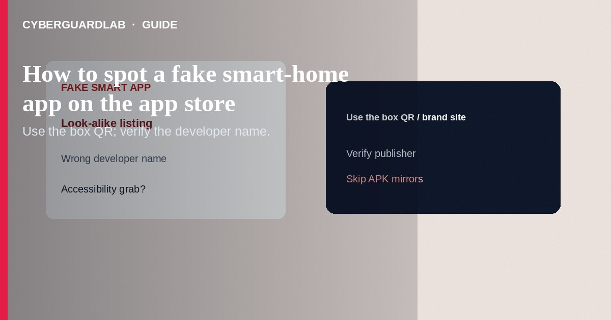
A fake smart-home app on the App Store or Google Play mimics a camera, doorbell, bulb, plug, or “universal remote” brand, then harvests account passwords, pushes overlays, or asks for accessibility / device-admin abuse. Install only from the QR code or URL printed in the manufacturer’s box or official site, then verify the developer name. This guide is store-app impersonation—not setting a doorbell password, not browser push scams, and not NAS hardening.

1. What this scam looks like
Search results show near-identical icons: “Ringg,” “Aquara,” “TP-Lnk,” or a generic “Smart Life Pro Max.” Reviews may be sparse, copied, or oddly new. After install, the app demands your Wi-Fi password, cloud login, SMS codes, or Accessibility permission “to pair devices.” Some are clones that relay credentials to thieves; others are adware.
Paid link
Norton 360 | See the Norton first-year offer

See the Norton first-year offer
Offer page: https://cyberguardlab.com/norton
Sideloaded APKs from random “firmware” blogs are an even higher-risk cousin—related patterns appear in fake carrier 5G upgrade APK guidance.
Even when a brand’s iOS app is legit, a random Android APK site claiming the “same” app is a classic malware drop. Use Play Store or the vendor’s signed download page only.

2. Legitimate vs scam cues
Cue | Likely legitimate | Likely scam
How you found it | QR/link from the box or brand.com Support | First random Play/App Store search hit
Developer name | Matches the manufacturer or known OEM partner | Unknown LLC; misspelled brand
Permissions | Camera/Bluetooth as needed to pair | Accessibility, SMS, call logs “required to continue”
Support path | Help opens the same brand domain | Only a Telegram “engineer”
Updates | Regular updates from the same developer | Abandoned listing; sudden permission creep

3. What to do before and after install
- Prefer the vendor’s documented app name; scan the in-box QR when present.
- Check developer publisher name, privacy policy domain, and recent update date.
- Decline Accessibility / device-admin unless the vendor clearly documents why (rare for bulbs/plugs).
- Use a unique password for the smart-home cloud account—see smart doorbell unique password patterns for IoT logins.
- If you already installed a fake: uninstall it; change Wi-Fi and cloud passwords from a clean device; revoke app passwords.
- Scan the phone with on-device Play Protect / Apple protections, plus a trusted product such as Norton or Bitdefender when you use one; TotalAV, McAfee, and Avast are other on-site options.

4. What to do before and after install
- Prefer the vendor’s documented app name; scan the in-box QR when present.
- Check developer publisher name, privacy policy domain, and recent update date.
- Decline Accessibility / device-admin unless the vendor clearly documents why (rare for bulbs/plugs).
- Use a unique password for the smart-home cloud account—see smart doorbell unique password patterns for IoT logins.
- If you already installed a fake: uninstall it; change Wi-Fi and cloud passwords from a clean device; revoke app passwords.
- Scan the phone with on-device Play Protect / Apple protections, plus a trusted product such as Norton or Bitdefender when you use one; TotalAV, McAfee, and Avast are other on-site options.

FAQ

The fake app was on the official store—how?
Stores remove listings after reports, but clones appear faster than review. Publisher verification still matters.

How is this different from a malicious browser push scam?
Push scams abuse notification permission in a browser. Fake smart-home apps are mobile installables that target IoT accounts and device permissions.

Can I use a “universal” third-party hub app?
Only if you trust that vendor and understand the permissions. Prefer first-party apps for security-sensitive cameras and locks.

What if I typed my Amazon / Google / Apple password into the clone?
Change that password and sign out other sessions immediately; enable MFA/passkeys.

If you still want a paid suite
Avoiding how to spot a fake smart-home app on the app store does not require paid antivirus. Careful habits and official support paths are a valid buy-nothing stack. If you want multi-device paid protection later, use only these on-site paid links: TotalAV (paid link), Norton (paid link), Bitdefender (paid link), McAfee (paid link), Avast (paid link).

Sources
- FTC: How to recognize and avoid phishing scams
- CISA: Secure our world — Recognize and report phishing
- Google Play Help: Stay safer with Google Play Protect
- Apple Support: How to install apps safely

Also read
- How to set a unique password on a smart doorbell
- How to spot a malicious browser push notification scam
- How to spot a fake carrier 5G upgrade malware APK
- How to check if an IoT device still gets security updates
- How to secure a home NAS or personal cloud drive

