
How to spot a fake Ring doorbell alert
Read online: https://cyberguardlab.com/blog/fake-ring-doorbell-alert
Published October 3, 2026 · Updated October 3, 2026
Short answer
Ignore the view-clip / verify / shared-access link in an unexpected Ring doorbell alert; check activity only in the Ring app or ring.com account you open yourself; never approve access or type a Ring password from a cold message.
Advertising disclosure: CyberGuardLab is an independent comparison site. We are not TotalAV, Norton, Bitdefender, McAfee, or Avast. If you buy through our links, we may earn a commission, which can affect ranking and placement.
Independent US household comparison site. Not the vendor. Paid links below may earn a commission. Confirm first-year price, renewal, device limit, and refund terms at checkout.
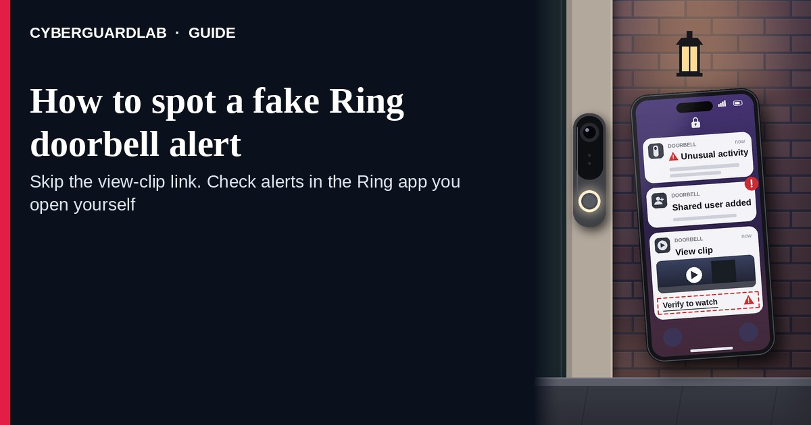
A fake Ring doorbell alert is an unexpected SMS, iMessage, or email that claims unusual Ring activity, shared access, “someone is at your door,” a clip to “view now,” or an account verify / unlock step through a cold link. Real Ring doorbell and camera controls live inside the Ring experience you open yourself — the Ring app you installed, ring.com account pages you type or bookmark, or Ring Help paths you look up yourself — not inside a cold shortener from an unexpected text. Ring publishes Help and sign-in pages; the safe habit is to ignore the cold “view clip / verify account” link, open the Ring app or ring.com yourself, and never enter a Ring password or shared-access approval on a page that arrived only from that message. This page is about Ring-branded unusual activity / shared access / “someone is at your door” / account-verify / view-clip phishing only. Related doorbell hygiene: Smart doorbell unique password. Related first-hour steps: Clicked a phishing link — first hour. CyberGuardLab is independent. Referral fees may affect product placement on other pages. Buying nothing and sticking to free verification habits is a valid outcome.

The short answer
Ignore the view-clip / verify / shared-access link in an unexpected Ring doorbell alert; check activity only in the Ring app or ring.com account you open yourself; never approve access or type a Ring password from a cold message.
Paid link
Norton 360 | See the Norton first-year offer

See the Norton first-year offer
Offer page: https://cyberguardlab.com/norton
Ad link: https://trysecurities.com/offer/norton?dtm=gg&cid=

What a fake Ring doorbell alert usually looks like
Scammers copy Ring alert language: “unusual activity,” “someone is at your door,” “shared device access,” “verify your account,” or “view live clip.” The job is credential theft, account takeover, malware, or tricking you into approving a stranger’s access.
Common shapes US households report:
- SMS or iMessage claiming Ring detected motion or a visitor with a short link to “view clip,” “live view,” or “see who is at your door.”
- Email about “unusual Ring activity” or “new shared user” with a bright View / Verify / Review Access button that does not land on ring.com.
- Look-alike Ring login or clip page after you tap — then a password harvest, 2FA code steal, or “approve shared access” prompt for someone you never invited.
- “Your Ring account will be locked — verify now” pitch that mixes a real-looking device nickname with a cold form outside Ring.
- Follow-up after any reply or tap — once you engage, expect more “Ring support” texts or a scripted call. Related first-hour steps: Clicked a phishing link — first hour. Related password hygiene for the doorbell itself: Smart doorbell unique password.
FTC phishing and spam-text guidance: do not click links in unexpected messages; if you think it might be real, contact the company with a website or phone number you know is real; forward scam texts to 7726 (SPAM) and report at ReportFraud.ftc.gov.
We do not claim Ring “never texts or emails about device activity.” Ring may send real alerts. The safe habit is always the same: leave the unexpected message, open the Ring app or ring.com yourself, and manage clips, shared users, and account settings only inside a session or channel you started.

Fake Ring doorbell alert vs real Ring notice vs related lure
Signal | Fake Ring unusual activity / view-clip / verify message | Real Ring notice (typical) | Related lure (account / password hygiene)
Opening hook | “Ring: someone is at your door — view clip / verify account / shared access.” | Alerts you can also see after you open the Ring app or ring.com yourself. | Reuse of a weak doorbell password elsewhere (see Smart doorbell unique password).
Ask | Cold link, Ring password on a look-alike page, approve a stranger’s share. | Usually none inside the message — open the app or account you already trust. | Unique password + 2FA on the Ring account you manage yourself.
Pressure | “Clip expires in 15 minutes,” “account locked unless you verify,” shared-access countdown. | Normal notification calendar; you check on your schedule. | Fear of a “hacked doorbell” used to skip opening the real app.
Safe next step | Ignore link. Open the Ring app or type ring.com yourself. | Confirm clips and users only inside Ring channels you start. | See Smart doorbell unique password; turn on 2FA where you can.
Related guide | This page | Ring app / ring.com typed by you · Ring Help | Smart doorbell unique password
If the page after the tap asks for a Ring password, a one-time code, or “approve shared access” on a domain that is not Ring, stop — that is account theft dressed as a doorbell alert.

How to verify a Ring doorbell alert (US household steps)
Do this when any unexpected Ring unusual-activity / shared-access / view-clip / verify message appears. You do not need a paid product to finish these steps.
- Do not tap the link, reply YES/NO, or call a number that lives only inside the message. Close the email or text. Do not discuss the “visitor” or “shared user” with a caller who contacted you first.
- Open Ring the way you already trust. Open the Ring app you installed earlier, type ring.com yourself (or use a bookmark you saved), or open Ring Help through a path you look up yourself — not the view-clip / verify / shared-access link from the unexpected message.
- Check activity, clips, and shared users only inside a session or channel you started. Look at event history and shared users in the Ring app or ring.com account you opened yourself. If nothing unexpected appears — or you were not expecting a visitor alert — treat the message as spam.
- Never approve a new shared user, enter a Ring password, or type a one-time code on a page that arrived from that cold message. Legitimate Ring alerts do not require you to trust an unexpected shortener or look-alike domain. Change shared-access settings only after you open the Ring app or ring.com yourself.
- If you already tapped, typed a password, or approved access, treat the first hour as incident response. Change the Ring password from a session you started; revoke any unknown shared users; enable or re-check 2FA. Follow Clicked a phishing link — first hour. Password hygiene for the doorbell account: Smart doorbell unique password. Report at ReportFraud.ftc.gov; if identity data was stolen, use IdentityTheft.gov.
- Report the message and tell the household. Mark the email as phishing / junk; forward scam texts to 7726 (SPAM); file at ReportFraud.ftc.gov. Agree that nobody opens Ring clips, shared-access approvals, or “verify account” steps from unexpected links — only via the Ring app or ring.com you open yourself. Checklist: How to report a scam to the FTC.

Signs the message is fake or unsafe (scan table)
Use this as a quick pass before you spend money or time.
Sign | Why it matters | What to do
View clip / verify / shared-access link lives only inside the unexpected message | Credential and account-takeover theft | Ignore; open Ring app or ring.com yourself
URL is a shortener, misspelled Ring name, or random form host | Phishing page | Never tap; open the app or type ring.com
Urgent “clip expires in 15 minutes” or “account locked unless you verify” | Fear used to skip verification | Slow down; check activity inside Ring you start
Asks you to approve a shared user you did not invite | Stranger access to your cameras | Stop; manage Shared Users only in the app you open (<a href="https://cyberguardlab.com/blog/home-security-cameras">tighten camera access</a>)
You were not expecting a visitor alert, or the app shows no matching event | Cold lure with fake doorbell chrome | Ignore; confirm only inside Ring you start
You already replied, tapped, or spoke to “Ring support” | Follow-up spam, malware, or account fraud risk | Stop engaging; open the app; run first-hour steps if you entered secrets

Free habits that reduce the blast radius
You do not need a new subscription to lower damage if a fake Ring doorbell alert gets through.
- Bookmark the Ring app / ring.com account; view clips and shared users only there — never from a cold alert link.
- Household rule: never use view-clip / verify / shared-access links inside unexpected Ring emails or texts.
- Give the Ring account a unique password and turn on stronger sign-in where available — see Smart doorbell unique password and Turn on 2FA for Gmail, Apple, bank.
- Forward obvious scam texts to 7726; enable carrier and mailbox spam filtering when available.
- Optional antivirus / web filtering is a separate layer after a bad tap; it does not replace the verify-in-Ring-app habit. Built-in Microsoft Defender plus those habits is enough for many households.

What this page is not
This page is not a guide to installing a Ring doorbell, not a review of Ring subscription plans, and not legal advice about a specific camera dispute.
It does not claim CyberGuardLab lab scores or “#1 anti-phishing” ranks. It does not tell you to ignore a real visitor event you can also see inside the Ring app you open yourself — it tells you to verify there, not in the cold message. It is not a general smart-doorbell password encyclopedia; for unique-password habits on the doorbell account, read Smart doorbell unique password. Official recovery and reporting stay with Ring Help, your email / password manager, ReportFraud.ftc.gov, and IdentityTheft.gov if personal data was stolen.

If you decide a paid extra is a real job
Most households can handle fake Ring doorbell alerts with the free steps above. Open a paid page only if you already named a job — for example broader web filtering, cross-device AV, or identity alerts after you gave a scammer personal data — and you will actually use it.
- PC / Mac suite with phishing and web protections many households already compare: Norton plans (paid link; confirm renewal price).
- Independent-test–oriented suite option: Bitdefender plans (paid link).
- Household suite shopping starting point: TotalAV plans (paid link; confirm renewal).
- Multi-device bill under one vendor: McAfee plans (paid link; confirm device limit).
- Another suite path some homes already use: Avast plans (paid link).
Buying nothing beyond free official-app / site verification habits is still valid. Paid links above are on-site only.

FAQ

Does Ring really text or email about doorbell activity?
Ring may send real device and account notices. That is why the safe test is not “Ring never messages,” but “I only view clips, shared users, or account settings inside the Ring app or ring.com I open myself — never from a cold link, and I never approve access from a text.”

The message shows my device nickname and a timestamp. Is that enough?
No. Device-like labels and times are easy to reuse from breaches, prior purchases, or guesswork. Trust the Ring session or app you start yourself, not the message chrome.

I already entered a Ring password or approved shared access on the “view clip / verify” page. What should I do first?
Open the Ring app or ring.com yourself, change the password, revoke unknown shared users, and re-check 2FA. Follow Clicked a phishing link — first hour. Report at ReportFraud.ftc.gov.

How is this different from a smart-doorbell password guide?
This page is Ring-branded unusual activity / view-clip / shared-access / verify phishing only. Smart doorbell unique password covers unique-password hygiene for the doorbell account. Same habit (open Ring yourself; never trust a cold link), different focus.

How do I report a fake Ring doorbell alert?
Mark the email as phishing / junk, forward scam texts to 7726 (SPAM), and file at ReportFraud.ftc.gov. Steps for the FTC side are in How to report a scam to the FTC.

Do I need paid antivirus to spot these messages?
No. Spotting is a verification habit: ignore the link, open the Ring app or ring.com, never approve access or enter secrets on a cold page. Microsoft Defender plus those habits is enough for many households. Antivirus can be a separate optional layer for malware after a bad tap; it does not replace that habit.

Sources
- Ring Help
- Ring sign-in
- How To Recognize and Avoid Phishing Scams (FTC)
- How to Recognize and Report Spam Text Messages (FTC)
- ReportFraud.ftc.gov
- IdentityTheft.gov
- Avoiding Social Engineering and Phishing Attacks (CISA)

Also read
- Smart doorbell unique password
- Home security cameras
- Turn on 2FA for Gmail, Apple and your bank
- Clicked a phishing link: the first hour
- How to report a scam to the FTC

