
How to spot a fake ISP outage or bill phishing email
https://cyberguardlab.com/blog/fake-isp-outage-bill-phishing
Independent US household comparison site. Not the vendor. Paid links below may earn a commission. Confirm first-year price, renewal, device limit, and refund terms at checkout.
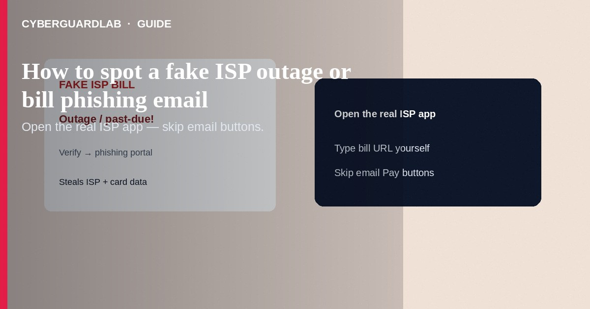
Fake ISP outage or bill phishing emails (and texts) claim your internet will be cut today unless you “verify,” “pay a past-due balance,” or “confirm outage credit” through a look-alike portal—then steal ISP account passwords, payment cards, or one-time codes. Open your real ISP app or type the billing URL from your paper/PDF bill—never the message button. This guide is ISP outage/bill phishing—not checking IoT security updates, not router admin changes, and not Play billing phishing.

1. What this scam looks like
Subject lines: “Service interruption in your area,” “Final notice—broadband suspension,” “Claim your outage refund.” Logos mimic national or local ISPs. Links use hyphenated domains or free redirectors. Callers may quote the last four of your street address scraped from people-search sites and demand gift cards or remote access “to restore the node.”
Paid link
Norton 360 | See the Norton first-year offer

See the Norton first-year offer
Offer page: https://cyberguardlab.com/norton
Refund phishing often looks friendlier than shutoff threats. Same rule: claim credits only inside the official account portal you navigate to yourself.

2. Legitimate vs scam cues
Cue | Likely legitimate | Likely scam
Where you pay | Official app / URL you type from the bill | Only via email/SMS “Pay now”
Payment types | Card/ACH inside the real portal | Gift cards, crypto, wire to a person
Outage news | Status page you open yourself; service may still work | “Click to restore in 10 minutes” pressure
Caller ID | You dial the bill number back | Inbound call demanding codes immediately

3. What to do if contacted
- Do not tap links or share one-time passcodes with callers.
- Open the ISP’s official mobile app or type the domain printed on a recent bill/statement.
- Check balance and tickets there. Pay only inside that session.
- For outages, use the ISP’s status page or app map—not the email.
- Report phishing to the ISP’s abuse address when published; file at ReportFraud.ftc.gov when money or identity data was at risk.
- Tell family: “We never pay the ISP with gift cards.”

4. If you already typed credentials or paid
- Change the ISP account password; enable any MFA the ISP offers.
- Call the number on your statement to flag fraud—not the number in the phishing email.
- Contact your bank/card issuer for unauthorized charges.
- Watch email filters for ISP-looking follow-ups.
- Harden the home gateway (admin password, WPA3) if remote “techs” guided clicks inside the router UI.
- Scan PCs with Norton or Bitdefender (TotalAV, McAfee, Avast on-site).

FAQ

My neighborhood really had an outage. Could the email still be fake?
Yes. Scammers time campaigns around real storms and fiber cuts. Still use the official app.

How is this different from IoT update checks?
IoT updates are about vendor firmware on cameras/TVs. ISP phishing steals billing logins and payments.

The SMS used my account number.
Account numbers leak from prior breaches or mail theft. Specificity ≠ authenticity.

Will Private DNS stop these emails?
No. DNS settings do not filter phishing inboxes.

If you still want a paid suite
Avoiding how to spot a fake ISP outage or bill phishing email does not require paid antivirus. Careful habits and official support paths are a valid buy-nothing stack. If you want multi-device paid protection later, use only these on-site paid links: TotalAV (paid link), Norton (paid link), Bitdefender (paid link), McAfee (paid link), Avast (paid link).

Sources
- FTC: Phishing
- FTC ReportFraud
- CISA: Phishing guidance
- FTC: Online payment scams

Also read
- How to spot a fake invoice or bill-pay scam
- How to spot a utility shutoff scam
- How to spot a phishing email
- How to spot a fake Google Play billing phishing email
- How to check if an IoT device still gets security updates

