
How to spot a fake Instagram login alert
Read online: https://cyberguardlab.com/blog/fake-instagram-login-alert
Published September 29, 2026 · Updated September 29, 2026
Short answer
Ignore the secure / confirm / reset link in an unexpected “new Instagram login” or “secure your account” message; verify only in the official Instagram app or on instagram.com you open yourself; never enter your Instagram password or one-time code on a cold page.
Advertising disclosure: CyberGuardLab is an independent comparison site. We are not TotalAV, Norton, Bitdefender, McAfee, or Avast. If you buy through our links, we may earn a commission, which can affect ranking and placement.
Independent US household comparison site. Not the vendor. Paid links below may earn a commission. Confirm first-year price, renewal, device limit, and refund terms at checkout.
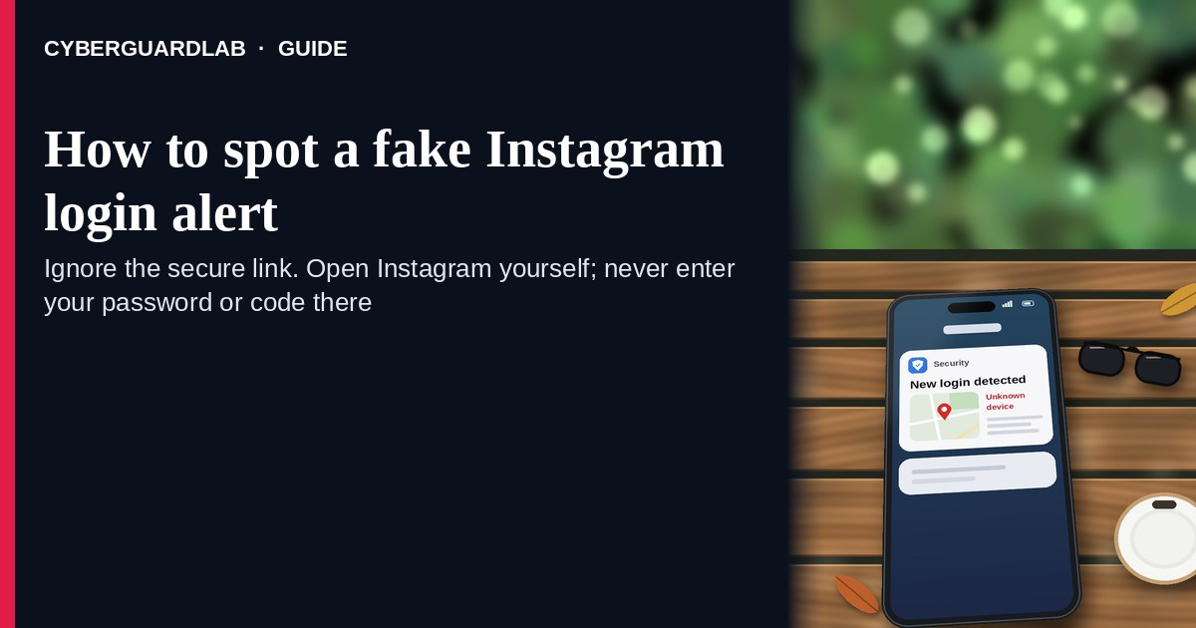
A fake Instagram login alert is an unexpected email, SMS, DM, or push-style message that claims someone “just logged into your Instagram,” that you must “secure your account,” or that you should “confirm this login” through a cold reset / confirm link. Real login and security controls live inside the Instagram account you open yourself in the official app or on instagram.com — not inside a cold “secure account” button in email or DM. Meta’s Instagram Help Center covers hacked-account recovery, scam avoidance, and unsafe links in Direct. This page is about login-alert phishing (cold reset / confirm links). It is not about prize, gift-card, or influencer-collaboration giveaways — that angle is covered in Instagram giveaway / influencer scam. CyberGuardLab is independent. Referral fees may affect product placement on other pages. Buying nothing and sticking to free verification habits is a valid outcome.

The short answer
Ignore the secure / confirm / reset link in an unexpected “new Instagram login” or “secure your account” message; verify only in the official Instagram app or on instagram.com you open yourself; never enter your Instagram password or one-time code on a cold page.
Paid link
Norton 360 | See the Norton first-year offer

See the Norton first-year offer
Offer page: https://cyberguardlab.com/norton
Ad link: https://trysecurities.com/offer/norton?dtm=gg&cid=

What a fake Instagram login alert usually looks like
Scammers copy Instagram security language: “New login from Chrome on Windows,” “We noticed a login from a city you don’t recognize,” “Secure your account now,” or “Confirm it’s you — password reset required.” The job is credential theft and account takeover.
Common shapes US households report:
- Email claiming a new login from an unfamiliar city or device with a bright “Secure account,” “This wasn’t me,” or “Reset password” button that does not land on instagram.com.
- SMS or iMessage about an “Instagram login attempt” with a short link to “review activity” or “unlock your profile.”
- DM from a look-alike “Instagram Support” account that pastes a cold “confirm login” or “appeal” link — different from giveaway / prize DMs covered in Instagram giveaway / influencer scam.
- Look-alike Instagram login page after you tap — then username, password, and often a one-time code harvest.
- Follow-up after any reply or tap — once you engage, expect more “support” emails, DMs, or a scripted call asking for codes. Related first-hour steps: Clicked a phishing link — first hour.
FTC phishing guidance: do not click links in unexpected messages; if you think it might be real, contact the company with a website or app you know is real; report at ReportFraud.ftc.gov.
We do not claim Instagram “never emails about logins.” Instagram / Meta may send real security notices. The safe habit is always the same: leave the unexpected message, open the official Instagram app or instagram.com yourself, and manage Login activity and 2FA only inside a session you started.

Fake Instagram login alert vs real Instagram notice vs giveaway / influencer scam
Signal | Fake Instagram login / secure-account message | Real Instagram security notice (typical) | Instagram giveaway / influencer scam
Opening hook | “New login from … — secure your account / confirm this login today.” | Security details you can also see after you open Instagram yourself (Login activity, emails on file). | “You won,” “free gift,” “collab fee,” or influencer prize DM / comment lure.
Ask | Cold reset / confirm link, Instagram password, OTP, or “support” chat codes. | Usually none inside the message — manage Login activity and 2FA inside signed-in Instagram. | Shipping fee, gift cards, crypto, remote access, or off-platform “winner form.”
Pressure | Same-day lockout, “unauthorized access now,” reset countdown. | Normal security timeline; you verify on your schedule. | “Prize expires today,” limited slots, or pay-to-claim urgency.
Safe next step | Ignore link. Open the official Instagram app or instagram.com yourself. | Confirm Login activity, emails, and 2FA only inside Instagram. | See Instagram giveaway / influencer scam; never pay to claim a prize.
Related guide | This page | Official Instagram app / instagram.com typed by you | Instagram giveaway / influencer scam
If the page after the tap asks for your Instagram password plus a one-time code on the same cold form, stop — that is credential theft dressed as a login alert. Also read: Instagram giveaway / influencer scam when the lure is a prize or collab instead of a login panic.

How to verify an Instagram login alert (US household steps)
Do this when any unexpected Instagram “new login” / “secure your account” / cold reset message appears. You do not need a paid product to finish these steps.
- Do not tap the link, reply YES/NO, or call a number that lives only inside the message. Close the email, text, or DM. Do not discuss the “login” with a caller who contacted you first, and do not trust a cold DM from “Instagram Support.”
- Open Instagram the way you already trust. Open the official Instagram app already on your phone, or type instagram.com yourself — not the secure / confirm / reset link from the unexpected message.
- Check Login activity, emails, and connected apps only inside a signed-in session you started. Look for unfamiliar devices or sessions and remove anything you do not recognize. Review email and phone on file. If nothing unexpected appears, treat the cold message as spam.
- Never enter your Instagram password or one-time code on a page that arrived from a cold email, text, or DM. Legitimate Instagram security work does not require you to trust an unexpected shortener or look-alike domain. Do not share 2FA codes with anyone who contacted you first.
- If you already tapped, typed a password or code, or lost access, treat the first hour as incident response. Change your Instagram password from the official app or instagram.com you open if you still can; turn on 2FA if it was off; review Login activity and remove unknown sessions; revoke suspicious third-party apps. If you already lost access, follow Instagram Help and Recover a hacked email or social media account, then Clicked a phishing link — first hour. Report at ReportFraud.ftc.gov; if identity data was stolen, use IdentityTheft.gov.
- Report the message and tell the household. Mark the email as phishing / junk; forward scam texts to 7726 (SPAM); report suspicious DMs or accounts inside Instagram’s built-in reporting tools; file at ReportFraud.ftc.gov. Agree that nobody “secures Instagram” from unexpected links. Checklist: How to report a scam to the FTC. Turn on 2FA on Instagram and the email that owns it.

Signs the message is fake or unsafe (scan table)
Use this as a quick pass before you spend money or time.
Sign | Why it matters | What to do
Secure / confirm / reset link lives only inside the unexpected email, text, or DM | Password and account takeover | Ignore; open the official Instagram app or instagram.com
URL is a shortener, misspelled Instagram / Meta name, or random form host | Phishing page | Never tap; open the official app
Urgent “secure in 15 minutes” or “account locked tonight” | Fear used to skip verification | Slow down; check Login activity inside Instagram
Sender is a look-alike “Instagram Support” DM or odd reply-to address | Easy to spoof display names and fake support accounts | Verify only inside a session you start; report the DM in-app
Page asks for Instagram password plus OTP on the same cold form | Credential harvest | Stop; change password from official Instagram if you typed anything
You already replied, tapped, shared a code, or spoke to a “support agent” | Follow-up spam, malware, or takeover risk | Stop engaging; verify in the official app; run first-hour steps if you entered secrets

Free habits that reduce the blast radius
You do not need a new subscription to lower damage if a fake Instagram login alert gets through.
- Keep only the official Instagram app (or type instagram.com); manage Login activity and 2FA only there.
- Household rule: never use secure / confirm / reset links inside unexpected Instagram emails, texts, or DMs; never share 2FA codes with cold “support.”
- Strong unique passwords + 2FA on Instagram and email limit what a stolen password can unlock.
- Forward obvious scam texts to 7726; enable carrier and mailbox spam filtering when available; use Instagram’s in-app report tools for suspicious DMs.
- Optional antivirus / web filtering is a separate layer after a bad tap; it does not replace the verify-in-official-app habit.

What this page is not
This page is not a full Instagram account-recovery walkthrough for every lockout case, not a Meta policy manual, and not legal advice about a specific takeover.
It does not claim CyberGuardLab lab scores or “#1 anti-phishing” ranks. It does not tell you to ignore a real login you can also see inside Login activity in the official app — it tells you to verify there, not in the cold message. It is not a giveaway / influencer prize guide; for that, read Instagram giveaway / influencer scam. Official recovery and reporting stay with Instagram Help, ReportFraud.ftc.gov, and IdentityTheft.gov if personal data was stolen.

If you decide a paid extra is a real job
Most households can handle fake Instagram login alerts with the free steps above. Open a paid page only if you already named a job — for example broader web filtering, cross-device AV, or identity alerts after you gave a scammer personal data — and you will actually use it.
- PC / Mac suite with phishing and web protections many households already compare: Norton plans (paid link; confirm renewal price).
- Independent-test–oriented suite option: Bitdefender plans (paid link).
- Household suite shopping starting point: TotalAV plans (paid link; confirm renewal).
- Multi-device bill under one vendor: McAfee plans (paid link; confirm device limit).
- Another suite path some homes already use: Avast plans (paid link).
Buying nothing beyond free official-app verification habits is still valid. Paid links above are on-site only.

FAQ

Does Instagram really email or text about new logins?
Instagram / Meta may send real security notices. That is why the safe test is not “Instagram never messages,” but “I only check Login activity inside the official Instagram app or instagram.com I open myself.”

The message shows my username, a city, or a device name. Is that enough?
No. Usernames, city labels, and device-like strings are easy to reuse from public profiles, breaches, or guesswork. Trust Login activity in the session you start yourself, not the message chrome.

I already entered my Instagram password on the secure-account page. What should I do first?
Change your Instagram password from the official app or instagram.com you open if you still can. Turn on 2FA if it was off. Review Login activity and remove unknown sessions. Follow Clicked a phishing link — first hour. Report at ReportFraud.ftc.gov. If you lost access, use Instagram Help and Recover a hacked email or social media account.

How is this different from an Instagram giveaway or influencer scam?
This page is about unexpected login / secure-account / reset links (email, text, or fake support DM). Instagram giveaway / influencer scam covers prize, gift-card, and collab lures that push you to pay or share data off-platform. Same platform, different hook — also read that page when the message is about winning something.

How do I report a fake Instagram login alert?
Mark the email as phishing / junk, forward scam texts to 7726 (SPAM), report suspicious DMs or accounts inside Instagram, and file at ReportFraud.ftc.gov. Steps for the FTC side are in How to report a scam to the FTC.

Do I need paid antivirus to spot these alerts?
No. Spotting is a verification habit: ignore the link, open the official Instagram app or instagram.com, never enter secrets on a cold page. Antivirus can be a separate optional layer for malware after a bad tap; it does not replace that habit.

Sources
- If you think your Instagram profile has been hacked (Instagram Help)
- Avoid getting scammed on Instagram (Instagram Help)
- Safe website browsing on Instagram Direct (Instagram Help)
- Abuse, Spam and Scams (Instagram Help)
- How To Recognize and Avoid Phishing Scams (FTC)
- How to Recognize and Report Spam Text Messages (FTC)
- ReportFraud.ftc.gov
- IdentityTheft.gov
- Avoiding Social Engineering and Phishing Attacks (CISA)

Also read
- Recover a hacked email or social media account
- Instagram giveaway / influencer scam
- Turn on 2FA for Gmail, Apple and your bank
- Clicked a phishing link — first hour
- How to report a scam to the FTC

