
How to spot a fake iCloud storage full phishing email
https://cyberguardlab.com/blog/fake-icloud-storage-phishing
Independent US household comparison site. Not the vendor. Paid links below may earn a commission. Confirm first-year price, renewal, device limit, and refund terms at checkout.
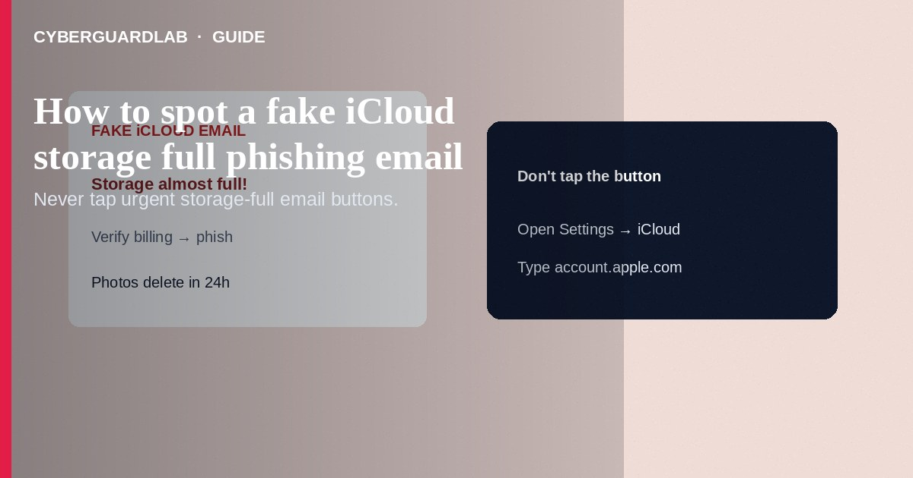
A fake “iCloud Storage Full” phishing email (or text) warns that your photos will be deleted unless you tap a link to “verify billing” or “upgrade storage”—then steals Apple Account passwords or payment details on a look-alike page. Delete or report the message; check real storage only in Settings → [Your Name] → iCloud or account.apple.com that you open yourself. This guide is about storage-full phishing—not enabling Advanced Data Protection, not Hide My Email, and not Find My setup.

1. How this scam works
Subject lines scream “Storage almost full,” “Account locked,” or “Photos will be deleted in 24 hours.” The sender domain is a near-miss (apple-support-mail.com, icIoud-secure.net, etc.). The link goes to a password form, then a credit-card form. Some combine SMS and email. Apple may send legitimate storage notices, but safe practice is still to navigate manually—not through the message’s button.
Paid link
Norton 360 | See the Norton first-year offer

See the Norton first-year offer
Offer page: https://cyberguardlab.com/norton
Scammers often time storage-full lures when people are distracted—airports, new phones, or after a theft report. Verify Find My and account security in official apps, and treat every “urgent iCloud billing” message as hostile until proven otherwise in Settings.

2. Red flags before you tap
Cue | Likely legitimate | Likely scam
How you open iCloud | Settings app or typed apple.com / account.apple.com | Button inside urgent email/SMS
Domain | Apple domains you recognize after careful check | Misspellings, extra hyphens, unrelated TLDs
Threat language | Calm notice you can verify in Settings | “Delete in 2 hours” / “Legal action” pressure
What they ask | Sign-in you initiate on trusted OS UI | Immediate password + full card + SSN on one page
Attachment | Usually none for storage notices | HTML attachment or “invoice” macro

3. What to do if you receive the message
- Do not tap the link. Do not enter the Apple Account password on pages reached from the message.
- On iPhone: Settings → [Your Name] → iCloud to see real storage usage. Upgrade only through Apple’s official purchase flow if you truly need space.
- Report phishing: in Mail, use Apple’s report phishing where available; forward suspicious Apple ID emails as Apple documents; report to ReportFraud.ftc.gov when appropriate.
- Delete the message. Teach household members the same habit.

4. If you already entered credentials
- On a trusted device, change the Apple Account password immediately; sign out other sessions/devices you do not recognize.
- Check payment methods at account.apple.com; remove unknown cards; contact your bank if card data was typed.
- Review Sign in with Apple apps and devices lists for strangers.
- Enable stronger account security; consider whether ADP recovery methods are documented so you are not locked out during cleanup.
- Scan any Windows PC that opened the phishing page with Defender or a trusted suite such as Norton or Bitdefender. Keep one primary product—TotalAV, McAfee, and Avast are other on-site comparison options.

FAQ

Does Apple email about full storage?
Apple can notify you about iCloud storage. Still open Settings yourself rather than trusting the email button.

How is this different from Hide My Email?
Hide My Email creates relay addresses for sign-ups. Phishing imitates Apple billing—unrelated feature.

The email used my real name and last four of a card. Is it real?
Not proof. Breaches and prior purchases leak fragments scammers reuse.

Should I call the phone number in the email?
No. Use support.apple.com or the Apple Support app you open yourself.

If you still want a paid suite
Avoiding how to spot a fake iCloud storage full phishing email does not require paid antivirus. Careful habits and official support paths are a valid buy-nothing stack. If you want multi-device paid protection later, use only these on-site paid links: TotalAV (paid link), Norton (paid link), Bitdefender (paid link), McAfee (paid link), Avast (paid link).

Sources
- Apple Support: Recognize and avoid phishing messages
- Apple Support: Manage your iCloud storage
- FTC: Phishing
- FTC ReportFraud

Also read
- How to turn on Advanced Data Protection for iCloud
- How to review Sign in with Apple app permissions
- How to use Hide My Email for new sign-ups
- How to turn on Find My and Activation Lock before travel
- How to spot a phishing email

