
How to spot a fake friend emergency Facebook message
https://cyberguardlab.com/blog/fake-friend-emergency-facebook-message
Independent US household comparison site. Not the vendor. Paid links below may earn a commission. Confirm first-year price, renewal, device limit, and refund terms at checkout.
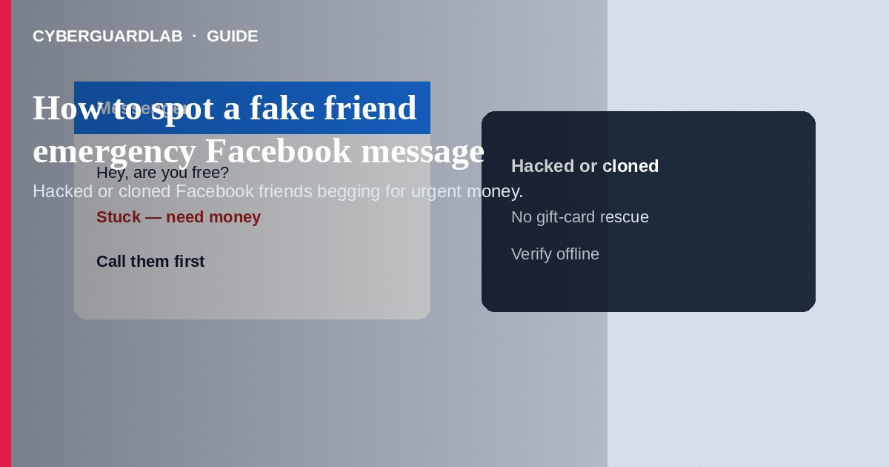
A fake friend emergency Facebook message comes from a hacked or cloned profile that pretends to be someone you know and asks for urgent money, gift cards, or account codes—often for a “stuck traveler,” hospital bill, or locked account. Do not send money from Messenger alone. Do not share one-time codes. Verify through a different channel (phone call or a known family group) before helping. If you already paid, stop contact, save the chat, and report through Meta’s tools and the FTC. This guide is about impersonated-friend emergencies on Facebook/Messenger—not Instagram giveaway prize bait, and not WhatsApp account takeover verification-code theft (though both can overlap when accounts are hijacked).

1. How this scam works
You get a Messenger note: “Hey, are you free?” then a crisis—wallet stolen abroad, rent due, or a child in trouble. The tone may feel slightly off. Sometimes a brand-new profile uses your friend’s photos (a clone). Other times the real account was taken over and posts odd links. They push you to Apple/Google gift cards, wires, Zelle, or crypto “because banks are closed.”
Paid link
Norton 360 | See the Norton first-year offer

See the Norton first-year offer
Offer page: https://cyberguardlab.com/norton
Phishing links that say “Facebook Security: confirm your identity” may arrive in the same thread. Treat those like other phishing; see how to spot a phishing email.

2. Red flags before you pay

3. Safer habits (buy-nothing)
- Pause. Call or text your friend using a contact method you already have—not a number in the chat.
- Ask a question only the real friend would know.
- Never buy gift cards or send wires based only on Messenger.
- Do not share one-time passcodes with anyone claiming to be your friend or Facebook Support.
- Report and block cloned profiles; warn mutual friends if an account looks compromised.
- For gift-card payment scripts, see gift card scams.
Search your own name occasionally for fake profiles using your photos. Enable two-factor authentication on Facebook so hijackers cannot easily keep your real account.

4. If you already paid
- Stop further payments. Screenshot the chat, profile URL, and payment receipts.
- Contact your bank, wire service, or gift-card issuer fraud line immediately.
- Report the account through Facebook/Messenger’s official reporting tools.
- File at ReportFraud.ftc.gov; use IdentityTheft.gov if you shared IDs or passwords.
- Tell mutual friends the profile may be fake or hacked so they are not next.
- If you typed credentials or opened attachments on a fake page, change passwords, enable two-factor authentication, and scan your device with a trusted tool such as Norton or Bitdefender. Keep one primary real-time antivirus—avoid stacking full suites. TotalAV, McAfee, and Avast are other on-site comparison options.

FAQ

My friend’s account posted that they were hacked. Is the emergency ask still real?
Often the hacker posts both. Verify offline before sending money.

How is this different from a WhatsApp takeover scam?
WhatsApp takeover often starts with a stolen SMS code so the attacker hijacks WhatsApp. This Facebook pattern centers on Messenger emergencies and clone profiles—though stolen Facebook sessions can look similar.

They asked me to send a code I just received by SMS. Should I?
No. That code is for account takeover. Never read codes aloud or type them into chats.

What if the person video-called me briefly?
Deepfakes and short stolen clips exist. Still confirm through a second channel before paying.

If you still want a paid suite
Avoiding a a fake friend emergency Facebook message does not require paid antivirus. Careful habits and official support paths are a valid buy-nothing stack. If you want multi-device paid protection later, use only these on-site paid links: TotalAV (paid link), Norton (paid link), Bitdefender (paid link), McAfee (paid link), Avast (paid link).

Sources
- FTC ReportFraud
- IdentityTheft.gov
- FTC: Social media scams
- FTC: Gift card scams
- Meta Help Center (report impersonation)

Also read
- How to spot a WhatsApp account takeover scam
- How to spot a gift card scam
- How to spot a phishing email
- How to spot an Instagram giveaway or influencer scam
- How to report a scam to the FTC

