
How to spot a fake Delta flight change text
Read online: https://cyberguardlab.com/blog/fake-delta-flight-change
Published October 3, 2026 · Updated October 3, 2026
Short answer
Ignore the rebook / confirm-seat / pay-fare-difference link in an unexpected Delta flight change text; manage trips only at delta.com or the Fly Delta app you open yourself; never pay or enter card / SkyMiles details from a cold message.
Advertising disclosure: CyberGuardLab is an independent comparison site. We are not TotalAV, Norton, Bitdefender, McAfee, or Avast. If you buy through our links, we may earn a commission, which can affect ranking and placement.
Independent US household comparison site. Not the vendor. Paid links below may earn a commission. Confirm first-year price, renewal, device limit, and refund terms at checkout.
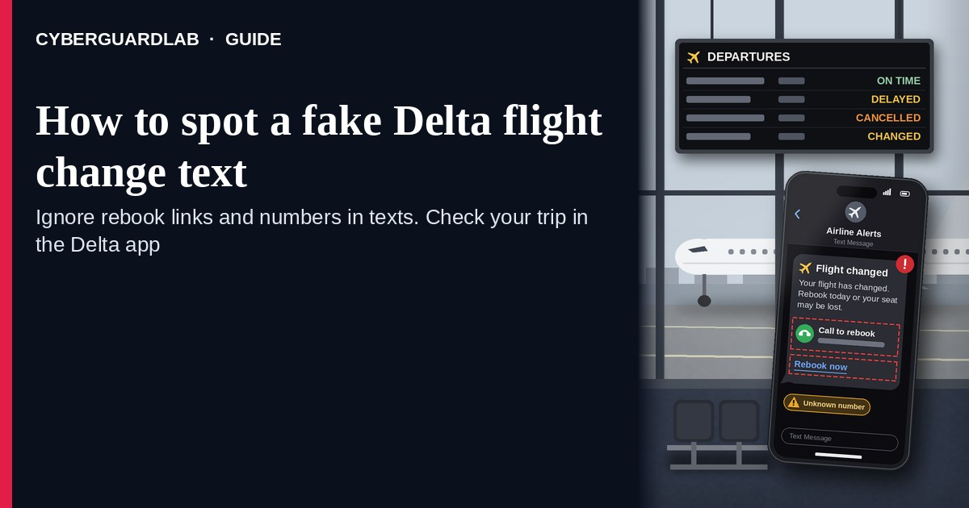
A fake Delta flight change text (or email) is an unexpected SMS, iMessage, or message that claims your Delta flight was changed, cancelled, or needs a rebook / “confirm seat” / “pay a fare difference” step through a cold link. Real Delta trip controls live inside the Delta experience you open yourself — delta.com, the Fly Delta app you installed, Find Your Trip / Flight Status pages you open yourself, or Help Center paths you look up yourself — not inside a cold shortener from an unexpected text. Delta publishes Help Center, Find Your Trip, and Flight Status tools; the safe habit is to ignore the cold rebook / confirm link, manage the trip only after you open Delta yourself, and never pay a “fare difference” or enter a SkyMiles / credit-card detail from that message. This page is about Delta-branded flight change / cancel / rebook / “confirm seat” SMS/email phishing only. The generic airline phone costume is Airline customer service impersonation scam. Related first-hour steps: Clicked a phishing link — first hour. CyberGuardLab is independent. Referral fees may affect product placement on other pages. Buying nothing and sticking to free verification habits is a valid outcome.

The short answer
Ignore the rebook / confirm-seat / pay-fare-difference link in an unexpected Delta flight change text; manage trips only at delta.com or the Fly Delta app you open yourself; never pay or enter card / SkyMiles details from a cold message.
Paid link
Norton 360 | See the Norton first-year offer

See the Norton first-year offer
Offer page: https://cyberguardlab.com/norton
Ad link: https://trysecurities.com/offer/norton?dtm=gg&cid=

What a fake Delta flight change text usually looks like
Scammers copy Delta itinerary language: “your flight has changed,” “cancelled — rebook now,” “confirm your seat,” “pay the fare difference,” or “your boarding pass is invalid.” The job is credential theft, card theft, malware, or a small “rebooking fee” cash-out.
Common shapes US households report:
- SMS or iMessage claiming Delta changed or cancelled your flight with a short link to “rebook,” “confirm seat,” or “view new itinerary.”
- Email about a Delta “schedule change” or “fare difference due” with a bright Rebook / Confirm / Pay button that does not land on delta.com.
- Look-alike Delta My Trips or login page after you tap — then a card / SkyMiles password harvest, or a “pay to keep your seat” form.
- “Confirm within 2 hours or lose your reservation” pitch that mixes a real-looking flight number with a payment form outside Delta.
- Follow-up after any reply or tap — once you engage, expect more “Delta agent” texts or a scripted call. Related phone costume (different angle): Airline customer service impersonation scam. Related first-hour steps: Clicked a phishing link — first hour.
FTC phishing and spam-text guidance: do not click links in unexpected messages; if you think it might be real, contact the company with a website or phone number you know is real; forward scam texts to 7726 (SPAM) and report at ReportFraud.ftc.gov.
We do not claim Delta “never texts or emails about flights.” Delta may send real itinerary notices. The safe habit is always the same: leave the unexpected message, open delta.com or the Fly Delta app yourself, and manage changes only inside a session or channel you started.

Fake Delta flight change text vs real Delta notice vs related lure
Signal | Fake Delta change / cancel / rebook / confirm-seat message | Real Delta notice (typical) | Related lure (airline CS call costume)
Opening hook | “Delta: flight changed / cancelled — rebook / confirm seat / pay now.” | Itinerary updates you can also see after you open Delta yourself. | “This is Delta customer service — call back / stay on the line” (see airline CS impersonation).
Ask | Cold link, card “to keep seat,” SkyMiles password on a look-alike page. | Usually none inside the message — manage trips inside Delta you open yourself. | Phone script pushing remote access, gift cards, or payment over the call.
Pressure | “Confirm in 2 hours,” “seat released tonight,” fare-difference countdown. | Normal schedule-change calendar; you verify on your schedule. | Same-day “account hold” or “ticket void” fear on a cold call.
Safe next step | Ignore link. Type delta.com or open the Fly Delta app yourself. | Confirm status only inside Delta channels you start. | See Airline customer service impersonation scam.
Related guide | This page | delta.com / Fly Delta app typed by you · Find Your Trip / Flight Status / Help Center | Airline customer service impersonation scam
If the page after the tap asks for a card, “rebooking fee,” or Delta / SkyMiles login on a domain that is not Delta, stop — that is theft dressed as a flight notice.

How to verify a Delta flight change message (US household steps)
Do this when any unexpected Delta change / cancel / rebook / confirm-seat / pay-fare-difference message appears. You do not need a paid product to finish these steps.
- Do not tap the link, reply YES/NO, or call a number that lives only inside the message. Close the email or text. Do not discuss the “new itinerary” with a caller who contacted you first.
- Open Delta the way you already trust. Type delta.com yourself (or open the Fly Delta app you installed earlier), use Find Your Trip / Flight Status tools you open yourself, or contact Delta Help Center through a path you look up yourself — not the rebook / confirm / pay link from the unexpected message.
- Check the trip only inside a session or channel you started. Look up the confirmation number (if you already have one from a real booking) on Find Your Trip or in the Fly Delta app you opened yourself. If nothing unexpected appears — or you were not expecting a Delta flight — treat the message as spam.
- Never pay a “fare difference,” “rebooking fee,” or “seat hold” from a cold text, and never enter card or SkyMiles login details on a page that arrived from that message. Legitimate Delta trip tools do not require you to trust an unexpected shortener or look-alike domain. If a real schedule change exists, you will still see it after you open delta.com or the Fly Delta app yourself — manage it only from there.
- If you already tapped, typed a password, or entered a card, treat the first hour as incident response. Change passwords from sessions you started if you typed any; call the number on the back of your card to watch for fraud (Credit card fraud — first hour). Follow Clicked a phishing link — first hour. Report at ReportFraud.ftc.gov; if identity data was stolen, use IdentityTheft.gov.
- Report the message and tell the household. Mark the email as phishing / junk; forward scam texts to 7726 (SPAM); file at ReportFraud.ftc.gov. Agree that nobody rebooks Delta, confirms a seat, or pays a fare difference from unexpected links — only via delta.com or the Fly Delta app you open yourself. Checklist: How to report a scam to the FTC.

Signs the message is fake or unsafe (scan table)
Use this as a quick pass before you spend money or time.
Sign | Why it matters | What to do
Rebook / confirm / pay link lives only inside the unexpected message | Card and credential theft | Ignore; open delta.com or Fly Delta app yourself
URL is a shortener, misspelled Delta name, or random form host | Phishing page | Never tap; type delta.com
Urgent “confirm in 2 hours” or “seat released tonight” | Fear used to skip verification | Slow down; check the trip inside Delta you start
Asks for a “fare difference,” “rebooking fee,” or card / SkyMiles login from the text | Direct cash-out or account theft | Stop; never pay from a cold text
You were not expecting a Delta flight, or Find Your Trip shows no matching itinerary | Cold lure with fake flight chrome | Ignore; confirm any real booking only inside Delta
You already replied, tapped, or spoke to a “Delta agent” | Follow-up spam, malware, or payment fraud risk | Stop engaging; verify on delta.com; run first-hour steps if you entered secrets

Free habits that reduce the blast radius
You do not need a new subscription to lower damage if a fake Delta flight change text gets through.
- Bookmark delta.com / the Fly Delta app; manage trips only there — never from a cold change link.
- Household rule: never use rebook / confirm-seat / pay-fare links inside unexpected Delta emails or texts.
- Differentiate costumes: cold airline “customer service” phone impersonation is covered in Airline customer service impersonation scam.
- Forward obvious scam texts to 7726; enable carrier and mailbox spam filtering when available.
- Optional antivirus / web filtering is a separate layer after a bad tap; it does not replace the verify-on-delta.com habit. Built-in Microsoft Defender plus those habits is enough for many households.

What this page is not
This page is not a guide to filing a real Delta refund or involuntary change claim, not a review of Delta fare products, and not legal advice about a specific cancelled flight.
It does not claim CyberGuardLab lab scores or “#1 anti-phishing” ranks. It does not tell you to ignore a real schedule change you can also see inside delta.com or the Fly Delta app you open yourself — it tells you to verify there, not in the cold message. It is not the generic airline customer-service phone impersonation guide; for that costume, read Airline customer service impersonation scam. Official recovery and reporting stay with Delta Help Center, your card issuer, ReportFraud.ftc.gov, and IdentityTheft.gov if personal data was stolen.

If you decide a paid extra is a real job
Most households can handle fake Delta flight change texts with the free steps above. Open a paid page only if you already named a job — for example broader web filtering, cross-device AV, or identity alerts after you gave a scammer personal data — and you will actually use it.
- PC / Mac suite with phishing and web protections many households already compare: Norton plans (paid link; confirm renewal price).
- Independent-test–oriented suite option: Bitdefender plans (paid link).
- Household suite shopping starting point: TotalAV plans (paid link; confirm renewal).
- Multi-device bill under one vendor: McAfee plans (paid link; confirm device limit).
- Another suite path some homes already use: Avast plans (paid link).
Buying nothing beyond free official-site / app verification habits is still valid. Paid links above are on-site only.

FAQ

Does Delta really text or email about flight changes?
Delta may send real itinerary and schedule notices. That is why the safe test is not “Delta never messages,” but “I only rebook or confirm a seat inside delta.com or the Fly Delta app I open myself — never from a cold link, and I never pay a fare difference from a text.”

The message shows a flight number and my airport codes. Is that enough?
No. Flight-like strings and airport labels are easy to reuse from breaches, prior purchases, or guesswork. Trust the Delta session or app you start yourself, not the message chrome.

I already entered a card or SkyMiles password on the “rebook / confirm” page. What should I do first?
Call the number on the back of your card about possible fraud, change any password you typed from a site you open, and follow Clicked a phishing link — first hour. Report at ReportFraud.ftc.gov.

How is this different from an airline customer service impersonation scam?
This page is Delta-branded flight change / cancel / rebook / confirm-seat SMS/email phishing only. Airline customer service impersonation scam covers the generic airline “customer service” phone costume. Same habit (do not trust cold asks; open the real airline yourself), different channel and brand focus.

How do I report a fake Delta flight change text?
Mark the email as phishing / junk, forward scam texts to 7726 (SPAM), and file at ReportFraud.ftc.gov. Steps for the FTC side are in How to report a scam to the FTC.

Do I need paid antivirus to spot these messages?
No. Spotting is a verification habit: ignore the link, open delta.com or the Fly Delta app, never pay a fee or enter secrets on a cold page. Microsoft Defender plus those habits is enough for many households. Antivirus can be a separate optional layer for malware after a bad tap; it does not replace that habit.

Sources
- Delta Help Center
- Find Your Trip (Delta)
- Delta Flight Status
- Delta Air Lines
- How To Recognize and Avoid Phishing Scams (FTC)
- How to Recognize and Report Spam Text Messages (FTC)
- ReportFraud.ftc.gov
- IdentityTheft.gov
- Avoiding Social Engineering and Phishing Attacks (CISA)

Also read
- Airline customer service impersonation scam
- Credit card fraud: the first hour
- Clicked a phishing link: the first hour
- How to report a scam to the FTC

