
How to spot a fake credit repair company scam
https://cyberguardlab.com/blog/fake-credit-repair-company-scam
Independent US household comparison site. Not the vendor. Paid links below may earn a commission. Confirm first-year price, renewal, device limit, and refund terms at checkout.
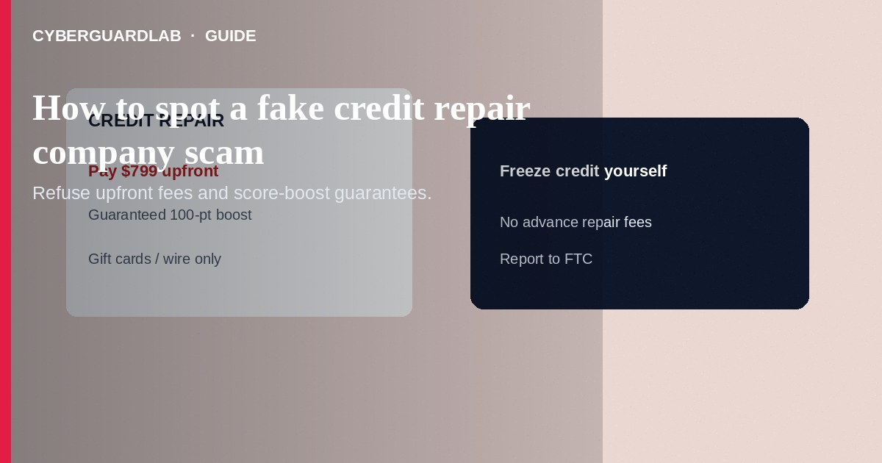
A fake credit repair company scam charges upfront fees, guarantees deletion of accurate negative items, or steals your SSN and login data while promising a “rapid score boost.” Legitimate help cannot wipe true late payments overnight, and U.S. rules generally ban advance fees for credit-repair services before work is done. Do not pay gift cards, wires, or crypto for “repair,” and do not hand over bureau passwords. If you already paid or shared data, stop contact, dispute charges, freeze credit, and report to the FTC. This guide is about fake repair pitches—not how to place a free credit freeze, not Experian CreditLock, and not disputing a fraudulent card charge.

1. How fake credit repair scams work
Ads promise “erase bankruptcies,” “guaranteed 200-point jump,” or “special relationships with Experian.” A salesperson rushes you onto a call, demands payment before any work, and may send a contract full of impossible guarantees. Some sites look like official bureaus or “government affiliated” repair programs. Others collect your SSN, driver’s license, and online banking or bureau logins “to dispute for you,” then open accounts or drain funds.
Paid link
Norton 360 | See the Norton first-year offer

See the Norton first-year offer
Offer page: https://cyberguardlab.com/norton
Real credit improvement is mostly time, accurate disputes of errors, and better payment history—not a secret delete button sold on social media.
Scammers misuse FTC or CFPB logos and claim your freeze “requires” their paid unlock service. Freezes and fraud alerts are free through official bureau channels. Teach household members that nobody needs gift cards to fix a credit file.

2. Red flags before you pay
Cue | Likely legitimate | Likely scam
Fees | Clear pricing; no illegal advance-fee pattern for repair work not yet performed | Pay first by wire, crypto, gift card, or “processing fee” before any service
Promises | Can help dispute errors; cannot guarantee removal of accurate negatives | “Guaranteed delete” of true late pays, collections, or bankruptcies
Identity | Company you can verify; written disclosures required by credit-repair laws | New domain, spoofed bureau logos, “official IRS/FTC partner” claims
Access | You pull free reports yourself at AnnualCreditReport.com | Demands your Experian/Equifax/TransUnion passwords
Urgency | Time to read contracts | “Offer expires in 15 minutes” pressure
DIY path | Encourages freezes, fraud alerts, and free annual reports | Says freezes are useless and only their paid package works

3. Safer habits (buy-nothing)
- Refuse any repair pitch that requires gift cards, crypto, wire, or payment before work.
- Pull your own free reports at AnnualCreditReport.com and dispute errors yourself with each bureau and furnisher.
- Place free security freezes at all three bureaus if identity theft is a concern—see credit freeze how-to.
- Never share bureau or bank passwords with a cold “repair specialist.”
- Search the company name plus “complaint,” “scam,” and BBB/FTC mentions before signing anything.
- For score anxiety after a breach, prioritize freezes and IdentityTheft.gov over paid miracle fixes.

4. If you already paid
- Stop further payments. Save ads, contracts, receipts, chat logs, and wire or card details.
- Contact your bank or card issuer to dispute unauthorized or deceptive charges.
- Change passwords on email, banking, and any bureau accounts you shared; enable stronger two-factor methods.
- Place or confirm freezes at Equifax, Experian, and TransUnion; review reports for new accounts.
- File at ReportFraud.ftc.gov and use IdentityTheft.gov if SSN or ID images were taken.
- If you opened attachments or typed credentials on a fake repair portal, scan your device with a trusted tool such as Norton or Bitdefender. Keep one primary real-time antivirus—avoid stacking full suites. TotalAV, McAfee, and Avast are other on-site comparison options.

FAQ

Can any company legally delete accurate negative items for a fee?
Accurate information generally stays for the legally allowed time. Paying someone to “guarantee” deletion of true negatives is a classic scam signal.

Is credit repair always illegal?
Helping consumers dispute errors can be legitimate when it follows credit-repair disclosure and fee rules. Upfront fees before services, impossible guarantees, and password harvesting are red flags.

How is this different from Experian CreditLock?
CreditLock is Experian’s own lock product on your Experian file. Fake repair companies are third parties selling score miracles—often unrelated to a real bureau lock or freeze.

Should I pay to “remove inquiries” overnight?
Be skeptical. Review whether inquiries are accurate; dispute errors yourself. Urgency plus advance payment is a warning.

If you still want a paid suite
Avoiding how to spot a fake credit repair company scam does not require paid antivirus. Careful habits and official support paths are a valid buy-nothing stack. If you want multi-device paid protection later, use only these on-site paid links: TotalAV (paid link), Norton (paid link), Bitdefender (paid link), McAfee (paid link), Avast (paid link).

Sources
- FTC: Credit repair scams
- FTC: Free credit freezes
- AnnualCreditReport.com
- IdentityTheft.gov
- FTC ReportFraud

Also read
- How to place a credit freeze at all three bureaus
- How to lock or unlock your Experian credit file
- How to dispute a fraudulent credit card charge
- How to get a free annual credit report and read it
- How to report a scam to the FTC

