
How to spot a fake Chase account locked alert
Read online: https://cyberguardlab.com/blog/fake-chase-account-locked
Published October 2, 2026 · Updated October 2, 2026
Short answer
Ignore the unlock / verify link in an unexpected Chase “account locked” or “unusual login” message; open the Chase app or chase.com you type yourself; call the number on the back of your card if needed — never tap a cold unlock link.
Advertising disclosure: CyberGuardLab is an independent comparison site. We are not TotalAV, Norton, Bitdefender, McAfee, or Avast. If you buy through our links, we may earn a commission, which can affect ranking and placement.
Independent US household comparison site. Not the vendor. Paid links below may earn a commission. Confirm first-year price, renewal, device limit, and refund terms at checkout.
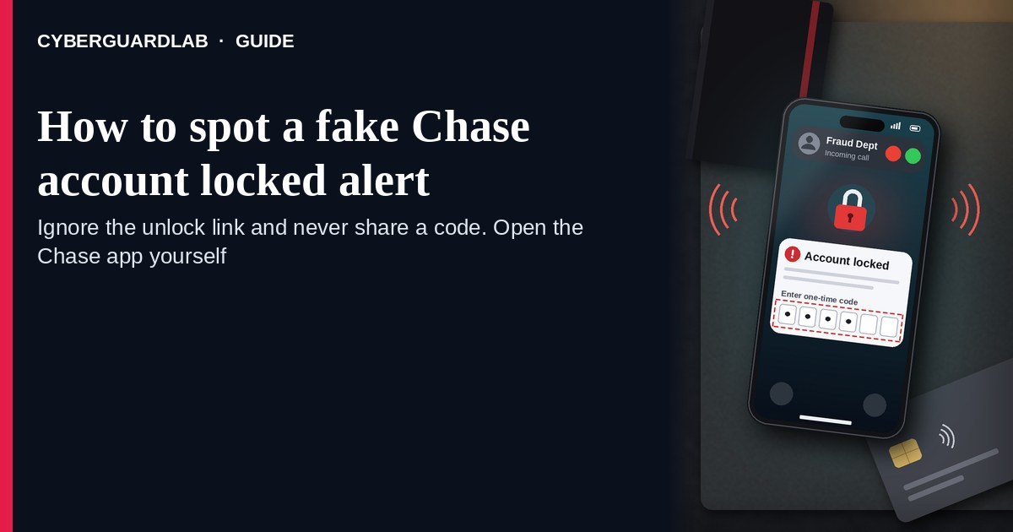
A fake Chase account locked alert is an unexpected email, SMS, push-style message, or call that claims your Chase account is “locked,” that Chase spotted an “unusual login,” or that you must “verify identity” / “unlock now” through a cold link. Real Chase account and security controls live inside the Chase experience you open yourself — the Chase Mobile app on your home screen, chase.com you type yourself, or the phone number on the back of your Chase card — not inside a cold “Unlock / Verify” link. Chase publishes customer-service and privacy/security resources; the safe habit is to never tap an unlock link from an unexpected message, open Chase yourself, and call the number on your card if you still need a human. This page is about Chase-branded account locked / unusual login / verify identity / unlock-now phishing only. The generic multi-bank fraud-SMS cousin is Fake bank fraud alert text. Related first-hour steps: Clicked a phishing link — first hour. CyberGuardLab is independent. Referral fees may affect product placement on other pages. Buying nothing and sticking to free verification habits is a valid outcome.

The short answer
Ignore the unlock / verify link in an unexpected Chase “account locked” or “unusual login” message; open the Chase app or chase.com you type yourself; call the number on the back of your card if needed — never tap a cold unlock link.
Paid link
Norton 360 | See the Norton first-year offer

See the Norton first-year offer
Offer page: https://cyberguardlab.com/norton
Ad link: https://trysecurities.com/offer/norton?dtm=gg&cid=

What a fake Chase account locked alert usually looks like
Scammers copy Chase security language: “account locked,” “unusual sign-in,” “verify your identity,” “unlock to restore access,” or “confirm this device.” The job is credential theft, one-time-code harvest, or both.
Common shapes US households report:
- Email claiming your Chase account is locked or suspended with a bright “Unlock now,” “Verify identity,” or “Secure my account” button that does not land on chase.com.
- SMS or iMessage about an “unusual Chase login” or “account locked” with a short link to “unlock,” “review activity,” or “confirm it was you.”
- Look-alike Chase login or “identity verification” page after you tap — then your username, password, and often a one-time code harvest.
- Callback or inbound call that asks you to read a code that just arrived on your phone — related to the broader bank-fraud alert pattern in Fake bank fraud alert text.
- Follow-up after any reply or tap — once you engage, expect more “fraud desk” emails or a scripted call. Related first-hour steps: Clicked a phishing link — first hour. Related hardening: Turn on 2FA.
FTC phishing and spam-text guidance: do not click links in unexpected messages; if you think it might be real, contact the company with a website or phone number you know is real; forward scam texts to 7726 (SPAM) and report at ReportFraud.ftc.gov.
We do not claim Chase “never emails or texts about security.” Chase may send real login and account notices. The safe habit is always the same: leave the unexpected message, open the Chase app or chase.com yourself (or dial the number on your card), and manage unlock / verification only inside a session or channel you started.

Fake Chase lock alert vs real Chase notice vs generic bank fraud text
Signal | Fake Chase account locked / unlock message | Real Chase notice (typical) | Related lure (generic bank fraud SMS)
Opening hook | “Chase account locked — unlock / verify identity / unusual login now.” | Security or login details you can also see after you open the Chase app or chase.com yourself. | “Fraud on your bank account — tap / call now” (any major bank costume).
Ask | Cold unlock link, password on a look-alike page, OTP to a caller. | Usually none inside the message — review activity inside Chase you open yourself. | Cold multi-bank fraud link or callback (see Fake bank fraud alert text).
Pressure | Same-day permanent lock, “unauthorized wire,” countdown to lose access. | Informational; you verify on your schedule in the app / site. | Countdown, large fake charge, “move money to stay safe.”
Safe next step | Ignore link. Open Chase app or type chase.com; card-back number if needed. | Confirm activity only inside Chase channels you start. | See Fake bank fraud alert text guide.
Related guide | This page | Chase app / chase.com typed by you · number on card | Fake bank fraud alert text
If the page after the tap asks for your Chase password plus a one-time code on a domain that is not Chase, stop — that is account takeover dressed as a lock notice.

How to verify a Chase account locked alert (US household steps)
Do this when any unexpected Chase locked / unusual-login / verify-identity / unlock-now message appears. You do not need a paid product to finish these steps.
- Do not tap the link, reply YES/NO, or call a number that lives only inside the message. Close the email or text. Do not discuss the “lock” with a caller who contacted you first, and never read a one-time code to that caller.
- Open Chase the way you already trust. Open the Chase Mobile app from your home screen, type chase.com yourself, use a bookmark you saved earlier, or dial the phone number printed on the back of your Chase card — not the unlock / verify link from the unexpected message.
- Check account status and recent activity only inside a session or channel you started. Look at sign-ins, alerts, and transfers in the Chase app or on chase.com after you sign in yourself. If nothing unexpected appears, treat the message as spam.
- Never enter your Chase password, username, or one-time code on a page that arrived from a cold email or text. Legitimate Chase security work does not require you to trust an unexpected shortener or look-alike domain.
- If you already tapped, typed a password, or shared a one-time code, treat the first hour as incident response. Change your Chase password from a session you started if you still can; review payees and transfers; call the number on the back of your card about possible fraud. Follow Clicked a phishing link — first hour. Turn on or confirm 2FA on the email that owns related accounts if it was off. Report at ReportFraud.ftc.gov; if identity data was stolen, use IdentityTheft.gov.
- Report the message and tell the household. Mark the email as phishing / junk; forward scam texts to 7726 (SPAM); file at ReportFraud.ftc.gov. Agree that nobody “unlocks Chase” or “verifies identity” from unexpected links — only via the Chase app, chase.com you type, or the number on the card. Checklist: How to report a scam to the FTC.

Signs the message is fake or unsafe (scan table)
Use this as a quick pass before you spend money or time.
Sign | Why it matters | What to do
Unlock / verify / review-activity link lives only inside the unexpected message | Password and OTP theft | Ignore; open Chase app or type chase.com
URL is a shortener, misspelled Chase name, or random form host | Phishing page | Never tap; type chase.com or use the app
Urgent “account permanently locked in 2 hours” or “wire leaves today” | Fear used to skip verification | Slow down; check inside Chase channels you start
Sender address is not a Chase domain you recognize, or reply-to looks odd | Easy to spoof display names | Verify only inside a session / channel you start
Page asks for Chase password plus OTP / SSN / card on the same cold form | Credential + identity harvest | Stop; change password from official Chase if you typed anything (see <a href="https://cyberguardlab.com/blog/bank-account-hacked-first-hour">bank account hacked — first hour</a>)
You already replied, tapped, or spoke to a “Chase fraud agent” who called you (see <a href="https://cyberguardlab.com/blog/otp-relay-scam-call">OTP relay scam call</a>) | Follow-up spam, OTP relay, or account takeover risk | Stop engaging; open Chase yourself; run first-hour steps if you entered secrets

Free habits that reduce the blast radius
You do not need a new subscription to lower damage if a fake Chase account locked alert gets through.
- Keep the Chase Mobile app on your home screen; open chase.com only by typing it or using a bookmark you saved — never from a cold unlock link.
- Household rule: never use unlock / verify / “secure account” links inside unexpected Chase emails or texts; dial the number on the card if you need a human.
- Strong unique passwords + 2FA on email and banking-related accounts limit what a stolen password can unlock.
- Differentiate from generic multi-bank fraud SMS: see the Fake bank fraud alert text guide.
- Forward obvious scam texts to 7726; enable carrier and mailbox spam filtering when available.
- Optional antivirus / web filtering is a separate layer after a bad tap; it does not replace the verify-in-Chase-app habit. Built-in Microsoft Defender plus those habits is enough for many households.

What this page is not
This page is not a guide to disputing a real Chase charge, not a review of Chase products, and not legal advice about a specific account freeze.
It does not claim CyberGuardLab lab scores or “#1 anti-phishing” ranks. It does not tell you to ignore a real security change you can also see inside the Chase app or chase.com you open yourself — it tells you to verify there, not in the cold message. It is not the generic bank fraud-alert text guide; for multi-bank “fraud alert” SMS costumes, read Fake bank fraud alert text. Official recovery and reporting stay with Chase customer service paths you start (app / chase.com / card-back number), ReportFraud.ftc.gov, and IdentityTheft.gov if personal data was stolen.

If you decide a paid extra is a real job
Most households can handle fake Chase account locked alerts with the free steps above. Open a paid page only if you already named a job — for example broader web filtering, cross-device AV, or identity alerts after you gave a scammer personal data — and you will actually use it.
- PC / Mac suite with phishing and web protections many households already compare: Norton plans (paid link; confirm renewal price).
- Independent-test–oriented suite option: Bitdefender plans (paid link).
- Household suite shopping starting point: TotalAV plans (paid link; confirm renewal).
- Multi-device bill under one vendor: McAfee plans (paid link; confirm device limit).
- Another suite path some homes already use: Avast plans (paid link).
Buying nothing beyond free official-app / site / card-back verification habits is still valid. Paid links above are on-site only.

FAQ

Does Chase really email or text about locked accounts or unusual logins?
Chase may send real security and account notices. That is why the safe test is not “Chase never messages,” but “I only unlock or verify inside the Chase app or chase.com I open myself — or by calling the number on my card — never from a cold link.”

The message shows my name, last four of my card, or city. Is that enough?
No. Names, last-four strings, and city labels are easy to reuse from breaches, prior purchases, or guesswork. Trust the Chase session or card-back channel you start yourself, not the message chrome.

I already entered my Chase password or one-time code on the unlock page. What should I do first?
Change your password from the Chase app or chase.com you open if you still can. Review recent transfers and payees. Call the number on the back of your card about possible fraud. Then work through Bank account hacked — first hour; for the link itself, see Clicked a phishing link — first hour. Report at ReportFraud.ftc.gov.

How is this different from a fake bank fraud alert text?
This page is Chase-branded account locked / unusual login / verify identity / unlock phishing only. Fake bank fraud alert text covers the generic multi-bank “fraud alert” SMS costume. Same habit (ignore cold links; open the real bank yourself), different brand focus.

How do I report a fake Chase account locked alert?
Mark the email as phishing / junk, forward scam texts to 7726 (SPAM), and file at ReportFraud.ftc.gov. Steps for the FTC side are in How to report a scam to the FTC.

Do I need paid antivirus to spot these messages?
No. Spotting is a verification habit: ignore the link, open the Chase app or chase.com, never enter secrets on a cold page. Microsoft Defender plus those habits is enough for many households. Antivirus can be a separate optional layer for malware after a bad tap; it does not replace that habit.

Sources
- Chase.com
- Chase Customer Service
- Chase Privacy & Security
- Chase Security
- Chase Secure sign-in
- How To Recognize and Avoid Phishing Scams (FTC)
- How to Recognize and Report Spam Text Messages (FTC)
- ReportFraud.ftc.gov
- IdentityTheft.gov
- Avoiding Social Engineering and Phishing Attacks (CISA)

Also read
- Fake bank fraud alert text
- Bank account hacked: the first hour
- OTP relay scam calls
- Turn on 2FA for Gmail, Apple and your bank
- How to report a scam to the FTC

