
How to spot a fake carrier 5G upgrade malware APK
https://cyberguardlab.com/blog/fake-carrier-5g-upgrade-apk
Independent US household comparison site. Not the vendor. Paid links below may earn a commission. Confirm first-year price, renewal, device limit, and refund terms at checkout.
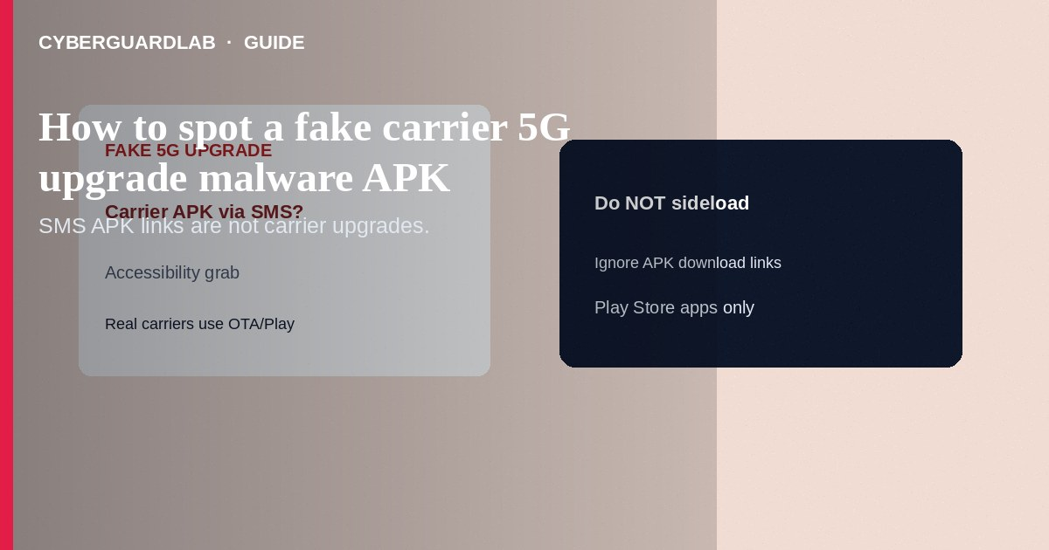
A fake carrier “5G upgrade” malware APK is a sideloaded Android package that pretends to unlock faster 5G, “VoLTE,” or a network tune-up from your mobile carrier—then asks for Accessibility, SMS, or Device Admin rights to steal codes and accounts. Real carriers push network settings through the SIM, official apps from Play Store, or over-the-air updates—not random APK links in SMS. This guide is sideloaded 5G/carrier APK malware—not fake Google Play billing phishing (email/charge links), not work-profile isolation, and not Private DNS setup.

1. What this scam looks like
SMS or WhatsApp: “Your line is ready for 5G—install Carrier_5G_Update.apk.” Links go to shortened URLs or look-alike carrier domains. The APK may request Accessibility (“to optimize signal”), SMS, call logs, or install unknown apps. Some show a fake progress bar then demand Google or banking passwords.
Paid link
Norton 360 | See the Norton first-year offer

See the Norton first-year offer
Offer page: https://cyberguardlab.com/norton
Unlike Play billing phishing, which steals credentials through fake receipts, this path installs code on the phone.
The same playbook uses VoLTE, Wi-Fi calling, or “SIM toolkit upgrade” filenames. Same rule: no sideload from SMS—only official Settings toggles and Play Store carrier apps.

2. Legitimate vs scam cues
Cue | Likely legitimate | Likely scam
Delivery | Play Store carrier app, Settings OTA, SIM provisioning | APK attachment or “tap to download update” SMS
Permissions | Normal network settings toggles | Accessibility + SMS + Device Admin for a “signal booster”
5G itself | Phone Settings → Network shows 5G when coverage and plan allow | Claims an APK “unlocks” 5G on any phone overnight
Brand check | You open the carrier app from Play yourself | Misspelled carrier name, free file hosts

3. What to do if you get the message
- Do not download or open the APK. Do not disable Play Protect to “allow install.”
- Confirm 5G status in Settings → Network & internet → SIMs / Mobile network—not via the text link.
- If you need the carrier app, install only from Google Play after searching the official name.
- Report the SMS as junk/fraud in your Messages app; forward phishing samples only through carrier-documented channels.
- Tell household members: carriers do not text mystery APKs for 5G.

4. If you already installed the APK
- Disconnect from Wi-Fi and mobile data if safe to do so briefly while you remove the app.
- Settings → Apps → find the fake updater → Uninstall. Revoke Accessibility and Device Admin first if Android blocks uninstall.
- Change Google, email, and banking passwords from a different clean device.
- Review unknown Google devices and SMS forwarding / notification access.
- Run Play Protect; consider a security wipe after backup if the malware resisted removal.
- Scan companion PCs that shared files with Norton or Bitdefender (TotalAV, McAfee, Avast on-site).

FAQ

Can an APK really unlock 5G?
Your radio, plan, and tower decide 5G—not a random APK. Treat “unlock 5G” sideloads as hostile.

How is this different from Play billing phishing?
Billing phish steals passwords via fake charge emails. 5G APK scams install malware through sideload.

Play Protect was off—what now?
Turn Play Protect on, uninstall unknowns, and assume account compromise until you rotate passwords.

Is the carrier’s real app on APKMirror safer?
Prefer Play Store or the carrier’s documented site. Third-party APK mirrors are a common malware vector.

If you still want a paid suite
Avoiding how to spot a fake carrier 5G upgrade malware APK does not require paid antivirus. Careful habits and official support paths are a valid buy-nothing stack. If you want multi-device paid protection later, use only these on-site paid links: TotalAV (paid link), Norton (paid link), Bitdefender (paid link), McAfee (paid link), Avast (paid link).

Sources
- Google Play Protect
- CISA: Protecting Against Malicious Applications
- FTC: Malware
- FTC ReportFraud

Also read
- How to spot a fake Google Play billing phishing email
- How to back up an Android phone before a security wipe
- How to use a work profile to isolate risky Android apps
- How to check a download before opening an EXE
- How to turn on Google Find My Device before you lose a phone

