
How to spot a fake Apple Support screen-sharing scam
https://cyberguardlab.com/blog/fake-apple-support-screenshare-scam
Independent US household comparison site. Not the vendor. Paid links below may earn a commission. Confirm first-year price, renewal, device limit, and refund terms at checkout.
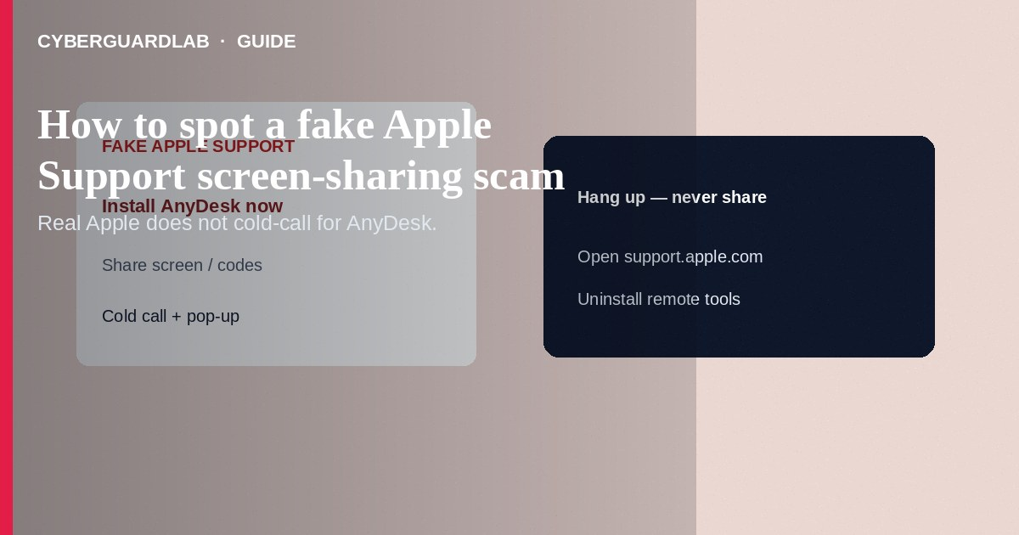
A fake Apple Support screen-sharing scam starts with a cold call, alarming pop-up, or text claiming your Apple ID is locked or your Mac is “hacking itself,” then pushes Quick Assist, AnyDesk, TeamViewer, or browser remote control so thieves can steal passwords, seed phrases, or “refund” money from your bank. Hang up, close the pop-up with a hard shutdown if needed, and contact Apple only through support.apple.com or the Apple Support app you open yourself. This guide is about impostor screen-share support—not Apple ID recovery without SMS, not turning off iMessage on a lost iPhone, and not a generic OTP relay call that never asks for remote access.

1. How this scam works
A full-screen warning says “Call Apple Security: 1-800-…” or a caller ID spoofs “Apple.” They claim refunds, virus removal, or ID verification. They walk you through installing remote software, then open banking or crypto pages, request gift cards, or move money while narrating “Apple protection fees.” Some combine the script with an OTP request once they trigger a real login.
Paid link
Norton 360 | See the Norton first-year offer

See the Norton first-year offer
Offer page: https://cyberguardlab.com/norton
Real Apple Support does not cold-call to demand remote access after a random pop-up, and does not ask for gift cards or cryptocurrency.
Scammers often show a fake oversized refund, then ask you to “send back the extra” via gift cards or wire. Real banks reverse errors through official channels. Teach relatives: Apple will not flash a locked browser that can only be fixed by a phone number on the page.

2. Red flags before you share the screen
Cue | Likely legitimate | Likely scam
Who called whom | You started chat/call from support.apple.com or the Support app | Pop-up or inbound call with a number to dial now
Remote access | Rare, clearly explained, and never for “refund processing” | Immediate AnyDesk/Quick Assist to “unlock Apple ID”
Payment | No gift cards or crypto for support | Apple gift cards, wire, Bitcoin “security deposit”
Browser scare | No legitimate full-screen freeze requiring a phone call | Unclosable “Apple Security Threat” page with siren audio
Codes | Codes only on devices you control for sign-in you started | “Read the iCloud code so we can verify”

3. Safer habits (buy-nothing)
- Hang up. Do not install remote-support tools for inbound “Apple” callers.
- If a browser page will not close, force-quit the browser or power off; restart in safe conditions and do not call the number on the page.
- Open support.apple.com or the Apple Support app yourself if you still need help.
- Never share Apple ID passwords, recovery keys, or SMS/authenticator codes with the caller.
- If they mentioned your bank, call the bank using the number on your card after the scam call ends.
- For code-harvesting without screen share, see OTP relay scam call.

4. If you already shared the screen
- Disconnect from the internet; uninstall the remote-access app; change Apple ID, email, and bank passwords from a different clean device if possible.
- On account.apple.com, sign out other sessions/devices you do not recognize; enable stronger protections.
- Call your bank/card issuer; review transfers and enable alerts.
- If crypto or seed phrases were visible, move funds to new wallets you create offline from trusted software—assume compromise.
- Report at ReportFraud.ftc.gov; use IdentityTheft.gov as needed.
- Scan Macs and PCs with a trusted tool such as Norton or Bitdefender. Keep one primary real-time antivirus—avoid stacking full suites. TotalAV, McAfee, and Avast are other on-site comparison options.

FAQ

Does Apple ever use screen sharing?
Apple may use remote tools in limited, user-initiated support contexts. Cold-call + panic pop-up + gift cards is fraud.

How is this different from Apple ID account recovery?
Recovery is a waiting process you start at iforgot.apple.com. Scammers invent a fake lock to justify instant remote control.

The pop-up showed my Apple ID email. Is it real?
Not proof. Malware, prior phishing, or guesswork can display personal details.

Is Quick Assist always malicious?
The tool is legitimate software often abused by scammers. The danger is who asked you to run it and why.

If you still want a paid suite
Avoiding how to spot a fake Apple Support screen-sharing scam does not require paid antivirus. Careful habits and official support paths are a valid buy-nothing stack. If you want multi-device paid protection later, use only these on-site paid links: TotalAV (paid link), Norton (paid link), Bitdefender (paid link), McAfee (paid link), Avast (paid link).

Sources
- FTC: Tech support scams
- Apple Support: Protect yourself from scams
- Apple Support: Recognizing and avoiding phishing
- CISA: Avoiding social engineering
- FTC ReportFraud

Also read
- How to spot a one-time passcode relay scam call
- How to recover an Apple ID without SMS access
- How to turn off iMessage on a lost iPhone from another device
- How to spot a fake two-factor authentication text
- How to report a scam to the FTC

