
How to spot a fake Apple Store gift card scam
https://cyberguardlab.com/blog/fake-apple-store-gift-card-scam
Independent US household comparison site. Not the vendor. Paid links below may earn a commission. Confirm first-year price, renewal, device limit, and refund terms at checkout.
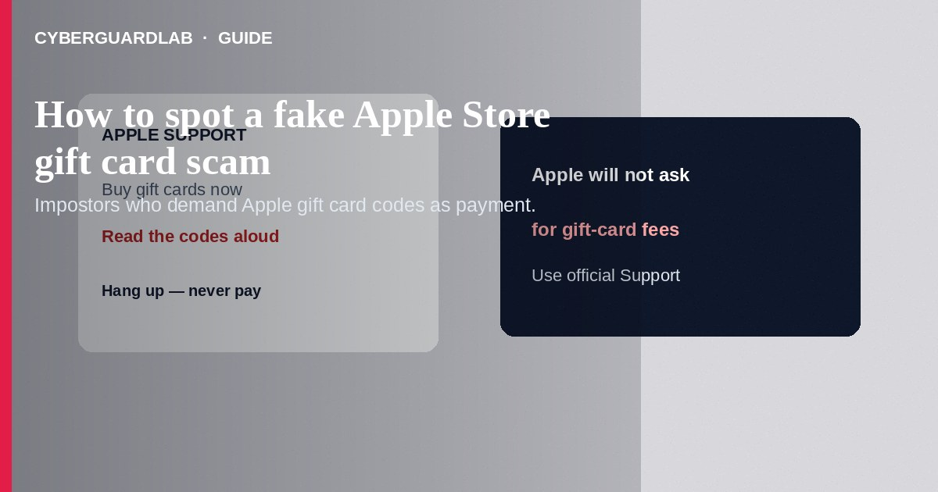
A fake Apple Store gift card scam pressures you to buy Apple Gift Cards (or App Store & iTunes cards) and read the numbers to a stranger posing as Apple Support, a family member in trouble, the IRS, a utility, or a bank. Do not pay any bill or security deposit with Apple gift cards. Do not share card codes by phone or chat. If you already gave numbers away, contact Apple’s gift card abuse resources and the FTC immediately.
This guide focuses on Apple-branded gift card payment demands and Apple Support impostors—not every generic gift card scam across other brands, though the tactics overlap with gift card scams. Phishing emails may link to fake Apple ID pages first; see how to spot a phishing email. Remote-access pressure overlaps with tech support phone scams. No software purchase required.
Paid link
Norton 360 | See the Norton first-year offer

See the Norton first-year offer
Offer page: https://cyberguardlab.com/norton

1. How fake Apple Store gift card scripts work
A caller claims your iCloud is hacked, an Apple ID charge is fraudulent, or your Apple account lawyer fee must be paid in cards. Browser pop-ups flash Apple logos and a phone number. Sometimes a grandchild texts that they need Apple cards for bail or travel. After codes are taken, cards are drained within minutes.
- Apple Support impostors — Cold calls demanding gift-card payment for account issues.
- Scareware pop-ups — Fake lock screens with a callback number.
- Family emergency twists — Relatives who need Apple cards right now.
- Government or bank variants — Same gift-card demand with different costumes (FTC gift card scam guidance).

2. Red flags before you buy cards
Cue | Likely legitimate | Likely scam
How Apple takes payment | Card or Apple Pay on official Apple/App Store flows | Demands you buy gift cards and read codes aloud
Support contact | You start at apple.com/support or the Support app | Cold call or pop-up number
Secrecy | No request to hide the purchase from family/bank | Do not tell anyone—investigation
Urgency | You can pause and verify on official channels | Arrest, account wipe, or family emergency countdown
Receipt path | Purchases appear under your Apple Account | Stranger needs unused card PINs immediately
Remote access | Not required to clear gift card balances | Screen-sharing to verify cards

3. Safer habits (buy-nothing)
- Hang up on gift-card payment demands. Apple will not ask you to pay fees with Apple Gift Cards.
- Check purchases and Apple ID security by opening Settings or appleid.apple.com yourself (Apple Support).
- Refuse pop-up phone numbers; force-quit scareware windows.
- Verify family emergency stories by calling the person on a known number.
- Tell retail staff if someone on the phone is directing a gift card purchase—many stores train for this.
- For broader gift-card pressure tactics, see gift card scam.

4. If you already paid
- Stop buying more cards. Keep remaining unspent cards and receipts.
- Contact Apple about gift card fraud using official Apple Support channels as soon as possible with card details and photos.
- Report to the store where cards were bought and to local police if amounts are significant (FTC if you were scammed).
- File at ReportFraud.ftc.gov; add IdentityTheft.gov if Apple ID or personal data was taken.
- Change your Apple ID password, sign out of unknown devices, and enable two-factor authentication.
- If you installed remote tools or visited fake Apple pages, change passwords and ignore recovery callers.

FAQ

Will Apple Support ever ask for gift card numbers?
No legitimate Apple fee works that way. Treat any such ask as fraud.

How is this different from a generic gift card scam?
The script specifically weaponizes Apple branding—iCloud fear, App Store charges, or Apple Store cards as the payment instrument. Generic scams may demand other brands; the refusal rule is the same.

I already read the codes. Can Apple reverse it?
Act immediately through official Apple Support. Recovery is not guaranteed once cards are redeemed, but speed matters.

A pop-up said my Mac is locked by Apple.
That is scareware. Quit the browser or force shutdown if needed; do not call the number on screen.

Are App Store & iTunes cards different from Apple Gift Cards here?
Scammers request both. The red flag is paying a stranger’s demand with any Apple-branded card codes.

Do I need paid antivirus to avoid an Apple gift card scam?
No. Refusing gift-card payments for fees is enough. Buy-nothing is valid.

If you still want a paid suite
Avoiding a fake Apple Store gift card scam does not require paid antivirus. Careful habits and official support paths are a valid buy-nothing stack. If you want multi-device paid protection later, use only these on-site paid links: TotalAV (paid link), Norton (paid link), Bitdefender (paid link), McAfee (paid link), Avast (paid link).

Sources
- Gift Card Scams (FTC)
- ReportFraud.ftc.gov
- IdentityTheft.gov
- Apple Support

Also read
- How to spot a gift card scam
- How to spot a tech support scam phone call
- How to spot a phishing email
- How to spot a fake IRS wage garnishment call
- How to report a scam to the FTC

