
How to spot a fake Apple ID lock alert
Read online: https://cyberguardlab.com/blog/fake-apple-id-lock-alert
Published September 28, 2026 · Updated September 28, 2026
Short answer
Ignore the unlock / verify link in an unexpected “Apple ID locked” or “unusual Apple sign-in” message; verify only in Settings or at appleid.apple.com you open yourself; never enter your Apple ID password or two-factor code on a cold page.
Advertising disclosure: CyberGuardLab is an independent comparison site. We are not TotalAV, Norton, Bitdefender, McAfee, or Avast. If you buy through our links, we may earn a commission, which can affect ranking and placement.
Independent US household comparison site. Not the vendor. Paid links below may earn a commission. Confirm first-year price, renewal, device limit, and refund terms at checkout.
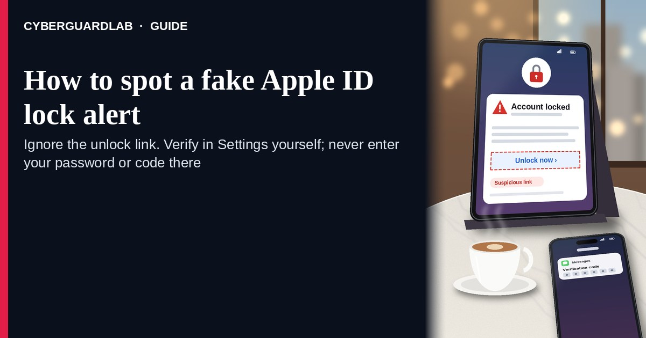
A fake Apple ID lock alert is an unexpected email, SMS, or browser-style message that claims your Apple ID was “locked,” that someone signed in from a new device, or that you must “unlock” or “verify” through a link before you lose Photos, iCloud, or App Store access. Real Apple ID security work lives inside appleid.apple.com or Settings on a device you unlock yourself — not inside a cold unlock / verify button. Apple’s phishing guidance is clear: do not enter your Apple ID password on pages that arrive from unexpected messages; go to Apple using a site or Settings path you trust. This lure is related to other brand-costume renewals such as a fake Microsoft 365 renewal, and it can escalate into a tech support phone scam. CyberGuardLab is independent. Referral fees may affect product placement on other pages. Buying nothing and sticking to free verification habits is a valid outcome.

The short answer
Ignore the unlock / verify link in an unexpected “Apple ID locked” or “unusual Apple sign-in” message; verify only in Settings or at appleid.apple.com you open yourself; never enter your Apple ID password or two-factor code on a cold page.
Paid link
Norton 360 | See the Norton first-year offer

See the Norton first-year offer
Offer page: https://cyberguardlab.com/norton
Ad link: https://trysecurities.com/offer/norton?dtm=gg&cid=

What a fake Apple ID lock alert usually looks like
Scammers copy Apple security language: “Your Apple ID has been locked,” “unusual sign-in from a new device,” “payment method failed — account suspended,” or “verify within 24 hours.” The job is credential theft, payment-card theft, or both.
Common shapes US households report:
- Email claiming Apple ID is locked with a bright “Unlock now” or “Verify Apple ID” button that does not land on appleid.apple.com.
- SMS or iMessage about an “unusual Apple ID sign-in” with a short link to “secure your account” or “review devices.”
- Look-alike Apple ID login page after you tap — then email/phone, password, and often a stolen two-factor code harvest.
- Fake App Store / iCloud billing lock that mixes real-looking invoice language with a “update payment to restore access” link outside Apple. The “iCloud storage is full” version of this bait is a different lure, covered in fake iCloud storage full phishing email; this page is about “your account is locked” alerts.
- Follow-up after any reply or tap — once you engage, expect more “Apple Support” emails or a scripted call pushing remote access. Related patterns: Fake Microsoft 365 renewal scam · Tech support scam phone call.
FTC phishing guidance: do not click links in unexpected messages; if you think it might be real, contact the company with a website or phone number you know is real; report at ReportFraud.ftc.gov.
We do not claim Apple “never emails about Apple ID.” Apple may send real sign-in alerts and account notices. The safe habit is always the same: leave the unexpected message, open Settings → [your name] or type appleid.apple.com yourself, and manage Apple ID only inside a session you started.

Fake Apple ID lock vs real Apple notice vs related Apple / tech-support scams
Signal | Fake Apple ID lock / verify message | Real Apple account notice (typical) | Related tech-support or SIM scam
Opening hook | “Apple ID locked — unlock now / unusual sign-in — verify today.” | Sign-in or purchase details you can also see in Settings → [your name] or appleid.apple.com yourself. | Cold “Apple Support” call for remote access, or a takeover via SIM swap.
Ask | Cold link, Apple ID password, two-factor code, or card “to unlock.” | Usually none inside the message — manage devices and payment inside Apple’s signed-in tools. | Remote-access software, gift cards, or passwords on a cold call.
Pressure | Same-day loss of Photos / iCloud / App Store, “final notice.” | Normal account alerts; you verify on your schedule. | Immediate “agent must stay on the line” urgency.
Safe next step | Ignore link. Open Settings or type appleid.apple.com. | Confirm devices, phone numbers, and payment methods only inside Apple account tools. | Hang up on cold callers; see tech-support and SIM-swap guides.
Related guide | This page | Settings → [your name] / appleid.apple.com typed by you | Tech support scam phone call · SIM swap
If the page after the tap asks for your Apple ID password plus a two-factor code or card on the same cold form, stop — that is credential theft dressed as an unlock.

How to verify an Apple ID lock alert (US household steps)
Do this when any unexpected Apple ID locked / unusual-sign-in / verify message appears. You do not need a paid product to finish these steps.
- Do not tap the link, reply YES/NO, or call a number that lives only inside the message. Close the email or text. Do not discuss the “lock” with a caller who contacted you first.
- Open Apple ID the way you already trust. On iPhone or Mac, open Settings → [your name] (or System Settings → Apple ID). Or type appleid.apple.com yourself in a browser — not the unlock / verify link.
- Check devices, phone numbers, and payment methods only inside a session you started. Look at Devices, Sign-In & Security, and Payment & Shipping. If nothing unexpected appears, treat the message as spam.
- Never enter your Apple ID password, two-factor code, or card on a page that arrived from a cold email or text. Legitimate Apple ID work does not require you to trust an unexpected shortener or look-alike domain. Do not share a code that appears on your trusted devices with anyone who messaged you first.
- If you already tapped, typed a password or code, or entered a card, treat the first hour as incident response. Change your Apple ID password from Settings or appleid.apple.com you open; review trusted phone numbers and devices; turn on or confirm two-factor authentication. Follow Clicked a phishing link — first hour. If phone service suddenly fails while someone else uses your number for codes, see SIM swap / stolen phone number. Report at ReportFraud.ftc.gov; if identity data was stolen, use IdentityTheft.gov.
- Report the message and tell the household. Mark the email as phishing / junk; forward scam texts to 7726 (SPAM); file at ReportFraud.ftc.gov. Agree that nobody “unlocks Apple ID” or “verifies devices” from unexpected links, and nobody installs remote tools for a cold “Apple Support” call. Checklist: How to report a scam to the FTC.

Signs the message is fake or unsafe (scan table)
Use this as a quick pass before you spend money or time.
Sign | Why it matters | What to do
Unlock / verify / secure link lives only inside the unexpected message | Password and code theft | Ignore; open Settings or appleid.apple.com
URL is a shortener, misspelled Apple name, or random form host | Phishing page | Never tap; type appleid.apple.com or use Settings
Urgent “Apple ID locked in 2 hours” or “Photos deleted tonight” | Fear used to skip verification | Slow down; check devices inside Apple account tools
Sender address is not an Apple domain you recognize, or reply-to looks odd | Easy to spoof display names | Verify only inside a session you start
Page asks for Apple ID password plus 2FA code / card on the same cold form | Credential + payment harvest | Stop; change password from official Apple tools if you typed anything
You already replied, tapped, or spoke to an “Apple Support agent” | Follow-up spam, remote access, or account takeover risk | Stop engaging; verify in Settings; run first-hour steps if you entered secrets

Free habits that reduce the blast radius
You do not need a new subscription to lower damage if a fake Apple ID lock alert gets through.
- Manage Apple ID only in Settings → [your name] or at appleid.apple.com you type yourself.
- Household rule: never use unlock / verify links inside unexpected Apple emails or texts; never share on-device codes with cold callers.
- Strong unique passwords + 2FA on email and Apple ID limit what a stolen password can unlock.
- Forward obvious scam texts to 7726; enable carrier and mailbox spam filtering when available.
- Optional antivirus / web filtering is a separate layer after a bad tap; it does not replace the verify-in-Settings habit.

What this page is not
This page is not a guide to recovering a truly forgotten Apple ID password, not a review of iCloud plans, and not legal advice about a specific App Store charge.
It does not claim CyberGuardLab lab scores or “#1 anti-phishing” ranks. It does not tell you to ignore a real Apple sign-in alert you can also see inside Settings or appleid.apple.com — it tells you to verify there, not in the cold message. Official recovery and reporting stay with Apple account security, your card issuer, ReportFraud.ftc.gov, and IdentityTheft.gov if personal data was stolen.

If you decide a paid extra is a real job
Most households can handle fake Apple ID lock alerts with the free steps above. Open a paid page only if you already named a job — for example broader web filtering, cross-device AV, or identity alerts after you gave a scammer personal data — and you will actually use it.
- PC / Mac suite with phishing and web protections many households already compare: Norton plans (paid link; confirm renewal price).
- Independent-test–oriented suite option: Bitdefender plans (paid link).
- Household suite shopping starting point: TotalAV plans (paid link; confirm renewal).
- Multi-device bill under one vendor: McAfee plans (paid link; confirm device limit).
- Another suite path some homes already use: Avast plans (paid link).
Buying nothing beyond free official-site verification habits is still valid. Paid links above are on-site only.

FAQ

Does Apple really email or text about Apple ID locks?
Apple may send real sign-in and account notices. That is why the safe test is not “Apple never messages,” but “I only manage Apple ID inside Settings or appleid.apple.com I open myself.”

The message shows my Apple ID email or a device model. Is that enough?
No. Email addresses and common device names are easy to reuse from breaches, prior purchases, or guesswork. Trust the Apple session you start yourself, not the message chrome.

I already entered my Apple ID password on the unlock page. What should I do first?
Change your Apple ID password from Settings or appleid.apple.com you open. Review devices and trusted phone numbers. Confirm two-factor authentication. Follow Clicked a phishing link — first hour. If the account really is locked and you cannot receive SMS codes, use How to recover an Apple ID without SMS access. Report at ReportFraud.ftc.gov.

How is this different from a tech support phone scam?
This page is about unexpected lock / verify links (email or text). The tech support scam phone call guide covers cold phone “Apple Support” agents pushing remote access or gift cards. Same brand costume, different channel.

How do I report a fake Apple ID lock alert?
Mark the email as phishing / junk, forward scam texts to 7726 (SPAM), and file at ReportFraud.ftc.gov. Steps for the FTC side are in How to report a scam to the FTC. Apple’s own phishing guidance is linked in Sources.

Do I need paid antivirus to spot these alerts?
No. Spotting is a verification habit: ignore the link, open Settings or appleid.apple.com, never enter secrets on a cold page. Antivirus can be a separate optional layer for malware after a bad tap; it does not replace that habit.

Sources
- Recognize and avoid phishing emails, support messages, and websites (Apple Support)
- If you think your Apple Account has been compromised (Apple Support)
- Two-factor authentication for Apple Account (Apple Support)
- How To Recognize and Avoid Phishing Scams (FTC)
- How to Recognize and Report Spam Text Messages (FTC)
- ReportFraud.ftc.gov
- IdentityTheft.gov
- Avoiding Social Engineering and Phishing Attacks (CISA)

Also read
- Fake iCloud storage full phishing email
- Recover an Apple ID without SMS access
- Tech support scam phone call
- Clicked a phishing link — first hour
- SIM swap / stolen phone number

