
How to spot a fake Amazon customer service call
https://cyberguardlab.com/blog/fake-amazon-customer-service-call
Independent US household comparison site. Not the vendor. Paid links below may earn a commission. Confirm first-year price, renewal, device limit, and refund terms at checkout.
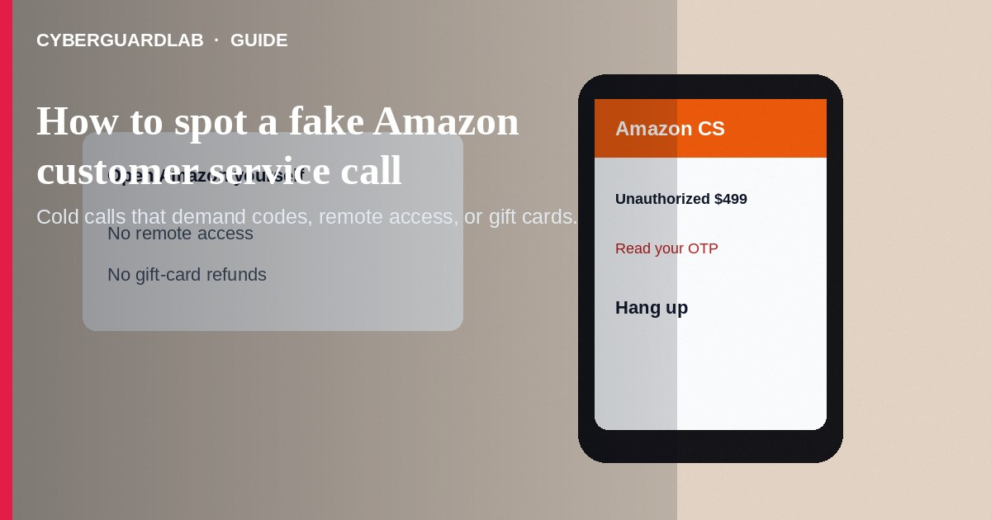
A fake Amazon customer service call is an unsolicited phone or voice message claiming unusual charges, a locked account, a Prime renewal problem, or a package issue—then pushing you to share codes, install remote software, or buy gift cards. Do not call back numbers from pop-ups. Do not give one-time passwords to callers. If you already shared access or paid, stop contact, secure accounts, and report to Amazon and the FTC.
This guide is about impostor Amazon phone and chat support—not a separate package holding-fee text that demands a delivery surcharge without claiming to be Amazon account support. Patterns overlap with tech support phone scams, gift card scams, and phishing emails. No software purchase required.
Paid link
Norton 360 | See the Norton first-year offer

See the Norton first-year offer
Offer page: https://cyberguardlab.com/norton

1. How fake Amazon customer service scripts work
Your phone rings: “Amazon Security—unauthorized $499 charge.” Or a browser pop-up says Amazon detected viruses and lists a phone number. Callers ask you to open your Amazon app, read a code, grant screen sharing, or move money to a “safe account.” Some claim they will refund you if you purchase gift cards or use a crypto ATM.
- Unauthorized-charge scare — Pressure to “cancel” a fake order by sharing codes.
- Pop-up callback trap — Scareware windows with a phone number (tech support scam patterns).
- Remote-access “refund” — AnyDesk or TeamViewer to move money or steal sessions.
- Gift-card settlement — Pay Amazon problems with retail cards (gift card scams).

2. Red flags on the call
Cue | Likely legitimate | Likely scam
Who starts contact | You open Amazon Help or Orders yourself | Cold call or pop-up with a phone number
Codes | Amazon never asks you to read OTP codes to a caller | Demands the SMS or app code out loud
Remote access | Not required for normal order help | AnyDesk/TeamViewer so we can refund you
Payment asks | Refunds appear in your original payment method | Gift cards, wires, crypto, or safe-account transfers
Tone | You control the pace inside your account pages | Threats of arrest, account wipe, or legal action
Verification | Order details match what you see when you log in yourself | Caller knows only vague suspicious-charge stories

3. Safer habits (buy-nothing)
- Hang up. Do not call numbers from pop-ups or unexpected texts.
- Open the Amazon app or amazon.com yourself and check Orders and Account (Amazon Customer Service Help).
- Never read one-time codes to anyone who called you.
- Do not install remote-access apps for Amazon support.
- Never pay Amazon-related problems with gift cards.
- If the story involves malware on your PC, compare with tech support phone scams.

4. If you already paid or shared access
- End remote sessions and uninstall unknown remote tools.
- Change your Amazon and email passwords from a device you trust; enable two-factor authentication.
- Call your bank or card issuer about unauthorized charges or gift-card purchases (FTC if you were scammed).
- Report through Amazon’s official Help/security reporting paths after you sign in yourself.
- File at ReportFraud.ftc.gov; use IdentityTheft.gov if personal data was taken.
- Ignore follow-up “senior agent” recovery callers who ask for more fees.

FAQ

Does Amazon ever call customers?
Amazon may contact customers in limited cases, but safe practice is to hang up and review your account yourself. Real help will not demand gift cards or OTP codes over the phone.

The caller knew my name and a recent order. Is it legit?
Not necessarily. Partial order data can leak from phishing or data breaches.

How is this different from a package holding fee scam?
Holding-fee scams push a delivery surcharge via text or email about a package. Fake Amazon CS calls impersonate account support with charges, refunds, or security theater—often including remote access.

A pop-up froze my browser with an Amazon logo.
That is a common scare tactic. Force-quit the browser; do not call the number on screen.

Should I argue with the caller?
No. Hang up. Debating gives them time to social-engineer more details.

Do I need paid antivirus to avoid a fake Amazon CS call?
No. Hang-up habits and opening Amazon yourself are enough. Buy-nothing is valid.

If you still want a paid suite
Avoiding a fake Amazon customer service call does not require paid antivirus. Careful habits and official support paths are a valid buy-nothing stack. If you want multi-device paid protection later, use only these on-site paid links: TotalAV (paid link), Norton (paid link), Bitdefender (paid link), McAfee (paid link), Avast (paid link).

Sources
- Imposter Scams (FTC)
- Phishing Scams (FTC)
- ReportFraud.ftc.gov
- Amazon Customer Service Help

Also read
- How to spot a tech support scam phone call
- How to spot a package holding fee delivery scam
- How to spot a gift card scam
- Amazon account hacked: first hour
- How to report a scam to the FTC

