
How to spot a fake Airbnb host message
Read online: https://cyberguardlab.com/blog/fake-airbnb-host-message
Published October 3, 2026 · Updated October 3, 2026
Short answer
Ignore pay / verify-booking / update-payout links in unexpected Airbnb-branded host messages; message and pay only inside the Airbnb app or airbnb.com account you open yourself; never send wire, gift card, or Zelle “to hold the stay” from a cold text.
Advertising disclosure: CyberGuardLab is an independent comparison site. We are not TotalAV, Norton, Bitdefender, McAfee, or Avast. If you buy through our links, we may earn a commission, which can affect ranking and placement.
Independent US household comparison site. Not the vendor. Paid links below may earn a commission. Confirm first-year price, renewal, device limit, and refund terms at checkout.
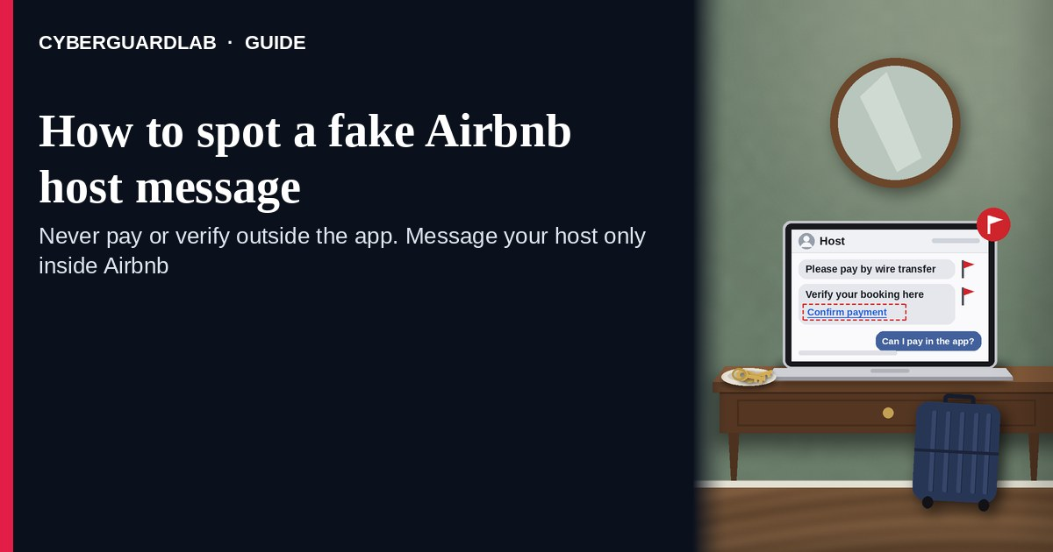
A fake Airbnb host message is an unexpected SMS, iMessage, email, or look-alike “Airbnb” thread that claims to be your host (or Airbnb support) and pushes off-platform payment, “verify booking,” “update payout,” a wire / gift-card / Zelle ask, or a cold login to “secure your reservation.” Real Airbnb messaging and payments live inside the Airbnb experience you open yourself — the Airbnb app or airbnb.com account you start, Help Center paths you look up yourself — not inside a cold shortener or a chat that jumped to text/email outside Airbnb. Airbnb publishes Help pages on staying inside the platform for payments; the safe habit is to ignore cold “pay / verify / update payout” links, open Airbnb yourself, and only message or pay inside that session. This page is about Airbnb-branded host/guest message phishing only (off-platform pay, verify booking, update payout, look-alike login). It is not a listing-deposit costume — those live at Apartment rental application scam and Craigslist rental deposit scam. Related first-hour steps: Clicked a phishing link — first hour. CyberGuardLab is independent. Referral fees may affect product placement on other pages. Buying nothing and sticking to free verification habits is a valid outcome.

The short answer
Ignore pay / verify-booking / update-payout links in unexpected Airbnb-branded host messages; message and pay only inside the Airbnb app or airbnb.com account you open yourself; never send wire, gift card, or Zelle “to hold the stay” from a cold text.
Paid link
Norton 360 | See the Norton first-year offer

See the Norton first-year offer
Offer page: https://cyberguardlab.com/norton
Ad link: https://trysecurities.com/offer/norton?dtm=gg&cid=

What a fake Airbnb host message usually looks like
Scammers copy Airbnb host language: “confirm your booking,” “pay the remaining balance off Airbnb,” “update your payout method,” “verify your trip,” or “your reservation will be cancelled.” The job is off-platform cash-out, credential theft, or a look-alike login harvest.
Common shapes US households report:
- SMS or iMessage claiming to be your Airbnb host with a short link to “pay the rest,” “verify booking,” or “secure your reservation” outside Airbnb.
- Email about “update payout” / “verify identity for your trip” with a bright Pay / Verify / Login button that does not land on airbnb.com.
- Look-alike Airbnb login or checkout page after you tap — then a password harvest, card form, or instructions to wire / Zelle / buy gift cards.
- Host asks you to leave Airbnb chat and continue on text/WhatsApp/email so payment can happen “faster” or “with a discount.”
- Follow-up after any reply or tap — once you engage, expect more “host” pressure or a scripted support call. Related listing/deposit costumes (different angle): Apartment rental application scam and Craigslist rental deposit scam. Related first-hour steps: Clicked a phishing link — first hour.
FTC phishing and spam-text guidance: do not click links in unexpected messages; if you think it might be real, contact the company with a website or phone number you know is real; forward scam texts to 7726 (SPAM) and report at ReportFraud.ftc.gov.
We do not claim Airbnb “never texts or emails about trips.” Airbnb may send real booking notices. The safe habit is always the same: leave the unexpected message, open the Airbnb app or airbnb.com yourself, and manage messages and payments only inside a session or channel you started.

Fake Airbnb host message vs real Airbnb notice vs related lure
Signal | Fake Airbnb host / verify / off-platform pay message | Real Airbnb notice (typical) | Related lure (listing / deposit costume)
Opening hook | “Your host: pay outside Airbnb / verify booking / update payout now.” | Trip updates you can also see after you open Airbnb yourself. | “Wire a deposit to hold this apartment” (see apartment / Craigslist rental guides).
Ask | Cold link, wire/Zelle/gift card, password on a look-alike page. | Usually none inside the message — pay and message inside Airbnb you open yourself. | Application fee or holding deposit before you ever see a real listing process.
Pressure | “Cancel in 2 hours,” “discount only if you pay off-platform,” payout countdown. | Normal trip calendar; you verify on your schedule. | “Unit will be rented tomorrow” deposit fear.
Safe next step | Ignore link. Open the Airbnb app or type airbnb.com yourself. | Message and pay only inside Airbnb channels you start. | See Apartment rental application scam / Craigslist rental deposit scam.
Related guide | This page | Airbnb app / airbnb.com typed by you · Airbnb Help | Apartment rental application scam · Craigslist rental deposit scam
If the page after the tap asks for a wire, gift card, Zelle, or Airbnb login on a domain that is not Airbnb, stop — that is theft dressed as a host message.

How to verify an Airbnb host message (US household steps)
Do this when any unexpected Airbnb-branded host / verify-booking / update-payout / off-platform-pay message appears. You do not need a paid product to finish these steps.
- Do not tap the link, reply YES/NO, send money, or call a number that lives only inside the message. Close the email or text. Do not continue a “host” chat that jumped off Airbnb without checking the trip inside Airbnb first.
- Open Airbnb the way you already trust. Open the Airbnb app you installed earlier, type airbnb.com yourself (or use a bookmark you saved), or open Airbnb Help through a path you look up yourself — not the pay / verify / update-payout link from the unexpected message.
- Check the trip and Messages only inside a session or channel you started. Open Trips / Messages for the reservation you already know about. If nothing matching appears — or you were not expecting an Airbnb stay — treat the message as spam.
- Never pay a host outside Airbnb from a cold text, and never enter an Airbnb password or card on a page that arrived from that message. Legitimate Airbnb payments and host messaging do not require you to trust an unexpected shortener, wire instructions, or look-alike domain. If a host asks you to pay outside Airbnb, stop and read Airbnb’s own Help guidance after you open Help yourself.
- If you already tapped, typed a password, or sent money, treat the first hour as incident response. Change passwords from sessions you started if you typed any; call the number on the back of your card if you entered card details; contact your bank if you wired or Zelled (see Zelle and Cash App payment scams). Follow Clicked a phishing link — first hour. Report at ReportFraud.ftc.gov; if identity data was stolen, use IdentityTheft.gov.
- Report the message and tell the household. Mark the email as phishing / junk; forward scam texts to 7726 (SPAM); file at ReportFraud.ftc.gov. Agree that nobody pays a host, “verifies booking,” or updates payout from unexpected links — only via the Airbnb app or airbnb.com you open yourself. Checklist: How to report a scam to the FTC.

Signs the message is fake or unsafe (scan table)
Use this as a quick pass before you spend money or time.
Sign | Why it matters | What to do
Pay / verify / update-payout link lives only inside the unexpected message | Credential theft and off-platform cash-out | Ignore; open Airbnb app or airbnb.com yourself
URL is a shortener, misspelled Airbnb name, or random form host | Phishing page | Never tap; type airbnb.com
Host pushes wire, Zelle, gift card, or “pay outside Airbnb for a discount” | Direct cash-out | Stop; pay only inside Airbnb you start
Urgent “cancel in 2 hours” or “payout fails unless you update now” | Fear used to skip verification | Slow down; check Trips / Messages inside Airbnb
You were not expecting a trip, or Airbnb shows no matching reservation | Cold lure with fake host chrome | Ignore; confirm any real trip only inside Airbnb
You already replied, tapped, or sent money to a “host” | Follow-up spam, malware, or payment fraud risk | Stop engaging; open Airbnb; run first-hour steps if you entered secrets or paid

Free habits that reduce the blast radius
You do not need a new subscription to lower damage if a fake Airbnb host message gets through.
- Bookmark the Airbnb app / airbnb.com; message and pay only there — never from a cold host link.
- Household rule: never use pay / verify-booking / update-payout links inside unexpected Airbnb emails or texts; never wire or gift-card a “host.”
- Differentiate costumes: apartment application-fee / holding-deposit lures are covered in Apartment rental application scam; Craigslist-style deposit pitches are covered in Craigslist rental deposit scam.
- Forward obvious scam texts to 7726; enable carrier and mailbox spam filtering when available.
- Optional antivirus / web filtering is a separate layer after a bad tap; it does not replace the verify-in-Airbnb habit. Built-in Microsoft Defender plus those habits is enough for many households.

What this page is not
This page is not a guide to filing a real Airbnb Resolution Center case, not a review of Airbnb host protection programs, and not legal advice about a specific cancelled stay.
It does not claim CyberGuardLab lab scores or “#1 anti-phishing” ranks. It does not tell you to ignore a real trip change you can also see inside Airbnb you open yourself — it tells you to verify there, not in the cold message. It is not the apartment-application or Craigslist-deposit guide; for those costumes, read Apartment rental application scam and Craigslist rental deposit scam. It is also not the fake-listing guide: Vacation rental scam covers rentals where the listing itself is fake, while this page covers messages that impersonate an Airbnb host to push off-platform payment, booking “verification,” or payout changes. Official recovery and reporting stay with Airbnb Help, your card issuer or bank, ReportFraud.ftc.gov, and IdentityTheft.gov if personal data was stolen.

If you decide a paid extra is a real job
Most households can handle fake Airbnb host messages with the free steps above. Open a paid page only if you already named a job — for example broader web filtering, cross-device AV, or identity alerts after you gave a scammer personal data — and you will actually use it.
- PC / Mac suite with phishing and web protections many households already compare: Norton plans (paid link; confirm renewal price).
- Independent-test–oriented suite option: Bitdefender plans (paid link).
- Household suite shopping starting point: TotalAV plans (paid link; confirm renewal).
- Multi-device bill under one vendor: McAfee plans (paid link; confirm device limit).
- Another suite path some homes already use: Avast plans (paid link).
Buying nothing beyond free official-app / site verification habits is still valid. Paid links above are on-site only.

FAQ

Does Airbnb really text or email about bookings?
Airbnb may send real trip and account notices. That is why the safe test is not “Airbnb never messages,” but “I only message and pay inside the Airbnb app or airbnb.com I open myself — never from a cold link, and I never pay a host outside Airbnb from a text.”

The message shows my trip city and check-in date. Is that enough?
No. City and date labels are easy to reuse from breaches, prior bookings, or guesswork. Trust the Airbnb session or app you start yourself, not the message chrome.

I already entered a password or sent a wire / Zelle / gift card to a “host.” What should I do first?
Change any password you typed from a site you open. Call the number on the back of your card or contact your bank about the payment. Follow Clicked a phishing link — first hour. Report at ReportFraud.ftc.gov.

How is this different from an apartment rental application or Craigslist deposit scam?
This page is Airbnb-branded host/guest message phishing only (off-platform pay, verify booking, update payout, look-alike login). Apartment rental application scam and Craigslist rental deposit scam cover listing and deposit costumes that are not pretending to be Airbnb inbox messages. Same habit (do not pay from a cold ask), different brand focus.

How do I report a fake Airbnb host message?
Mark the email as phishing / junk, forward scam texts to 7726 (SPAM), and file at ReportFraud.ftc.gov. Steps for the FTC side are in How to report a scam to the FTC.

Do I need paid antivirus to spot these messages?
No. Spotting is a verification habit: ignore the link, open Airbnb yourself, never pay off-platform or enter secrets on a cold page. Microsoft Defender plus those habits is enough for many households. Antivirus can be a separate optional layer for malware after a bad tap; it does not replace that habit.

Sources
- Airbnb Help Center
- If a host asks you to pay outside Airbnb (Airbnb Help)
- Payment methods accepted (Airbnb Help)
- Airbnb log in
- How To Recognize and Avoid Phishing Scams (FTC)
- How to Recognize and Report Spam Text Messages (FTC)
- ReportFraud.ftc.gov
- IdentityTheft.gov
- Avoiding Social Engineering and Phishing Attacks (CISA)

Also read
- Vacation rental scams
- Zelle and Cash App payment scams
- Craigslist rental deposit scam
- Clicked a phishing link: the first hour
- How to report a scam to the FTC

