
How to lock or unlock your Experian credit file
https://cyberguardlab.com/blog/experian-credit-lock-how-to
Independent US household comparison site. Not the vendor. Paid links below may earn a commission. Confirm first-year price, renewal, device limit, and refund terms at checkout.
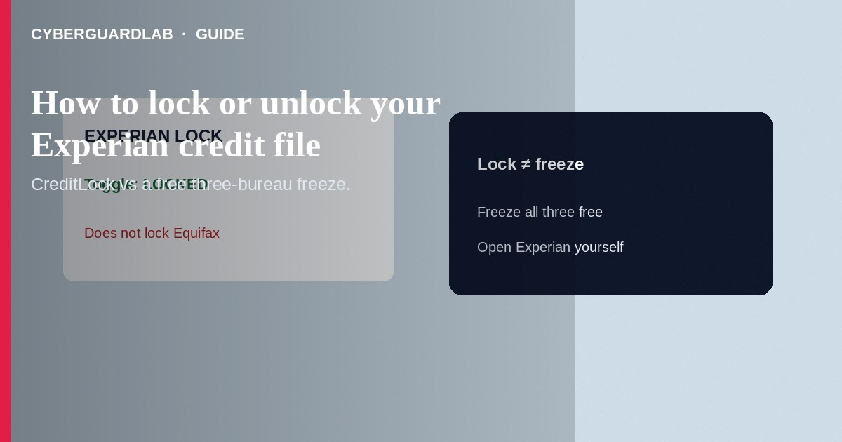
Experian CreditLock lets you restrict and restore access to your Experian credit file—often with a quick in-app or web toggle—so most new creditors cannot use that Experian report while the lock is on. Sign in through Experian channels you open yourself, confirm whether CreditLock is included in your membership, then lock or unlock as needed before applying for credit. A lock at Experian does not lock Equifax or TransUnion. This how-to is about Experian’s lock product—not a free security freeze at all three bureaus, not an IRS IP PIN, and not fake credit repair score guarantees.

1. Lock vs freeze
A security freeze is a free, federal right at each nationwide bureau and is often the baseline defense after a breach. Experian CreditLock is Experian’s lock feature—commonly offered inside paid Experian membership tiers—with convenient toggle access and related alerts Experian documents for that product. You can use a freeze without buying a lock. If you only lock Experian, Equifax and TransUnion files can still be pulled unless you freeze or lock those too.
Paid link
Norton 360 | See the Norton first-year offer

See the Norton first-year offer
Offer page: https://cyberguardlab.com/norton
After data breaches, fake “Experian Lock” pages harvest SSNs. Prefer bookmarks to experian.com, and remember a free freeze does not require buying monitoring. Store recovery codes offline—not only in SMS.

2. Quick comparison
Action | Experian CreditLock | Security freeze
Cost | Typically part of an Experian membership that includes CreditLock | Free to place and lift at each bureau
Scope | Experian file only | Only the bureau you freeze—do all three for broad coverage
Control style | Often instant app/web toggle | Online/phone/mail PIN or account flows at each bureau
Tax filing | Does not replace IRS IP PIN | Does not replace IRS IP PIN

3. Steps: lock or unlock at Experian
- Decide your goal: standing protection vs temporary access for a loan or card application.
- Open Experian’s official site or app yourself (experian.com). Avoid ads that say “lock credit now” with odd domains.
- Sign in to your Experian account. If CreditLock requires a membership Experian lists for that feature, review the offer terms—do not confuse a sales page with the free freeze center.
- Find CreditLock under credit / quick actions (wording varies in the app or web UI). Note whether status shows locked or unlocked.
- Toggle to Lock when you want to restrict new-credit access to the Experian file. Wait for confirmation (Experian often emails a status change).
- Before a lender pulls Experian, toggle to Unlock, complete the application, then Lock again if you still want protection.
- Separately place free freezes at Equifax and TransUnion (and Experian’s freeze center if you prefer freezes over or in addition to lock)—see three-bureau freeze how-to.
- Keep freeze PINs and Experian login credentials offline and phishing-resistant. After suspicious emails about “your lock failed,” scan with a trusted tool such as Norton or Bitdefender. Keep one primary real-time antivirus—avoid stacking full suites. TotalAV, McAfee, and Avast are other on-site comparison options.

4. If something goes wrong
- Lender rejected you while locked: unlock Experian (and thaw freezes at the bureau they name), then re-lock or re-freeze after.
- You cannot find CreditLock: you may be on a free freeze path or a plan without that feature—use Experian’s official freeze center instead of paying a random “lock broker.”
- Phishing “unlock your Experian” links: type the URL yourself; never enter passwords from SMS ads.
- New accounts still appear: freeze all three bureaus, review AnnualCreditReport.com, and start IdentityTheft.gov if needed.
- Shared household logins: do not leave CreditLock unlocked on a shared computer session.

FAQ

Is CreditLock the same as a credit freeze?
No. Both restrict new-credit access to a file, but freezes are free statutory tools at each bureau; CreditLock is Experian’s lock product with its own enrollment and controls.

Does locking Experian protect Equifax and TransUnion?
No. Act at each bureau—or freeze all three.

Will locking hurt my credit score?
Restricting access for new applications is not the same as lowering your score; Experian and FTC educational materials treat freezes as score-neutral. Follow Experian’s product help for lock-specific notes.

Should I use lock instead of freeze?
Many people rely on free freezes at all three bureaus. Use CreditLock only if you understand the membership terms and still cover the other bureaus.

If you still want a paid suite
Avoiding how to lock or unlock your Experian credit file does not require paid antivirus. Careful habits and official support paths are a valid buy-nothing stack. If you want multi-device paid protection later, use only these on-site paid links: TotalAV (paid link), Norton (paid link), Bitdefender (paid link), McAfee (paid link), Avast (paid link).

Sources
- Experian: CreditLock overview
- Experian: Freeze vs lock explained
- Experian security freeze center
- FTC: Credit freezes and fraud alerts
- IdentityTheft.gov

Also read
- How to place a credit freeze at all three bureaus
- How to spot a fake credit repair company scam
- How to get a free annual credit report and read it
- How to set up an IRS Identity Protection PIN
- How to spot synthetic identity theft on a credit file

