
How to erase an Apple Watch after it is lost
https://cyberguardlab.com/blog/erase-lost-apple-watch
Independent US household comparison site. Not the vendor. Paid links below may earn a commission. Confirm first-year price, renewal, device limit, and refund terms at checkout.
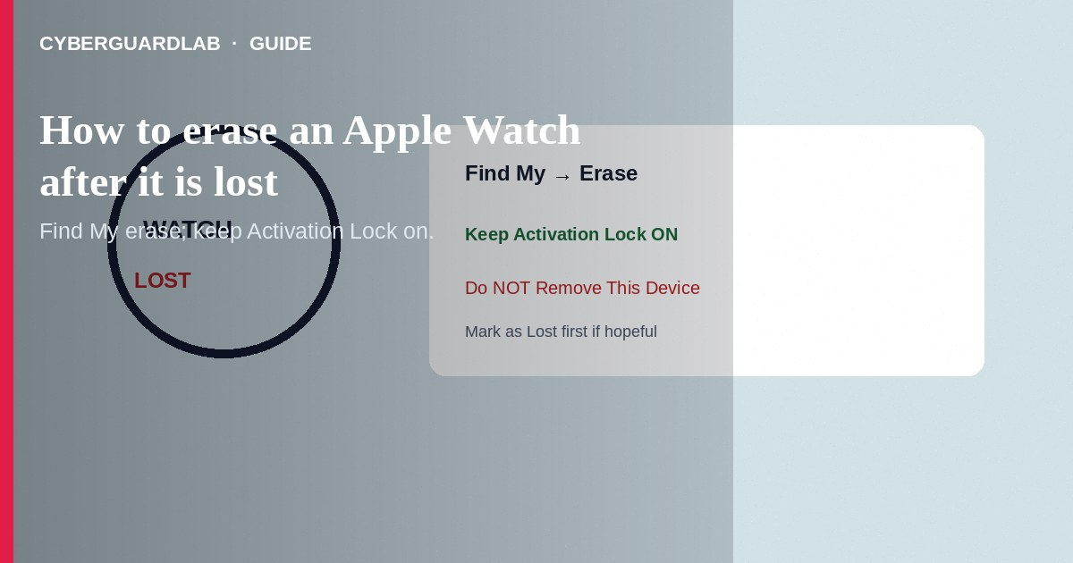
If your Apple Watch is lost or stolen and you accept you may not get the hardware back, erase it from the Find My app or icloud.com/find so personal data is wiped while Activation Lock stays on—do not remove the watch from your account until erase completes (or you intentionally transfer ownership). Prefer Mark as Lost first when recovery is still possible. This how-to is about remote erase of a missing Apple Watch—not Stolen Device Protection / recovery contacts, not configuration profiles on iPhone, and not Google Find My Device on Android.

1. Before you erase
Erasing cannot be undone. Try play sound and Mark as Lost first. Confirm Find My was enabled on the paired iPhone before the loss—remote erase needs that setup. Contact your carrier to suspend cellular service on GPS + Cellular models if charges are a concern.
Paid link
Norton 360 | See the Norton first-year offer

See the Norton first-year offer
Offer page: https://cyberguardlab.com/norton
Sites and chats that sell unlocks for Activation-locked Watches are often fraud or fencing tools. Apple’s lock exists to protect you—do not pay strangers to bypass it on a device you do not own, and do not disable it for cold callers.

2. Erase vs Mark as Lost vs Remove
Action | Effect | When
Mark as Lost | Locks, can show message; tracks when possible | First response for most losses
Erase | Wipes data; Activation Lock can remain | Recovery unlikely; protect data
Remove This Device | Can clear Activation Lock path for reuse | Only after erase when selling/giving away—or when you no longer need lock

3. Steps: erase from Find My or iCloud
Steps: erase from the Find My app
- On another iPhone, iPad, or Mac signed into the same Apple Account, open Find My.
- Tap Devices, then select the missing Apple Watch by name.
- Try Play Sound or Mark as Lost if you still hope to recover it.
- When ready to wipe: choose Erase This Device (or Erase), tap Continue, and follow prompts.
- Enter your Apple Account password when asked. Confirm erase.
- If the watch is offline, status may show erase pending until it reconnects to power and network.
- Keep Activation Lock: do not tap Remove This Device while the watch is still missing—removal can allow someone else to activate it after erase completes.
- Change the Apple Account password if theft is likely; review devices at account.apple.com.
Steps: erase from iCloud on the web
- On a trusted computer, open icloud.com/find and sign in with the Apple Account (use a hardware key or backup codes if your only phone is gone).
- Select the Apple Watch → Erase This Device → follow on-screen steps.
- Same rule: leave it in Find My with Activation Lock until you recover it or complete a deliberate ownership transfer.

4. After erase
- Unpair leftovers on a replacement iPhone only through official Apple Watch unpair/restore flows when you have the hardware.
- Watch for fake App Store receipt phishing or “Apple Support found your Watch” emails—open Find My yourself.
- On Windows PCs used for iCloud.com, keep one real-time antivirus such as Norton or Bitdefender (TotalAV, McAfee, Avast are other on-site options).

FAQ

Will erase turn off Activation Lock?
Remote erase is designed to keep Activation Lock so thieves cannot reactivate without your Apple Account. Removing the device from Find My is the step that risks dropping that protection—avoid it while the watch is missing.

Can I still see the watch after erase?
Apple documents that locating after erase can still be possible in some software/network cases; do not count on it. Mark as Lost first if location matters most.

The watch was never in Find My.
You cannot remotely erase what was never enrolled. Change Apple Account credentials, suspend cellular if applicable, and report to police/carrier with serial if you have it.

Is this the same as erasing an Android Wear watch?
No. Use Google’s Find My Device / Find Hub tools for Android Wear OS—see Google Find My Device setup.

If you still want a paid suite
Avoiding how to erase an Apple Watch after it is lost does not require paid antivirus. Careful habits and official support paths are a valid buy-nothing stack. If you want multi-device paid protection later, use only these on-site paid links: TotalAV (paid link), Norton (paid link), Bitdefender (paid link), McAfee (paid link), Avast (paid link).

Sources
- Apple Support: Use Find My to locate a lost device
- Apple Support: Erase a device in Find My
- Apple Support: Activation Lock on Apple Watch
- FTC: If your phone is lost or stolen

Also read
- How to turn on Stolen Device Protection recovery contacts
- How to check for configuration profiles on iPhone
- How to turn on Google Find My Device before you lose a phone
- How to turn on Find My and Activation Lock before travel
- How to lock a lost phone on Apple or Google

