
How to spot an eBay seller impersonation scam
https://cyberguardlab.com/blog/ebay-seller-impersonation-scam
Independent US household comparison site. Not the vendor. Paid links below may earn a commission. Confirm first-year price, renewal, device limit, and refund terms at checkout.
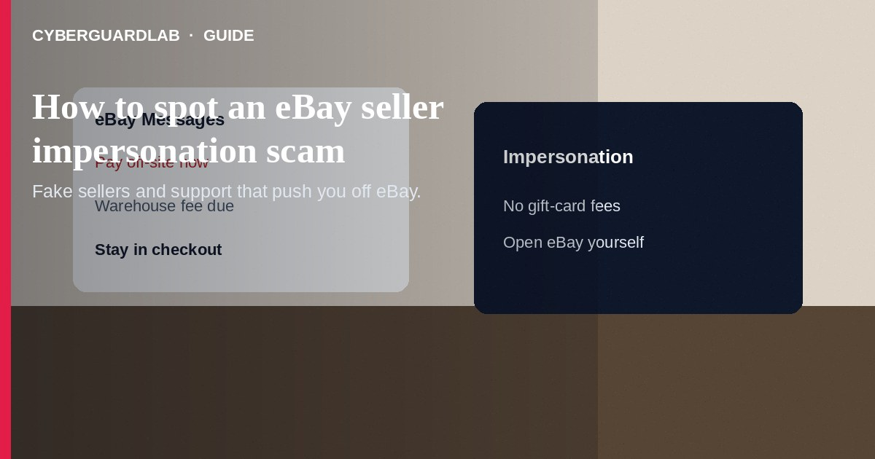
An eBay seller impersonation scam happens when someone pretends to be the seller you messaged—or pretends to be eBay Support—and pushes you off the official listing into gift cards, wires, crypto, or a look-alike payment page. Do not reply to “new” seller emails that appear after you bid or buy. Do not send codes from eBay texts to anyone. If you already paid outside eBay, stop contact, save everything, and report through eBay Help and the FTC.
This guide is about impersonation and off-platform payment tricks—not ordinary PayPal Goods and Services disputes on a real checkout flow. It overlaps with phishing emails and Zelle or Cash App payment scams. No software purchase required.
Paid link
Norton 360 | See the Norton first-year offer

See the Norton first-year offer
Offer page: https://cyberguardlab.com/norton

1. How eBay seller impersonation scripts work
You win a bid or message a seller. Soon email or SMS “from the seller” demands a secure link, warehouse fee, or buyer-protection upgrade. A second account may continue the chat after the listing vanishes and pushes WhatsApp or gift cards.
- Fake seller follow-up — Free-mail or look-alike domains ask you to pay outside eBay checkout.
- Trust & Safety impostors — Callers demand one-time codes, remote access, or “refund verification” payments.
- Replacement seller handoff — The listing disappears; a new account continues the deal off-platform.
- Phishing invoice pages — Links harvest passwords or cards (FTC phishing guidance).

2. Red flags before you pay
Cue | Likely legitimate | Likely scam
Where you talk | eBay Messages on the same listing and username | Sudden move to text, WhatsApp, or a new email
Payment | Checkout on eBay with methods eBay shows | Gift cards, crypto, wire, or pay-my-assistant
Support contact | You open Help from ebay.com yourself | Cold call or email asking for codes or remote desktop
Listing continuity | Same item ID and seller feedback history | Listing deleted; replacement seller continues
Extra fees | Fees shown inside checkout before confirm | Surprise insurance, holding, or customs fee by text
Urgency | Normal shipping timelines | Pay in 15 minutes or auction void

3. Safer habits (buy-nothing)
- Stay inside the original eBay listing and Messages.
- Open ebay.com or the official app yourself—never stranger links (FTC online shopping tips).
- Ignore anyone who asks you to leave eBay to finish the sale.
- Never share one-time codes, passwords, or remote-access apps with callers claiming to be eBay.
- If the price is far below market and the seller rushes you, walk away.
- For instant-pay pressure on cash apps, see Zelle and Cash App payment scams.

4. If you already paid
- Stop further payments. Screenshot chats, emails, usernames, and transaction IDs.
- Report the member through eBay’s official tools in Help (eBay Help).
- Contact your bank, card issuer, or payment provider if funds left outside eBay (FTC guidance if you were scammed).
- If you bought gift cards for the scammer, contact each issuer’s fraud line with numbers and photos.
- File at ReportFraud.ftc.gov and use IdentityTheft.gov if passwords or ID photos were taken.
- If you typed credentials on a fake page, change eBay and email passwords, enable two-factor authentication, and ignore recovery callers.

FAQ

Is eBay Support going to call me after I buy something?
Real support contact usually starts from help pages you open yourself. Treat cold calls that demand codes or remote access as fraud.

A seller said PayPal Friends and Family is safer. Is that true?
Often the opposite for buyers. Off-platform or Friends and Family pushes are a red flag—especially with impersonation emails.

How is this different from a PayPal Goods and Services scam?
PayPal G&S abuse centers on invoices and claims inside PayPal. This scam centers on fake sellers or fake eBay staff steering you away from eBay’s official checkout.

The email used my item title and bid amount. Does that mean it is real?
Not necessarily. Scammers scrape public listing details or phish earlier messages to sound specific.

What if I only shared a phone number?
Expect follow-up phishing texts. Do not click links; report and block. Change passwords if you also reused that number for account recovery.

Do I need paid antivirus to avoid an eBay impersonation scam?
No. Staying in official checkout and refusing codes to cold callers is enough. Buy-nothing is valid.

If you still want a paid suite
Avoiding a eBay seller impersonation scam does not require paid antivirus. Careful habits and official support paths are a valid buy-nothing stack. If you want multi-device paid protection later, use only these on-site paid links: TotalAV (paid link), Norton (paid link), Bitdefender (paid link), McAfee (paid link), Avast (paid link).

Sources
- Online Shopping Tips (FTC)
- ReportFraud.ftc.gov
- IdentityTheft.gov
- eBay Help

Also read
- How to spot a phishing email
- How to spot a PayPal goods and services scam
- How to spot a Zelle or Cash App payment scam
- How to spot an OfferUp meetup scam
- How to report a scam to the FTC

