
How to spot a DMV or license renewal text scam
https://cyberguardlab.com/blog/dmv-license-renewal-text-scam
Independent US household comparison site. Not the vendor. Paid links below may earn a commission. Confirm first-year price, renewal, device limit, and refund terms at checkout.
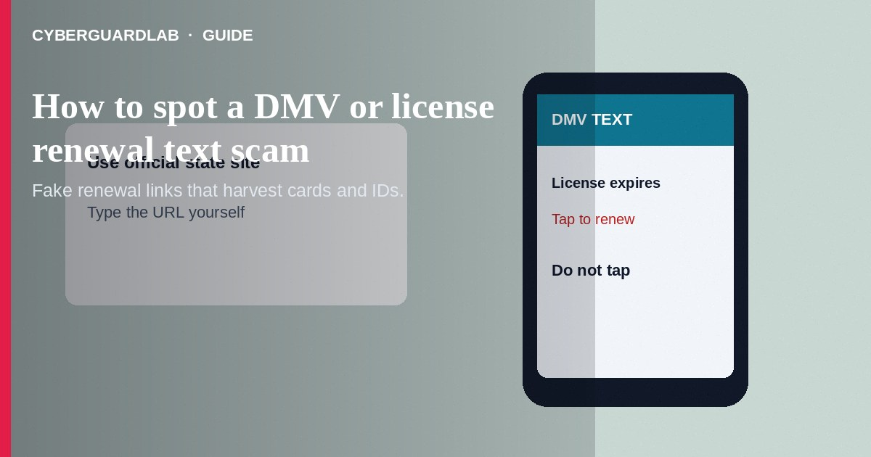
A DMV or license renewal text scam sends an SMS or email claiming your driver's license, registration, or “DMV account” will suspend unless you pay through a link. The link is usually phishing. Do not tap it. Do not pay with gift cards. Renew only through your state DMV's official site or office.
This is about fake renewal texts—not IRS wage calls or jury-duty warrant threats. Design cues match other phishing; see how to spot a phishing email and fake invoice patterns. No software purchase required.
Paid link
Norton 360 | See the Norton first-year offer

See the Norton first-year offer
Offer page: https://cyberguardlab.com/norton

1. How DMV and license renewal text scripts work
- Urgent SMS — “FINAL NOTICE: License expires in 24 hours,” “Toll unpaid—license hold,” or “Click to renew now” (FTC government impersonation guidance).
- Look-alike short links — URLs mimic state names with extra letters and lead to pages that harvest license numbers, SSN fragments, card details, or logins (FTC phishing guidance).
- Seasonal timing — Blasts arrive around real renewal seasons so the story feels plausible.
- Spoofed labels — Sender names may show “DMV,” “MVA,” “BMV,” or your state. Labels are not proof.
- PDF citation emails — Some campaigns use email with fake citations attached instead of SMS.

2. Red flags before you tap
Cue | Likely legitimate | Likely scam
How you renew | Official state DMV website, app, or office you navigate to yourself | Cold text with a pay link
Tone | Standard reminders through channels you opted into when offered | Extreme urgency and suspension threats in one SMS
URL | Exact government domain for your state | Shortened links, misspellings, unusual top-level domains
Payment | Card or approved methods on the official site | Gift cards, crypto, wiring to a person
Data asked | Only what the official renewal flow requires | Odd combo of SSN, card, and photo of license via a text page
Spelling and design | Consistent with your state's real site | Generic templates, wrong state seals, broken English

3. Safer habits (buy-nothing)
- Do not tap the link. Delete the text or mark it as junk.
- Renew by typing your state DMV address yourself or using a bookmark you saved earlier.
- Call the phone number published on the official DMV site if you need status.
- Never pay a license renewal with gift cards.
- Share the scam sample with family members who drive—teens and older adults are frequent targets.
- Bookmark your real state page now so you are not searching under panic later.

4. If you already paid or typed data
- Call your bank or card issuer to watch for charges and replace the card if needed.
- Change passwords for email and any “DMV” account you created on the fake site.
- Save screenshots of the text, URL, and page.
- Report at ReportFraud.ftc.gov. Report phishing to your state DMV if they publish a channel.
- Consider credit monitoring steps via IdentityTheft.gov if SSN-level data was entered.
- Do not install apps from the phishing flow; update your phone OS (FTC guidance if you were scammed).

FAQ

My state sometimes texts me. How do I tell?
Use official account settings you already established. When unsure, ignore the link and visit the official site directly.

The text used my real name. Is it legit?
Not necessarily. Names and partial license data can leak from breaches or prior forms.

Is a DMV scam the same as a toll-road text scam?
Closely related. Both use motor-vehicle panic and phishing links. Verify tolls and renewals only on official sites.

Can clicking alone infect my phone?
Sometimes pages try drive-by downloads or trick you into install prompts. Do not install apps from those flows. Update your phone OS.

What if I gave my license number but not a card?
Still treat it as sensitive. Watch for identity misuse and phishing follow-ups that reference that number.

Do I need paid antivirus to avoid a DMV text scam?
No. Ignoring cold links and using official state sites are enough. Buy-nothing is valid.

If you still want a paid suite
Avoiding a DMV license renewal text scam does not require paid antivirus. Official-site habits are a valid buy-nothing stack. If you want multi-device paid protection later, use only these on-site paid links: TotalAV (paid link), Norton (paid link), Bitdefender (paid link), McAfee (paid link), Avast (paid link).

Sources
- Government Impersonation Scams (FTC)
- How To Recognize and Avoid Phishing Scams (FTC)
- ReportFraud.ftc.gov
- IdentityTheft.gov

Also read
- How to spot a phishing email
- How to spot a fake delivery text scam
- How to spot a fake invoice or bill-pay scam
- How to stop spam text messages
- How to report a scam to the FTC

