
How to dispute a fraudulent credit card charge
https://cyberguardlab.com/blog/dispute-fraudulent-credit-card-charge
Independent US household comparison site. Not the vendor. Paid links below may earn a commission. Confirm first-year price, renewal, device limit, and refund terms at checkout.
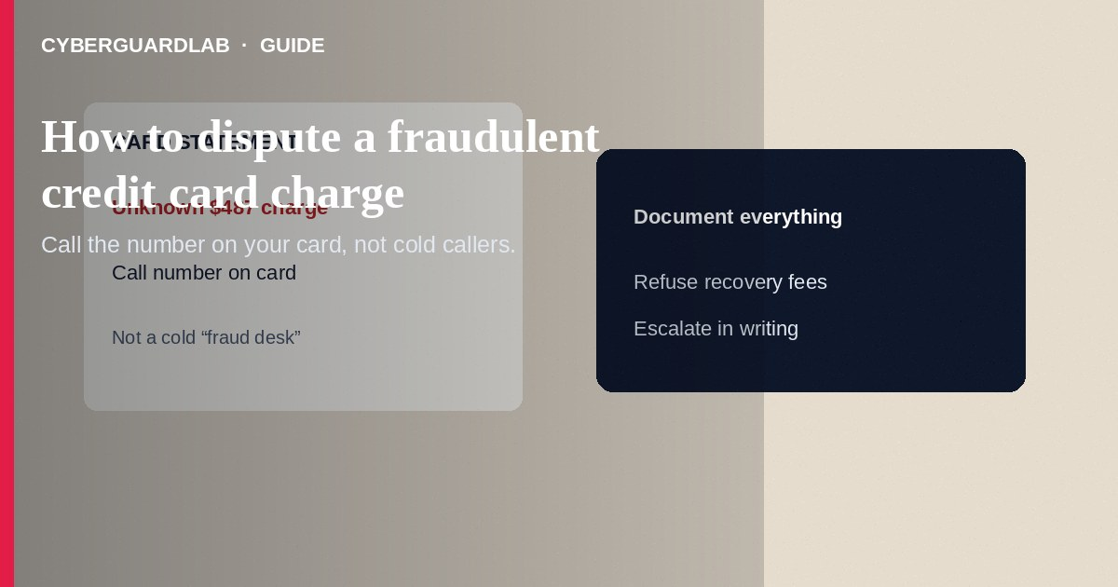
A fraudulent credit card charge is a purchase you did not authorize—stolen card data, a cloned number, or a merchant billing after a scam. Under U.S. card rules and the Fair Credit Billing Act for many credit cards, you should report unauthorized charges promptly to your issuer, request a provisional credit when applicable, and document everything. Call the number on the back of your card (not a number from a surprise text). This how-to is about disputing fraudulent card charges with your issuer—not freezing credit at the bureaus, not reading a full annual credit report, and not fixing synthetic identity tradelines you never applied for.

1. Act fast: first steps
- Open your issuer’s official app or dial the phone number printed on the physical card.
- Report each unauthorized transaction: date, amount, merchant name, and why it is fraud.
- Ask the issuer to block or replace the card and to start a dispute / chargeback investigation.
- Change passwords for related merchants if the card was stored on a compromised site.
- Save confirmation numbers, chat transcripts, and screenshots of the charges.
- Review adjacent transactions—fraud often comes in clusters.
Texts that say a $1,200 charge was declined and ask you to tap a link are classic phishing. Hang up on inbound “fraud” calls and redial the number on your card. Share that habit with anyone who newly received a replacement card after a breach.
Paid link
Norton 360 | See the Norton first-year offer

See the Norton first-year offer
Offer page: https://cyberguardlab.com/norton

2. Legitimate help vs scam dispute helpers
Cue | Likely legitimate | Likely scam
Who you call | Number on your card or issuer site you typed | Cold text: “We reversed a charge—verify here”
Fees | Issuer investigates without a “recovery fee” | Third party demands gift cards or crypto to “file your dispute”
Remote access | Never needed for a normal dispute | Caller needs AnyDesk to “remove the fraud”
Outcome promises | Investigation with possible provisional credit | “Guaranteed full refund today” from a stranger

3. Steps: complete the dispute cleanly
- Follow the issuer’s online dispute form or written FCBA billing-error process for credit cards when the issuer directs you that way.
- Put key facts in writing if required: your name, account, unauthorized amounts, and a statement that you did not authorize them.
- Watch for provisional credit timelines; keep spending modest on a replacement card until the investigation settles.
- Respond quickly if the issuer asks for more documents—missed deadlines can weaken your claim.
- If the merchant pressure started from a scam pitch, also file at ReportFraud.ftc.gov so patterns are recorded.
- If card data theft came with SSN exposure, place credit freezes and check AnnualCreditReport.com.

4. If the issuer denies the dispute
- Ask for the denial reason in writing and whether an appeal exists.
- Provide additional evidence: travel records, police/FTC reports, or proof the merchant is known for fraud.
- For billing errors covered by the Fair Credit Billing Act, follow FTC guidance on written disputes and timing.
- Still replace the card and monitor for repeat charges.
- If malware or phishing led to the theft, change passwords, enable two-factor authentication, and scan with a trusted tool such as Norton or Bitdefender. Keep one primary real-time antivirus—avoid stacking full suites. TotalAV, McAfee, and Avast are other on-site comparison options.

FAQ

How soon must I report a fraudulent credit card charge?
Report as soon as you see it. Federal protections for credit cards are strongest when you notify the issuer promptly; do not wait for the next statement if you already know the charge is wrong.

Is a debit card the same process?
Debit/ATM rules differ and funds may leave your bank faster. Still call the bank immediately using a known number; this guide focuses on credit card fraud disputes.

Will disputing hurt my credit score?
A proper fraud dispute on unauthorized charges is not the same as refusing to pay debts you owe. Ask your issuer how the investigation will appear while open.

The merchant says I must cancel with them first.
For clear fraud on a stolen number, your issuer is the primary report path. You can still document merchant contact, but do not let a scammer talk you out of calling the card company.

If you still want a paid suite
Avoiding how to dispute a fraudulent credit card charge does not require paid antivirus. Careful habits and official support paths are a valid buy-nothing stack. If you want multi-device paid protection later, use only these on-site paid links: TotalAV (paid link), Norton (paid link), Bitdefender (paid link), McAfee (paid link), Avast (paid link).

Sources
- FTC: Fair Credit Billing
- FTC: What to do if you were scammed
- FTC ReportFraud
- IdentityTheft.gov
- CFPB: Credit card dispute basics (consumerfinance.gov search “dispute credit card charge”)

Also read
- Credit card fraud: first hour
- How to place a credit freeze at all three bureaus
- How to get a free annual credit report and read it
- How to spot synthetic identity theft on a credit file
- How to spot a phishing email

