
How to spot a Disney Plus billing scam
Read online: https://cyberguardlab.com/blog/disney-plus-billing-scam
Published September 29, 2026 · Updated September 29, 2026
Short answer
Ignore the cancel / dispute / update-payment link in an unexpected “Disney+ charge” or “membership renews” message; verify only through disneyplus.com or the official Disney+ app and account tools you open yourself; never enter your Disney password or card on a cold page.
Advertising disclosure: CyberGuardLab is an independent comparison site. We are not TotalAV, Norton, Bitdefender, McAfee, or Avast. If you buy through our links, we may earn a commission, which can affect ranking and placement.
Independent US household comparison site. Not the vendor. Paid links below may earn a commission. Confirm first-year price, renewal, device limit, and refund terms at checkout.
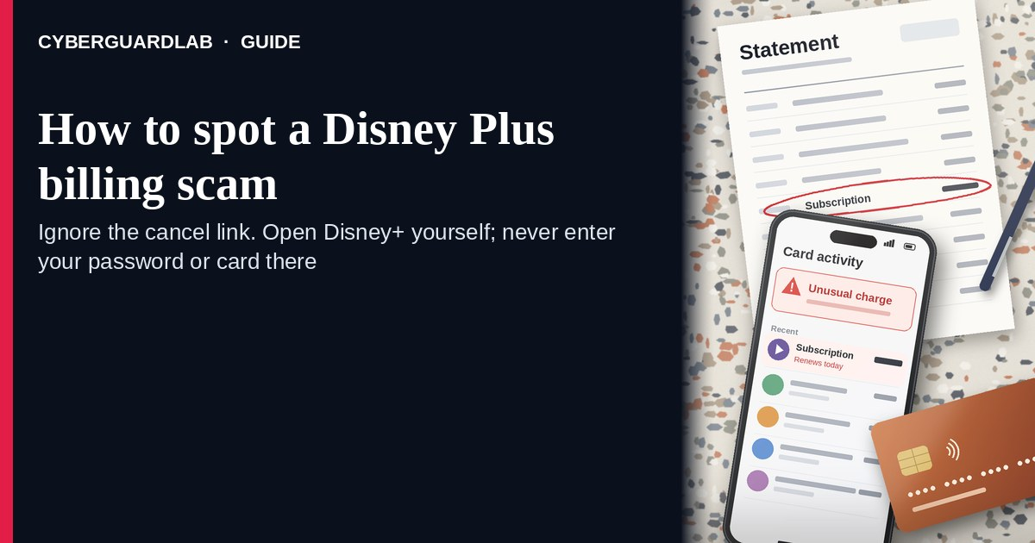
A Disney Plus billing scam is an unexpected email, SMS, or push-style message that claims Disney+ charged an unusual amount, that your membership “renews today,” or that you must “cancel,” “dispute,” or “update payment” through a link. Real Disney+ billing lives inside the account you open yourself through Disney+ help and account tools — not inside a cold cancel / dispute button. The FTC’s phishing guidance is clear: do not click links in unexpected messages; if you think a charge might be real, go to the company using a website or app you know is real. This lure is related to other membership-billing traps such as an Amazon Prime renewal scam or Fake Google Play billing phishing. CyberGuardLab is independent. Referral fees may affect product placement on other pages. Buying nothing and sticking to free verification habits is a valid outcome.

The short answer
Ignore the cancel / dispute / update-payment link in an unexpected “Disney+ charge” or “membership renews” message; verify only through disneyplus.com or the official Disney+ app and account tools you open yourself; never enter your Disney password or card on a cold page.
Paid link
Norton 360 | See the Norton first-year offer

See the Norton first-year offer
Offer page: https://cyberguardlab.com/norton
Ad link: https://trysecurities.com/offer/norton?dtm=gg&cid=

What a Disney Plus billing scam usually looks like
Scammers copy Disney+ membership language: “Your Disney+ membership renews today,” “Unauthorized charge — cancel now,” “Payment failed — update card,” or “Dispute this billing to keep watching.” The job is credential theft, card theft, or tricking you into sending money to “fix” a fake charge.
Common shapes US households report:
- Email claiming a Disney+ renewal or unexpected charge with a bright “Cancel membership,” “Dispute charge,” or “Update payment” button that does not land on an official Disney+ account page.
- SMS or iMessage about a “Disney+ billing problem” with a short link to “stop the charge” or “manage subscription.”
- Look-alike Disney+ / Disney account login page after you tap — then email, password, and often a one-time code or card harvest.
- Fake invoice / receipt that mixes real-looking order or membership IDs with a cold “manage billing” link outside Disney+.
- Follow-up after any reply or tap — once you engage, expect more “Disney support” emails or a scripted call. Related renewal / billing angles: Amazon Prime renewal scam · Fake Microsoft 365 renewal scam · Fake Google Play billing phishing.
FTC phishing guidance: do not click links in unexpected messages; if you think it might be real, contact the company with a website or phone number you know is real; report at ReportFraud.ftc.gov.
We do not claim Disney+ “never emails about billing.” Disney+ may send real membership and payment notices. The safe habit is always the same: leave the unexpected message, open the official Disney+ site or app yourself, and manage subscription and payment only inside a session you started.

Fake Disney+ billing vs real Disney+ notice vs related streaming billing scams
Signal | Fake Disney+ billing / renewal message | Real Disney+ membership notice (typical) | Related Prime / Play / Microsoft renewal scam
Opening hook | “Disney+ charged $X — cancel now / membership renews — update payment today.” | Billing or subscription details you can also see after you sign into Disney+ yourself. | Unexpected Prime, Google Play, or Microsoft 365 renew / dispute lure on those brands.
Ask | Cold link, Disney password, OTP, card, or a “refund fee” payment. | Usually none inside the message — manage subscription inside signed-in Disney+ account tools. | Cold renew / dispute link or password on a look-alike page for that other brand.
Pressure | Same-day loss of streaming, “final chance to cancel,” refund countdown. | Normal billing calendar; you verify on your schedule. | Same-day “keep benefits” or “stop charge” urgency on another service.
Safe next step | Ignore link. Open disneyplus.com or the official Disney+ app yourself. | Confirm subscription and payment method only inside Disney+ account tools. | See Prime, Google Play, or Microsoft 365 guides; verify only on those official sites/apps.
Related guide | This page | Official Disney+ account / Help you open yourself | Amazon Prime renewal scam · Fake Google Play billing phishing · Fake Microsoft 365 renewal scam
If the page after the tap asks for your Disney password plus a one-time code or card on the same cold form, stop — that is credential theft dressed as a billing alert.

How to verify a Disney Plus billing message (US household steps)
Do this when any unexpected Disney+ billing / renewal / cancel / dispute message appears. You do not need a paid product to finish these steps.
- Do not tap the link, reply YES/NO, or call a number that lives only inside the message. Close the email or text. Do not discuss the “charge” with a caller who contacted you first.
- Open Disney+ the way you already trust. Type disneyplus.com yourself, use a bookmark you saved earlier, or open the official Disney+ app already on your phone — not the cancel / dispute link. If you subscribe through a store (Apple, Google, Amazon, cable, or wireless), also check that store’s subscription list you open yourself.
- Check subscription and payment only inside a signed-in session you started. Look at plan status, renewal date, and payment method. If nothing unexpected appears, treat the message as spam. Official Help articles explain how to manage subscription and update payment on Disney+.
- Never enter your Disney password, one-time code, or card on a page that arrived from a cold email or text. Legitimate Disney+ account work does not require you to trust an unexpected shortener or look-alike domain. Do not send money or gift cards to “cancel” or “refund” a charge you never made.
- If you already tapped, typed a password or code, or entered a card, treat the first hour as incident response. Change your Disney account password from the official Disney+ site or app you open; review payment method and devices; turn on 2FA on the email that owns the account if it was off; call the number on the back of your card to watch for fraud. Follow Clicked a phishing link — first hour. Report at ReportFraud.ftc.gov; if identity data was stolen, use IdentityTheft.gov.
- Report the message and tell the household. Mark the email as phishing / junk; forward scam texts to 7726 (SPAM); file at ReportFraud.ftc.gov. Agree that nobody cancels Disney+ charges or “confirms billing” from unexpected links. Checklist: How to report a scam to the FTC.

Signs the message is fake or unsafe (scan table)
Use this as a quick pass before you spend money or time.
Sign | Why it matters | What to do
Cancel / dispute / update-payment link lives only inside the unexpected message | Password and payment theft | Ignore; open disneyplus.com or the official app
URL is a shortener, misspelled Disney name, or random form host | Phishing page | Never tap; type disneyplus.com
Urgent “cancel in 15 minutes” or “membership ends tonight” | Fear used to skip verification | Slow down; check subscription inside Disney+
Sender address is not a Disney domain you recognize, or reply-to looks odd | Easy to spoof display names | Verify only inside a session you start
Page asks for Disney password plus OTP / card on the same cold form | Credential + payment harvest | Stop; change password from official Disney+ if you typed anything
You already replied, tapped, sent money, or spoke to a “Disney agent” | Follow-up spam, malware, or account takeover risk | Stop engaging; verify on disneyplus.com; run first-hour steps if you entered secrets

Free habits that reduce the blast radius
You do not need a new subscription to lower damage if a fake Disney+ billing alert gets through.
- Bookmark disneyplus.com (or keep only the official app); manage subscription and payment only there — or in the store (Apple / Google / Amazon / cable) you actually used to subscribe.
- Household rule: never use cancel / dispute / update-payment links inside unexpected Disney+ emails or texts; never send money to “reverse” a cold alert.
- Strong unique passwords + 2FA on email and Disney accounts limit what a stolen password can unlock.
- Forward obvious scam texts to 7726; enable carrier and mailbox spam filtering when available.
- Optional antivirus / web filtering is a separate layer after a bad tap; it does not replace the verify-on-official-site habit.

What this page is not
This page is not a guide to canceling a real Disney+ plan for a refund, not a review of Disney Bundle pricing, and not legal advice about a specific disputed charge.
It does not claim CyberGuardLab lab scores or “#1 anti-phishing” ranks. It does not tell you to ignore a real charge you can also see inside your signed-in Disney+ account or the store that billed you — it tells you to verify there, not in the cold message. Official recovery and reporting stay with Disney+ account security (and the store that billed you, if any), your bank or card issuer, ReportFraud.ftc.gov, and IdentityTheft.gov if personal data was stolen.

If you decide a paid extra is a real job
Most households can handle Disney+ billing scams with the free steps above. Open a paid page only if you already named a job — for example broader web filtering, cross-device AV, or identity alerts after you gave a scammer personal data — and you will actually use it.
- PC / Mac suite with phishing and web protections many households already compare: Norton plans (paid link; confirm renewal price).
- Independent-test–oriented suite option: Bitdefender plans (paid link).
- Household suite shopping starting point: TotalAV plans (paid link; confirm renewal).
- Multi-device bill under one vendor: McAfee plans (paid link; confirm device limit).
- Another suite path some homes already use: Avast plans (paid link).
Buying nothing beyond free official-site verification habits is still valid. Paid links above are on-site only.

FAQ

Does Disney+ really email or text about billing and renewals?
Disney+ may send real membership and payment notices. That is why the safe test is not “Disney+ never messages,” but “I only check subscription and payment inside disneyplus.com or the official app (or the store that billed me) that I open myself.”

The message shows my name, plan name, or a transaction ID. Is that enough?
No. Names, plan labels, and transaction-like strings are easy to reuse from breaches, prior purchases, or guesswork. Trust the signed-in Disney+ session (or store subscription list) you start yourself, not the message chrome.

I already entered my Disney password on the cancel page. What should I do first?
Change your Disney account password from disneyplus.com or the official app you open. Review payment method and devices. Turn on 2FA on the email that owns the account if it was off. Follow Clicked a phishing link — first hour. Report at ReportFraud.ftc.gov.

How is this different from an Amazon Prime or Google Play billing scam?
This page is about unexpected Disney+ billing / renewal / cancel links. Amazon Prime renewal scam covers Prime membership panic. Fake Google Play billing phishing covers Play Store purchase and refund lures. Fake Microsoft 365 renewal scam covers Microsoft subscription renewals. If the message is a fake streaming password-reset email rather than a charge, read Fake Netflix or streaming password-reset email. Same money panic, different brand.

How do I report a Disney Plus billing scam?
Mark the email as phishing / junk, forward scam texts to 7726 (SPAM), and file at ReportFraud.ftc.gov. Steps for the FTC side are in How to report a scam to the FTC.

Do I need paid antivirus to spot these alerts?
No. Spotting is a verification habit: ignore the link, open disneyplus.com or the official app (or the store that billed you), never enter secrets on a cold page. Antivirus can be a separate optional layer for malware after a bad tap; it does not replace that habit.

Sources
- Protect your account (Disney+ Help)
- Manage your subscription (Disney+ Help)
- Update your payment method (Disney+ Help)
- Cancel your subscription (Disney+ Help)
- How To Recognize and Avoid Phishing Scams (FTC)
- How to Recognize and Report Spam Text Messages (FTC)
- ReportFraud.ftc.gov
- IdentityTheft.gov
- Avoiding Social Engineering and Phishing Attacks (CISA)

Also read
- Fake Amazon Prime renewal notice
- Fake Netflix or streaming password-reset email
- Fake Microsoft 365 renewal scam
- Clicked a phishing link — first hour
- How to report a scam to the FTC

