
How to spot a Discord nitro or crypto giveaway scam
https://cyberguardlab.com/blog/discord-nitro-crypto-giveaway-scam
Independent US household comparison site. Not the vendor. Paid links below may earn a commission. Confirm first-year price, renewal, device limit, and refund terms at checkout.
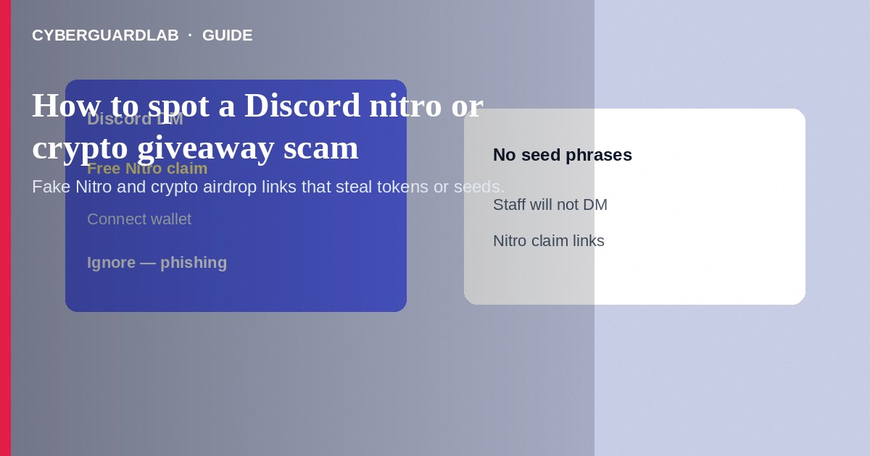
A Discord Nitro or crypto giveaway scam uses fake prize bots, cloned moderator accounts, or “steam/nitro/crypto” claim links to steal Discord tokens, passwords, or wallet seed phrases. Do not click free Nitro links from strangers. Do not enter seed phrases to “validate” a wallet prize. If you already authorized a malicious app or shared a token, change passwords, revoke sessions, and warn server mods. This guide is about Discord giveaway and crypto-airdrop bait—not WhatsApp account takeover SMS-code theft, and not Instagram influencer giveaways.

1. How this scam works
DMs or server messages announce “Discord gifted you Nitro—claim here” or “Elon/Tesla/crypto airdrop—connect wallet.” Links lead to look-alike login pages or “Authorize” OAuth screens that steal access. Some malware-laden “generators” ask you to download a file. Crypto variants demand a small “gas fee” or full seed phrase backup to receive coins.
Paid link
Norton 360 | See the Norton first-year offer

See the Norton first-year offer
Offer page: https://cyberguardlab.com/norton
Unlike WhatsApp takeover, the usual prize is account access or wallet draining—not necessarily messaging your SMS contacts first (though compromised Discord accounts may later spam friends).

2. Red flags before you pay

3. Safer habits (buy-nothing)
- Ignore free Nitro and crypto airdrop DMs from unknown users.
- Never enter Discord passwords on pages reached from chat links—open the official app yourself.
- Never type seed phrases into websites or Discord forms.
- Check server verification and report scam DMs to moderators.
- Avoid “Nitro generator” downloads; they are often malware.
- For general phishing patterns, see how to spot a phishing email.
New members in game servers are prime targets. Mods should disable random DMs where possible and pin a “staff will never DM Nitro links” notice. Parents: free Nitro offers are a top lure for teens.

4. If you already paid
- Stop interacting with the site or bot. Screenshot usernames, invite links, and wallet addresses.
- Change your Discord password; sign out other sessions; enable two-factor authentication; remove suspicious authorized apps.
- If a crypto wallet was exposed, move remaining funds from a secure device to a new wallet; treat the old seed as burned.
- Contact your exchange or bank if you sent funds; file at ReportFraud.ftc.gov and IC3.gov.
- Tell server admins so they can ban the accounts and warn members.
- If you typed credentials or opened attachments on a fake page, change passwords, enable two-factor authentication, and scan your device with a trusted tool such as Norton or Bitdefender. Keep one primary real-time antivirus—avoid stacking full suites. TotalAV, McAfee, and Avast are other on-site comparison options.

FAQ

Does Discord staff DM free Nitro?
Treat unsolicited Nitro DMs as scams. Use official Discord channels you open yourself for account issues.

How is this different from a WhatsApp takeover scam?
WhatsApp takeover hinges on SMS registration codes. Discord giveaway scams hinge on fake claim pages, token theft, and wallet drains.

I authorized an app and now my account sends spam. What now?
Revoke authorized apps, change password, enable 2FA, and notify friends that messages from you may be malicious.

Is every crypto giveaway on Discord fake?
Many are. Any giveaway that needs your seed phrase or unexpected fees is fraud.

If you still want a paid suite
Avoiding a a Discord nitro or crypto giveaway scam does not require paid antivirus. Careful habits and official support paths are a valid buy-nothing stack. If you want multi-device paid protection later, use only these on-site paid links: TotalAV (paid link), Norton (paid link), Bitdefender (paid link), McAfee (paid link), Avast (paid link).

Sources
- FTC ReportFraud
- IdentityTheft.gov
- FTC: Cryptocurrency scams
- FTC: How to recognize phishing
- Discord Safety Center

Also read
- How to spot a WhatsApp account takeover scam
- How to spot an Instagram giveaway or influencer scam
- How to spot a phishing email
- How to spot a pig butchering investment romance scam
- How to report a scam to the FTC

