
How to spot a deepfake video call scam
https://cyberguardlab.com/blog/deepfake-video-call-scam
Independent US household comparison site. Not the vendor. Paid links below may earn a commission. Confirm first-year price, renewal, device limit, and refund terms at checkout.
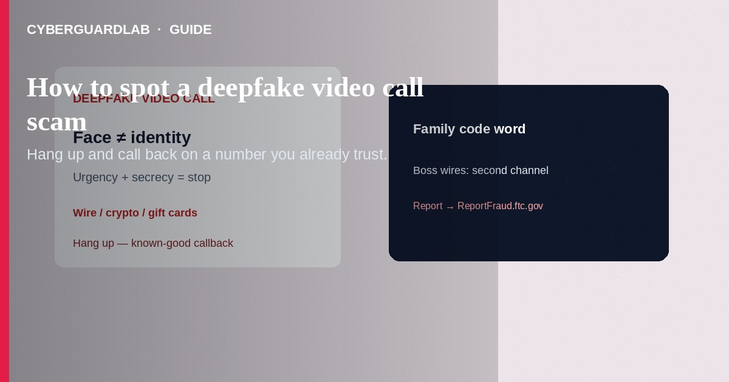
A deepfake video call scam is when someone uses AI-altered or AI-generated video (and often cloned audio) so a call looks and sounds like a relative, boss, or official—then pressures you to send money, gift cards, crypto, or credentials. The FTC warns that scammers already use AI voice cloning in family-emergency schemes: a short public audio clip can be enough to sound like someone you love. Video deepfakes raise the same rule: do not trust the face or voice alone—verify on a channel you already know is real. This guide covers live/recorded deepfake video-call pressure. It is related to grandparent emergency money scams and tech-support phone scripts, but the focus here is synthetic video/voice on the call itself.

How these scams usually work
- Family emergency — “I’m in jail / in a crash / stuck abroad—send money now, and don’t tell Mom/Dad.” FTC: cloned voices make this more convincing; the fix is still an independent callback.
- Boss / wire request — A “CEO” or coworker on a video meeting asks for an urgent transfer or gift cards. Face and voice are not proof of identity.
- Tech support or bank “secure video” — Someone insists you must share screens, install remote tools, or read codes during a video session (overlaps with classic phone tech-support scams).
- Hard-to-reverse pay rails — Wire, crypto, gift-card numbers/PINs, or payment apps—FTC flags these payment methods as common scam pressure.
CISA’s social-engineering guidance still applies: attackers use urgency, authority, and fear; verify identity with the real organization using contact details you already trust—not numbers or links from the suspicious call.
Paid link
Norton 360 | See the Norton first-year offer

See the Norton first-year offer
Offer page: https://cyberguardlab.com/norton

Red flags on a video call
Cue | What to do
Money, codes, or remote access demanded “right now” | End the call. Real emergencies can wait for a second channel check.
“Don’t tell anyone else in the family / company” | Tell someone. Secrecy protects the scammer.
Odd lighting, frozen mouth lipsync, unnatural blinking, metallic/echo voice, delayed reactions | Treat as suspicious—but absence of glitches does not prove the call is real.
Payment only by wire, crypto, gift cards, or payment app | Walk away; those rails are hard to reverse (FTC).
They refuse a family code word or a callback to a known number | Hang up. That refusal is the answer.

What to do (buy-nothing steps)
- Hang up / leave the meeting — Do not send money or read one-time codes during the call.
- Call back on a number you already have — FTC guidance for cloned-voice emergencies: contact the person who supposedly called you using a phone number you know is theirs; if you cannot reach them, try another family member or friend.
- Use a family/work code phrase — Agree ahead of time on a word only your household or team knows. Ask for it before any money talk.
- For “boss” wires — Confirm via a second channel (known office phone, in-person, or established chat)—never only via the video session that made the ask.
- If you already paid — Contact your bank, wire service, payment app, or gift-card issuer immediately and ask about reversal/refund options; then report at ReportFraud.ftc.gov (FTC what-to-do steps).
- If you shared passwords or remote access — Change passwords, turn on multi-factor authentication, and run a malware scan. Microsoft Defender is enough for many Windows PCs; paid suites are optional.

FAQ

Can a video call still be a deepfake if it looks perfect?
Yes. Glitches help, but polished fakes exist. Identity is proven by out-of-band contact, not by how real the picture looks.

How is this different from a normal grandparent money scam?
Same emotional script; AI voice/video makes the impersonation stronger. FTC still says: don’t trust the voice—verify independently. See also grandparent emergency money scams.

Will antivirus detect a deepfake call?
Not as its main job. Antivirus helps with malware after a bad download or remote-tool install. Spotting pressure and verifying people is the primary defense.

What payment methods should make me stop immediately?
FTC repeatedly flags wires, crypto, gift cards, and similar hard-to-reverse methods when someone pressures you in an emergency story.

Where should I report this?
ReportFraud.ftc.gov. Also tell your bank/app and local law enforcement if money moved.

If you still want a paid suite
Spotting a deepfake video call scam does not require paid antivirus. If you still want multi-device paid protection, use only these on-site links: Norton (paid link), Bitdefender (paid link), TotalAV (paid link), McAfee (paid link), Avast (paid link).

Extra caution
A familiar face on a screen is not a payment authorization. End the call, use a known-good number, and never buy gift cards or send crypto because a video stranger (or “relative”) told you to.

Sources
- FTC: Scammers use AI to enhance their family emergency schemes
- FTC: Fighting back against harmful voice cloning
- FTC: What to do if you were scammed
- CISA: Avoiding social engineering and phishing attacks
- ReportFraud.ftc.gov

Also read
- Grandparent emergency money scam
- Tech support scam phone call
- Wire transfer / romance advance-fee scam
- Is Microsoft Defender enough?
- Gift card payment scams
- Clicked a phishing link: first hour

