
How to spot a fake debt collection scam
https://cyberguardlab.com/blog/debt-collection-scam
Independent US household comparison site. Not the vendor. Paid links below may earn a commission. Confirm first-year price, renewal, device limit, and refund terms at checkout.
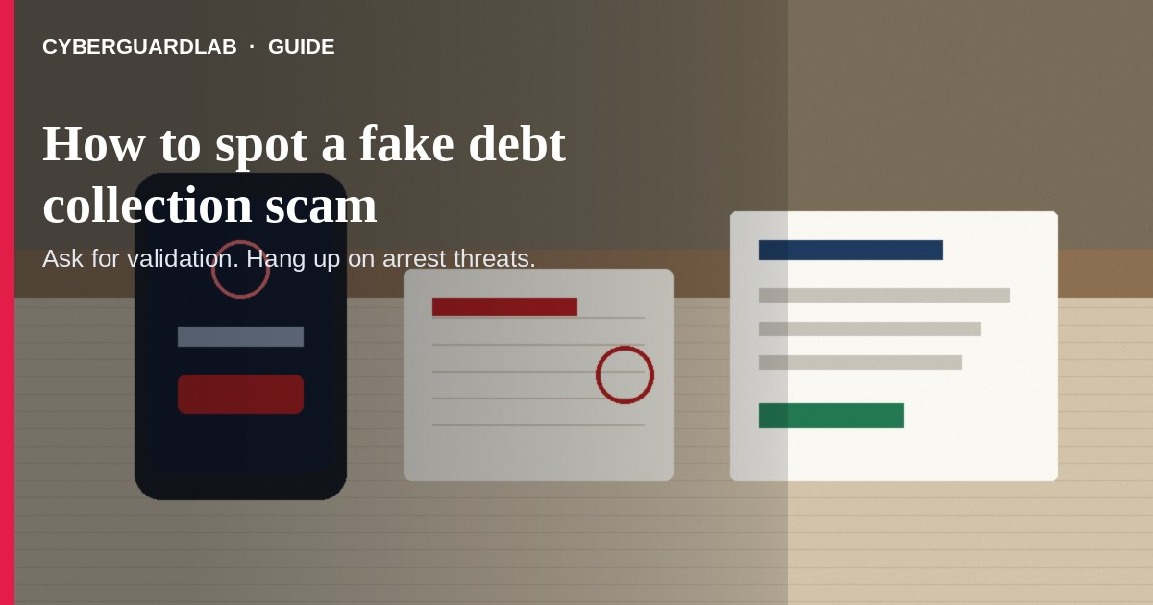
A fake debt collection scam is when someone claims you owe money you don’t recognize — or pressures you to pay a real-sounding debt with threats and hard-to-reverse payments. Per the FTC, not every caller who says “you owe a debt” is a real collector on a real debt. This guide is about collection calls and messages, not Social Security impersonation, utility shutoff threats, or tech support phone scams. You do not need to buy antivirus to hang up and demand validation.

1. How the scam usually works
From FTC fake/abusive debt collector guidance:
Paid link
Norton 360 | See the Norton first-year offer

See the Norton first-year offer
Offer page: https://cyberguardlab.com/norton
Ad link: https://trysecurities.com/offer/norton?dtm=gg&cid=
- Unexpected “you owe” call — The caller names a payday loan, medical bill, or other debt you don’t recognize.
- Pressure + threats — Arrest, jail, losing a license, or workplace contact if you don’t pay “today.”
- No clear identity — They refuse a mailing address, phone number, company name, or written details.
- Hard-to-reverse payment — Wire, gift cards, crypto, or payment apps before you get validation information.
- Fake authority — They pretend to be a lawyer, law firm, or government agent.

2. What to do in the first 5 minutes
- Don’t pay or share personal/financial info on the spot — FTC: confirm the debt is yours before you pay.
- Ask for validation information — Collectors must give company/debt details when they first contact you or within five days (collector name, creditor, amount including fees/interest, mailing address on file, and your rights).
- Write down who called — Name, company, phone, amount claimed, and what they threatened.
- Hang up on arrest/jail threats — FTC: threats of arrest for unpaid consumer debt are a classic scam tell.
- Check your own records — Credit reports, bank statements, and the original creditor if you think the debt might be real.
- If you don’t recognize it, dispute in writing within 30 days — Ask for written verification (for example a copy of the original bill).

3. If you already paid or shared info
- Contact your bank, card issuer, or the payment company and say it was a scam.
- Change passwords and turn on MFA on email and bank accounts if you gave login or account details.
- Consider a credit freeze vs monitoring if Social Security number or account numbers were shared.
- Report at ReportFraud.ftc.gov, your state attorney general, and the CFPB.
- Keep copies of call notes, texts, and payment receipts.

4. Household habits that cut risk (no software purchase required)
- Agree: nobody in the house pays a “debt” over the phone without a validation notice.
- Never pay collectors with gift cards, wires, or crypto — see also gift card scams.
- Keep a shared folder of real creditor contacts (mortgage, auto, medical billing).
- Teach teens and older relatives the “ask for validation, then hang up on threats” pause.
- Use report a scam to the FTC steps when something feels off.

FAQ

How do I spot a fake debt collection scam?
Unrecognized debt + threats of arrest + refusal to give company details + pressure for wire/gift-card/crypto payment matches FTC fake-collector patterns.

What if I might actually owe the debt?
Still get validation information first. FTC: you have rights even if you owe; collectors can’t harass, lie, or treat you unfairly.

Can I be arrested for unpaid consumer debt?
FTC guidance treats “pay or we’ll arrest you” as a major red flag for fake collectors — don’t panic-pay.

Is Microsoft Defender required here?
No. This is a phone/mail social-engineering problem. Defender is optional later if you also clicked a weird link on a PC — see Is Microsoft Defender enough?.

Where do I report it?
ReportFraud.ftc.gov, your state attorney general, and the CFPB. Also see how to report a scam to the FTC.

If you still want a paid suite
Stopping a fake collector call does not require paid antivirus. Microsoft Defender is a valid buy-nothing choice for many Windows households. What actually helps is validation information and refusing irreversible payments. If the household later wants multi-device paid protection, use only these on-site paid links: TotalAV (paid link), Norton (paid link), Bitdefender (paid link), McAfee (paid link), Avast (paid link).

Sources
- Fake and Abusive Debt Collectors (FTC)
- Debt collection: Know your rights, avoid scams (FTC)
- What should I do when a debt collector contacts me? (CFPB)
- ReportFraud.ftc.gov (FTC)
- How To Avoid a Scam (FTC)

Also read
- How to spot a tech support scam phone call
- How to spot a Social Security scam
- How to spot a utility shutoff scam
- How to spot a gift card scam
- How to report a scam to the FTC
- Credit freeze vs identity monitoring

