
How to place a credit freeze at all three bureaus
https://cyberguardlab.com/blog/credit-freeze-three-bureaus-how-to
Independent US household comparison site. Not the vendor. Paid links below may earn a commission. Confirm first-year price, renewal, device limit, and refund terms at checkout.
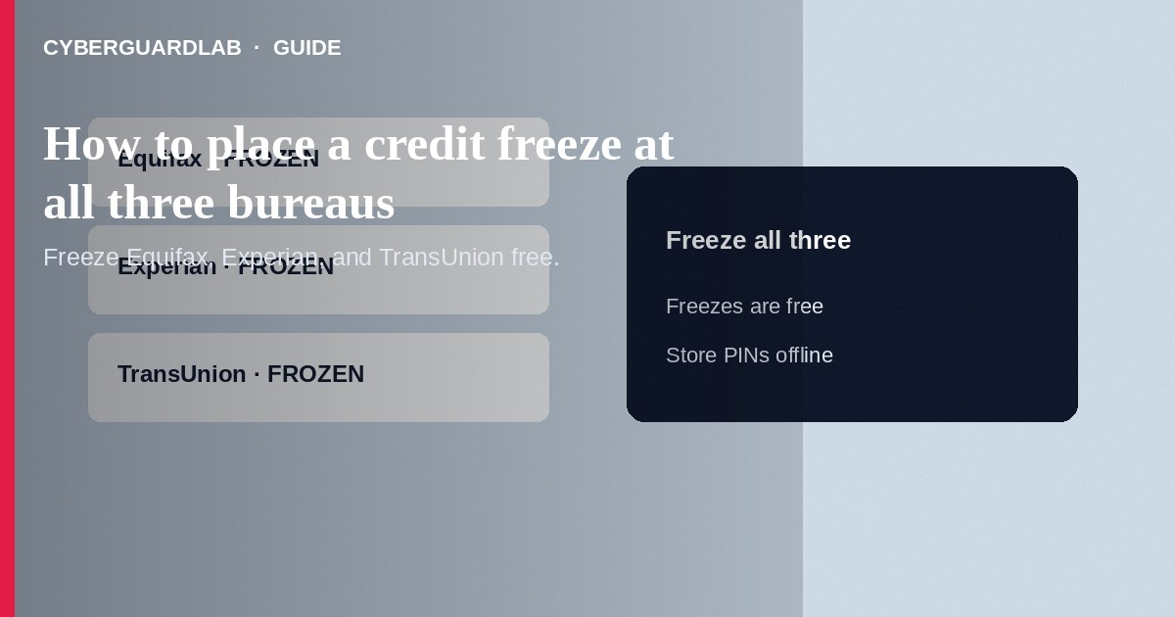
A credit freeze (security freeze) tells Equifax, Experian, and TransUnion not to release your credit report to most new creditors, which makes it much harder for someone to open new accounts in your name. Freezes are free to place and lift. Place a freeze at all three nationwide bureaus—one freeze does not cover the others—then store your PINs or login credentials securely. This how-to is about placing freezes at the three bureaus—not how to read your free annual credit report, not how to spot synthetic identity theft on a file, and not how to dispute a fraudulent card charge.

1. When a freeze helps
Use a freeze if your SSN may be exposed, you see unexplained inquiries, or you simply want standing protection. A freeze does not block existing creditors you already have, does not affect your credit score, and is stronger than a fraud alert for stopping new-account openings. You will temporarily lift (thaw) freezes when you apply for new credit, utilities, or some jobs that run credit checks.
Paid link
Norton 360 | See the Norton first-year offer

See the Norton first-year offer
Offer page: https://cyberguardlab.com/norton
After breaches, scammers email “Click to freeze your credit now” links. Type bureau URLs yourself or use bookmarks. Store freeze PINs offline—not in the same inbox that receives phishing.

2. Freeze vs fraud alert
Tool | What it does | How many bureaus to contact
Credit freeze | Blocks most new-credit access to your report until you lift it | All three, separately
Initial fraud alert | Asks creditors to take extra identity steps; does not lock the file the same way | One bureau notifies the other two
Extended fraud alert | Longer alert for identity theft victims with a report | One bureau notifies the other two (with proof)

3. Steps: freeze at all three bureaus
- Decide to freeze Equifax, Experian, and TransUnion—all three. Budget time for three separate online accounts or phone calls.
- Equifax: Open the official Equifax credit freeze page yourself (equifax.com credit freeze / freeze center). Create or sign in to your myEquifax account and place a freeze. Save any PIN or confirmation.
- Experian: Open Experian’s official security freeze page yourself. Place the freeze online or by phone and record confirmation details.
- TransUnion: Open TransUnion’s official credit freeze service yourself. Place the freeze and store login or PIN data offline in a safe place.
- Confirm status shows frozen at each bureau. Do not use random “freeze for you” third-party ads or paid upsells required to freeze—federal rules make freezes free.
- Optional: Place an initial fraud alert at one bureau (it notifies the other two). A fraud alert is complementary; it is not a substitute for freezes at all three.
- When you need new credit, lift the freeze only at the bureau the lender names, for a set window or permanently, then re-freeze when done.
- After any SSN phishing or data breach, also review reports via AnnualCreditReport.com and consider IdentityTheft.gov if misuse appears.

4. If something goes wrong
- If a site asks for payment to place a basic freeze, leave—you are on the wrong page or an upsell path.
- If you lose a PIN, use each bureau’s official recovery process; do not email PINs to strangers offering “recovery help.”
- If new accounts still appear, dispute them, add a fraud alert, and follow IdentityTheft.gov; freezes stop many—but not all—forms of misuse (for example, some existing-account takeovers).
- If a phishing email claimed to be a bureau freeze notice, open freeze pages from bookmarks you typed yourself.
- Keep devices clean when managing freeze logins—scan with a trusted tool such as Norton or Bitdefender if you suspect malware. Keep one primary real-time antivirus—avoid stacking full suites. TotalAV, McAfee, and Avast are other on-site comparison options.

FAQ

Does a freeze hurt my credit score?
No. The FTC states a freeze does not affect your credit score.

Do I need to freeze only one bureau?
No. Each bureau maintains its own file. Freeze all three for broad protection.

Is a freeze the same as locking my credit card?
No. Freezes target new credit applications using your report. Still monitor cards and bank accounts separately.

Can employers or existing lenders still see my report?
Existing creditors you already have can generally still access your report. New credit usually cannot until you lift the freeze. Ask the specific lender which bureau they use before thawing.

If you still want a paid suite
Avoiding how to place a credit freeze at all three bureaus does not require paid antivirus. Careful habits and official support paths are a valid buy-nothing stack. If you want multi-device paid protection later, use only these on-site paid links: TotalAV (paid link), Norton (paid link), Bitdefender (paid link), McAfee (paid link), Avast (paid link).

Sources
- FTC: Credit freezes and fraud alerts
- Equifax credit freeze
- Experian security freeze
- TransUnion credit freeze
- IdentityTheft.gov
- AnnualCreditReport.com

Also read
- How to get a free annual credit report and read it
- How to spot synthetic identity theft on a credit file
- How to dispute a fraudulent credit card charge
- Credit freeze vs identity monitoring
- Credit card fraud: first hour

