
How to spot a Craigslist rental deposit scam
https://cyberguardlab.com/blog/craigslist-rental-deposit-scam
Independent US household comparison site. Not the vendor. Paid links below may earn a commission. Confirm first-year price, renewal, device limit, and refund terms at checkout.
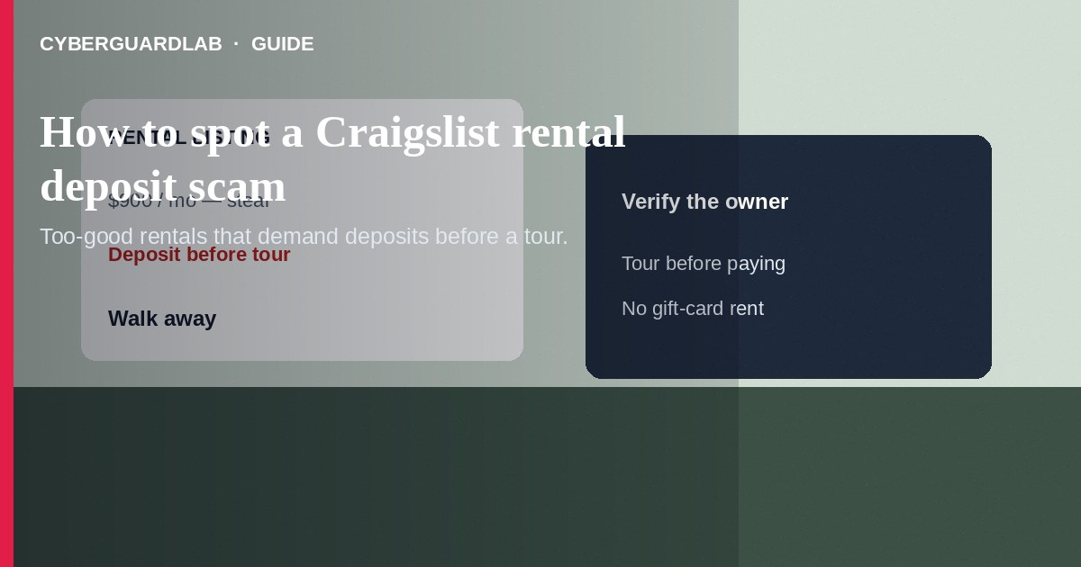
A Craigslist rental deposit scam advertises a too-good apartment or house, then demands a deposit, first month’s rent, or “application fee” before you can tour—or after a rushed virtual tour. Do not wire money, buy gift cards, or Zelle a stranger for a key you have not seen in person. Do not sign papers emailed from a free address without verifying ownership. If you already sent a deposit, stop contact, save records, and report to the FTC and local police.
This guide covers fake rental listings and deposit bait on classified sites—not timeshare exit schemes. It overlaps with fake check overpayment and apartment application scams. No software purchase required.
Paid link
Norton 360 | See the Norton first-year offer

See the Norton first-year offer
Offer page: https://cyberguardlab.com/norton

1. How Craigslist rental deposit scripts work
- Remote landlord story — Out-of-town or deployed owners demand payment before keys, often with stolen photos (FTC rental listing scams).
- Deposit-before-tour — Holding fees “expire tonight” while other applicants are wiring today.
- Fake-check wrap — A check for moving costs asks you to refund the difference (fake check scam).
- Uncontrolled showing — Someone shows a property they do not manage, then collects money and disappears.

2. Red flags before you send money
Cue | Likely legitimate | Likely scam
Tour | In-person showing or verified agent | Deposit required before any real-world viewing
Rent vs market | Close to nearby comps | Far below neighborhood rates with a soft excuse
Payment | Traceable methods to a named landlord after paperwork | Gift cards, crypto, wire, or instant cash apps
Ownership proof | You can verify owner or licensed agent | Refuses ID, deed, or management company contact
Communication | Local phone and consistent identity | Only email; story keeps changing
Documents | Standard lease you can review calmly | Urgent sign-and-pay PDF from a free mailbox

3. Safer habits (buy-nothing)
- Never send a deposit before you tour the unit or confirm a trusted agent.
- Reverse-image search listing photos when something feels off.
- Refuse gift cards, crypto, and hold-my-unit wires.
- Check county property records or ask a local realtor to sanity-check the listing.
- Use Craigslist’s official flagging tools; keep talks in channels you can document.
- If someone sends a check and asks for a partial return, see fake check scam guidance.

4. If you already paid
- Stop all further payments and cease contact except as advised by law enforcement.
- Save the ad URL, photos, emails, payment receipts, and usernames.
- Contact your bank, wire service, or cash-app support immediately (FTC if you were scammed).
- If gift cards were used, contact each issuer’s fraud department.
- Report at ReportFraud.ftc.gov and file a local police report.
- If you opened attachments or logged into a portal, change passwords and ignore recovery callers.

FAQ

Can a real landlord ever ask for a deposit by Zelle?
Some individuals do, but it is high risk. Prefer methods with clearer records after you verify the person and the property.

The rent is only a little low. Could it still be a scam?
Yes. Slight discounts plus remote-only landlords and deposit-before-tour rules are still common fraud patterns.

How is this different from a timeshare exit scam?
Timeshare exit targets people who already own a timeshare. Craigslist rental deposit scams target people hunting for a place to live.

Should I use a roommate finder instead?
Any platform can host fakes. Verify the unit, never pay blind, and beware overpayment refunds.

What if I already signed a PDF lease?
Signing a document from a scammer does not make the payment safe. Still report and pursue bank recovery steps.

Do I need paid antivirus to avoid a rental deposit scam?
No. Touring first and refusing gift-card deposits is enough. Buy-nothing is valid.

If you still want a paid suite
Avoiding a Craigslist rental deposit scam does not require paid antivirus. Careful habits and official support paths are a valid buy-nothing stack. If you want multi-device paid protection later, use only these on-site paid links: TotalAV (paid link), Norton (paid link), Bitdefender (paid link), McAfee (paid link), Avast (paid link).

Sources
- Rental Listing Scams (FTC)
- ReportFraud.ftc.gov
- IdentityTheft.gov
- Fake Check Scams (FTC)

Also read
- How to spot an apartment rental application scam
- How to spot a fake check scam
- How to spot a timeshare exit scam
- How to spot a Zelle or Cash App payment scam
- How to report a scam to the FTC

