
What to do if you clicked a phishing link
https://cyberguardlab.com/blog/clicked-phishing-link-first-hour
Independent US household comparison site. Not the vendor. Paid links below may earn a commission. Confirm first-year price, renewal, device limit, and refund terms at checkout.
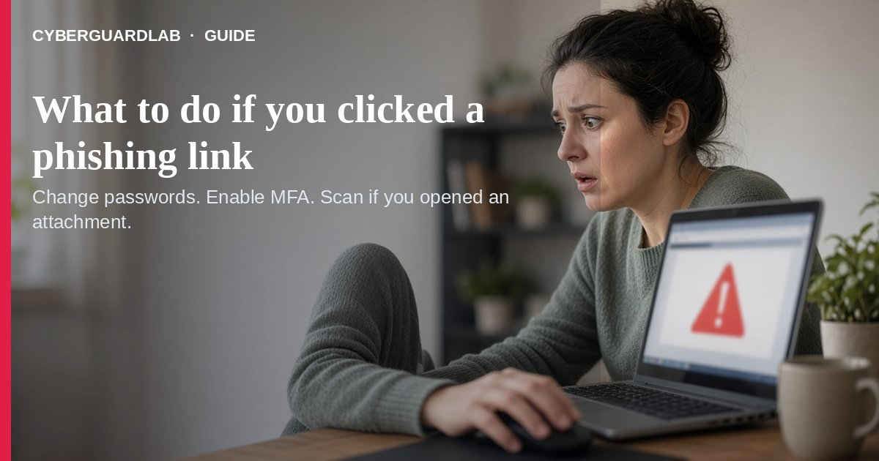
You clicked a phishing link (or opened a phishing attachment) when a message tricked you into visiting a fake site or downloading something harmful. Per the FTC, if you think a scammer has your Social Security, credit card, or bank details, start at IdentityTheft.gov; if you think malware downloaded, update your security software, run a scan, and remove what it finds.
This guide is the first-hour recovery after a click, not how to spot a phishing email before you click. Stay calm: most households can lock accounts down without buying anything if Defender (or your phone’s built-in protections) is already on.
Paid link
Norton 360 | See the Norton first-year offer

See the Norton first-year offer
Offer page: https://cyberguardlab.com/norton
Ad link: https://trysecurities.com/offer/norton?dtm=gg&cid=

1. First 15 minutes — stop the damage
From FTC phishing advice and CISA “recognize and report” guidance:
- Disconnect if you entered a password on a fake page. Close the tab. On Wi‑Fi you do not trust, switch networks or turn off Wi‑Fi briefly while you change passwords from a known-good device.
- Change the password for the account the phish targeted (bank, email, shopping, employer portal) using a device/browser you trust — not the fake page’s “reset” form.
- Change your email password next if the phish might have captured it — email resets everything else. See hacked email or social account.
- Turn on multi-factor authentication where it is missing — FTC lists MFA as a core phishing defense. Household walkthrough: turn on 2FA.
- Do not call numbers or reuse links from the phishing message. Contact the company via the app, statement, or website you type yourself (CISA).

2. If you entered financial or SSN details
- Go to IdentityTheft.gov for steps matched to what was stolen (FTC).
- Call the number on the back of your card or in your banking app for unauthorized charges — see also credit card fraud first hour and bank account hacked.
- Place fraud alerts / consider a credit freeze if SSN or identity data was shared — see credit freeze vs identity monitoring.
- Check whether your email appears in known breaches: check email data breach.

3. If you fear malware from a link or attachment
FTC: update security software, run a scan, remove problems it finds.
- On Windows, update Microsoft Defender and run a full scan; for stubborn infections consider an Offline scan.
- On phone, update the OS, remove unknown apps, and on Android run Play Protect.
- Uninstall shady browser extensions: remove scam Chrome extension.
- Back up important files once the device is cleaned (FTC lists backups as phishing protection).

4. Report and warn the household
- Forward phishing email to reportphishing@apwg.org; forward phishing texts to 7726 (SPAM) — FTC.
- Report at ReportFraud.ftc.gov — report a scam to the FTC.
- Tell family members which message was fake so they do not click the same lure.
- Review recent sign-ins on Google, Apple, Microsoft, and bank apps for unknown devices.

FAQ

What should I do first after clicking a phishing link?
Close it, change the targeted account password from a trusted device, enable MFA, then scan for malware if you opened an attachment or installed anything (FTC).

Is clicking always game over?
No. Many phish fail if you did not enter credentials or download malware. Still change passwords for anything you typed and report the message.

Where do I go if they have my SSN or bank numbers?
IdentityTheft.gov plus your bank/card issuer (FTC). Also see report identity theft.

How is this different from “how to spot phishing”?
Spotting is prevention; this page is recovery after a click. Start with how to spot a phishing email next time.

Do I must buy antivirus right now?
No. Defender + OS updates + password/MFA changes are a valid buy-nothing path. Paid suites are optional — see Is Microsoft Defender enough?.

If you still want a paid suite
Recovery after a phishing click does not require a paid suite if Defender (or your phone’s built-in tools) is current. If the household wants multi-device paid protection, use only these on-site paid links: TotalAV (paid link), Norton (paid link), Bitdefender (paid link), McAfee (paid link), Avast (paid link).

Sources
- How To Recognize and Avoid Phishing Scams (FTC)
- Recognize and Report Phishing (CISA)
- ReportFraud.ftc.gov (FTC)
- IdentityTheft.gov (FTC)

Also read
- How to spot a phishing email
- How to turn on 2FA for Gmail, Apple, and bank
- What to do if your email or social account is hacked
- How to check if your email is in a data breach
- What to do if your credit card is used fraudulently
- How to run a Microsoft Defender Offline scan
- How to report a scam to the FTC
- How to report identity theft at IdentityTheft.gov

