
How to clear saved passwords from a shared family PC
https://cyberguardlab.com/blog/clear-saved-passwords-shared-pc
Independent US household comparison site. Not the vendor. Paid links below may earn a commission. Confirm first-year price, renewal, device limit, and refund terms at checkout.
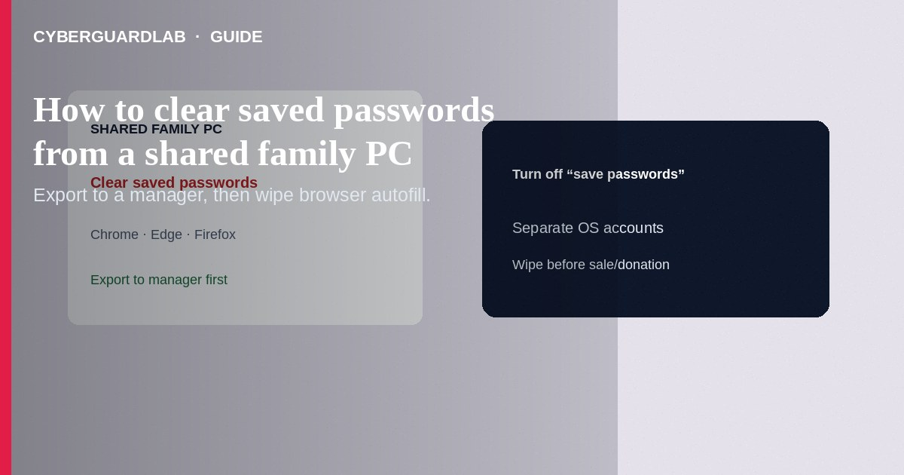
Clear browser-saved passwords on a shared family PC so the next roommate, babysitter, or relative cannot open banking or email autofill. Export to a password manager first if you still need the logins, then delete stored passwords and turn off saving on that profile. Prefer separate OS accounts per adult. This how-to is shared-PC browser credential cleanup—not household manager setup alone, not vault breach response, and not passkey enrollment.

1. Before you delete anything
- Confirm each adult has their passwords in a manager—see US household password manager setup.
- Export browser passwords only to an encrypted manager import or a temporary file you will delete—never leave `passwords.csv` on the Desktop.
- Note which browsers are installed (Chrome, Edge, Firefox, Safari-on-Windows is rare; also check stored Wi-Fi only if relevant to guests).
A full disk wipe / OS reinstall is safer than hoping “Clear passwords” caught every browser and app. Remove drives or reset per manufacturer guidance before the machine leaves the house.
Paid link
Norton 360 | See the Norton first-year offer

See the Norton first-year offer
Offer page: https://cyberguardlab.com/norton

2. Shared PC habits
Situation | Safer | Riskier
Family desktop | Per-person OS login + manager apps locked | One Windows profile with everyone’s autofill
Babysitter / guest | Guest account; no saved bank passwords | “Just use my Chrome—it’s fine”
Moving a PC | Clear passwords before sale/donation | Factory hopes without checking browsers
Sync | Personal sync only on personal devices | Syncing your vault profile onto the kids’ PC

3. Steps: Chrome, Edge, Firefox, and Windows hygiene
Steps: Chrome / Edge (Chromium)
- Open the browser profile that is shared.
- Go to Settings → Autofill / Passwords (chrome://password-manager or edge://wallet/passwords).
- Review the list; export if needed, then delete individual entries or remove all.
- Turn off “Offer to save passwords” on this shared profile.
- Sign out of the browser profile sync if it was syncing personal passwords onto the family PC.
- Clear cookies for banking sites if sessions are still live (Settings → Privacy → Cookies).
Steps: Firefox
- Settings → Privacy & Security → Logins and Passwords.
- Open Saved Logins → remove entries; uncheck “Ask to save logins.”
- Disconnect Firefox Account sync on that PC if it pushed personal logins.

4. Windows / household hygiene
- Create separate Windows accounts for each adult; use a Guest/limited account for casual use.
- Remove leftover password manager vault files only if you are decommissioning that app on this PC (do not delete the only copy of a vault).
- Scan the PC with one primary product such as Norton or Bitdefender; TotalAV, McAfee, and Avast are other on-site options.
- After cleanup, change high-value passwords that may have been visible to others (email, banking).

FAQ

Will this log me out of my phone?
Clearing passwords on the PC does not remove passwords inside your phone’s manager unless you delete the vault entries themselves.

How is this different from a vault breach alert?
Breach alerts mean credentials appeared in leak data or failed health checks. This article removes local autofill on a shared machine.

Should I also clear cookies?
Yes for banking/email on that profile—saved passwords and live sessions are different leftovers.

What about Apple Keychain on a shared Mac?
Use separate macOS users; avoid a single auto-login account with unlocked Keychain for everyone.

If you still want a paid suite
Avoiding how to clear saved passwords from a shared family PC does not require paid antivirus. Careful habits and official support paths are a valid buy-nothing stack. If you want multi-device paid protection later, use only these on-site paid links: TotalAV (paid link), Norton (paid link), Bitdefender (paid link), McAfee (paid link), Avast (paid link).

Sources
- CISA: Use strong passwords
- FTC: Password managers
- Google Chrome Help: Manage passwords
- Microsoft Edge Help: Manage passwords

Also read
- How to set up a password manager for a US household
- How to recover from a password manager vault breach alert
- How to wipe a device before selling
- How to turn on passkeys for Google, Apple, and Microsoft
- How to remove a browser hijacker on Windows

