
How to turn on enhanced Safe Browsing in Chrome
https://cyberguardlab.com/blog/chrome-enhanced-safe-browsing
Independent US household comparison site. Not the vendor. Paid links below may earn a commission. Confirm first-year price, renewal, device limit, and refund terms at checkout.
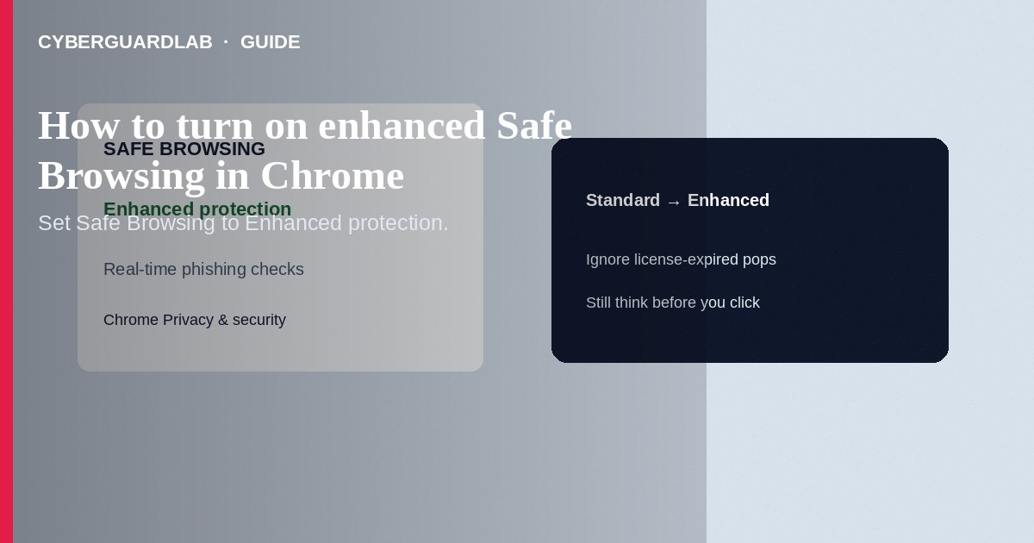
Enhanced protection (Enhanced Safe Browsing) in Google Chrome warns about more dangerous sites, downloads, and extensions than Standard protection—by sending additional security-related data to Google Safe Browsing in real time. Turn it on in Chrome Settings → Privacy and security → Safe Browsing. This how-to is Chrome’s browsing protection level—not Google third-party app access, not Find My Device, and not Android work profiles.

1. What Enhanced does
Standard protection blocks many known bad sites. Enhanced adds deeper checks for newly seen threats, suspicious downloads, and risky extensions, with more URL/content signals sent to Google for security analysis. You can stay on Standard if you prefer less sharing; Enhanced is the stronger security choice Google documents for Chrome.
Paid link
Norton 360 | See the Norton first-year offer

See the Norton first-year offer
Offer page: https://cyberguardlab.com/norton
Full-screen warnings with phone numbers are classic tech-support scams, not Chrome UI. Close the tab or soft-reset the browser; verify Safe Browsing only under chrome://settings (or the Settings menus above).

2. Levels compared
Level | Protection idea | Tradeoff
Enhanced protection | Stronger, newer-threat oriented checks | More security data to Google Safe Browsing
Standard protection | Default known-danger protection | Less data sharing than Enhanced
No protection | Off—not recommended | No Safe Browsing warnings in Chrome

3. Steps: turn on Enhanced protection
- Open Chrome → More (⋮) → Settings.
- Open Privacy and security → Safe Browsing.
- Select Enhanced protection.
- Optionally review related toggles Google shows for download scanning / improve security when signed in—read each description before enabling.
- Keep Chrome updated (About Chrome) so Safe Browsing lists and features stay current.
- Open Chrome → More → Settings → Privacy and security.
- Tap Safe Browsing.
- Select Enhanced protection.
- Open Chrome → ⋯ → Settings → Privacy and Security (labels vary).
- Open Safe Browsing / security browsing options and choose Enhanced if offered on your version.
- Note: Safari on iPhone uses Apple’s own fraud tools—Enhanced Safe Browsing is a Chrome setting, not an iOS system switch.

4. Pair with account hygiene
- Enhanced does not revoke bad OAuth apps—still review third-party access.
- It does not replace a full-disk antivirus on Windows; use Defender or one primary suite such as Norton or Bitdefender (TotalAV, McAfee, Avast on-site).
- Ignore scareware pop-ups that claim “Safe Browsing disabled—call this number.” Check the real Settings page yourself.

FAQ

Does Enhanced slow browsing a lot?
Google states Enhanced is designed not to meaningfully slow normal browsing; if something feels wrong, check extensions first.

Is this the same as Android Google Play Protect?
No. Play Protect scans apps/devices; Enhanced Safe Browsing is a Chrome browsing setting.

Will it stop fake Play billing emails?
It may warn on malicious links you open in Chrome, but you must still avoid phishing—see fake Google Play billing.

Do I need Enhanced on every profile?
Enable it on each Chrome profile you use, including work profiles if policy allows.

If you still want a paid suite
Avoiding how to turn on enhanced Safe Browsing in Chrome does not require paid antivirus. Careful habits and official support paths are a valid buy-nothing stack. If you want multi-device paid protection later, use only these on-site paid links: TotalAV (paid link), Norton (paid link), Bitdefender (paid link), McAfee (paid link), Avast (paid link).

Sources
- Google Chrome Help: Choose Safe Browsing protection level
- Google Chrome Help: How Safe Browsing keeps data private
- FTC: Malware and phishing basics
- FTC: Secure your computer

Also read
- How to review Google account third-party app access
- How to spot a fake Google Play billing phishing email
- How to remove a browser hijacker from Windows
- How to spot a phishing email
- How to use a work profile to isolate risky Android apps

