
How to turn on number lock at T-Mobile, Verizon, or AT&T
https://cyberguardlab.com/blog/carrier-number-lock-tmobile-verizon-att
Independent US household comparison site. Not the vendor. Paid links below may earn a commission. Confirm first-year price, renewal, device limit, and refund terms at checkout.
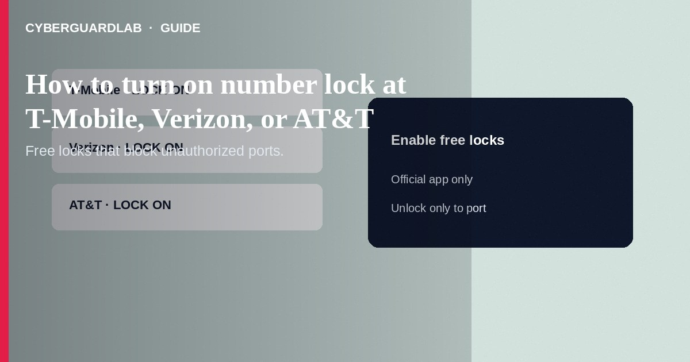
Number lock (and related SIM / wireless account lock features) stops most unauthorized moves of your mobile number to another SIM or carrier until you turn the protection off. Enable the free toggles in your carrier’s official app or account security page, keep a strong account PIN, and disable locks only when you intentionally port or change SIM/eSIM. This how-to covers T-Mobile, Verizon, and AT&T style locks—not fake 2FA texts, not authenticator migration, and not IRS or credit freezes.

1. What to turn on (by carrier family)
Labels differ. Verizon documents Number Lock (port-out protection) and separate SIM Protection. T-Mobile documents SIM Protection and account PIN / port-validation style passcodes. AT&T documents Wireless Account Lock on the myAT&T app to block sensitive wireless changes including SIM and number transfers. Use the primary account holder login. Features and menus change—confirm on the carrier’s help pages you open yourself.
Paid link
Norton 360 | See the Norton first-year offer

See the Norton first-year offer
Offer page: https://cyberguardlab.com/norton
If you plan a carrier-authorized eSIM change abroad, unlock protections on purpose first, complete the change, then lock again. Do not accept “tourist help desk” offers to unlock your account for you.

2. Feature cheat sheet
Carrier | Common protection name | Typical use
Verizon | Number Lock + SIM Protection | Block ports; separately block SIM changes
T-Mobile | SIM Protection + account PIN / port validation | Block unauthorized SIM moves; harden care auth
AT&T | Wireless Account Lock | Block sensitive account changes including SIM/port style actions

3. Steps: enable locks safely
- Update the official carrier app from your phone’s app store, or sign in on the carrier website you type yourself.
- Open Security / Profile / Account protection (wording varies).
- Verizon: enable Number Lock for each line you want protected; also enable SIM Protection. Remember Number Lock alone does not block every SIM/device change—use both when offered.
- T-Mobile: enable SIM Protection for the line or account in T-Life or T-Mobile.com; set a strong account PIN; ask care about port-out validation passcodes if your account type uses them.
- AT&T: in the myAT&T app, turn on Wireless Account Lock for postpaid consumer accounts when available; unlock only when you need a blocked change.
- Verify status shows On/Locked. Save a note offline that locks must be off before a legitimate port or SIM swap you initiate.
- Reduce SMS 2FA on email and banking—prefer authenticator apps or Google Prompt.
- If you receive unexpected “disable number lock” texts, ignore them. Carriers state they will not cold-ask you to unlock for “fraud reversal.” Scan phishing-hit devices with a trusted tool such as Norton or Bitdefender. Keep one primary real-time antivirus—avoid stacking full suites. TotalAV, McAfee, and Avast are other on-site comparison options.

4. If something goes wrong
- Legitimate port fails: disable Number Lock / Account Lock temporarily via official app or *611-style care you initiate, complete the port, then re-enable.
- New phone eSIM error: turn off SIM protection only long enough to complete the carrier’s official transfer steps.
- Service dies without your action: call the carrier from another phone; request fraud review and re-lock.
- Someone asks you to screenshot lock settings: refuse—that can help social engineers.

FAQ

Is number lock the same as an account PIN?
No. PINs authenticate you to staff; number/SIM/account locks are toggles that block specific changes until disabled.

Do I need locks if I use authenticator apps?
Yes. Locks protect the phone number itself; authenticators protect account logins. Use both.

Will locks stop all fraud?
They block many unauthorized ports and SIM changes. Still avoid SMS-only 2FA and phishing.

Prepaid vs postpaid?
Availability differs. Check your carrier’s prepaid help for SIM protection or account lock variants.

If you still want a paid suite
Avoiding how to turn on number lock at T-Mobile, Verizon, or AT&T does not require paid antivirus. Careful habits and official support paths are a valid buy-nothing stack. If you want multi-device paid protection later, use only these on-site paid links: TotalAV (paid link), Norton (paid link), Bitdefender (paid link), McAfee (paid link), Avast (paid link).

Sources
- Verizon: Number Lock / port-out FAQs
- Verizon knowledge base: SIM Protection and Number Lock
- T-Mobile: Account fraud protections
- AT&T: Wireless Account Lock
- IdentityTheft.gov

Also read
- How to set a carrier account PIN to stop SIM swap
- How to spot a fake two-factor authentication text
- How to turn on Google Prompt instead of SMS codes
- How to move authenticator apps to a new phone safely
- How to spot a WhatsApp account takeover scam

