
How to set a carrier account PIN to stop SIM swap
https://cyberguardlab.com/blog/carrier-account-pin-sim-swap
Independent US household comparison site. Not the vendor. Paid links below may earn a commission. Confirm first-year price, renewal, device limit, and refund terms at checkout.
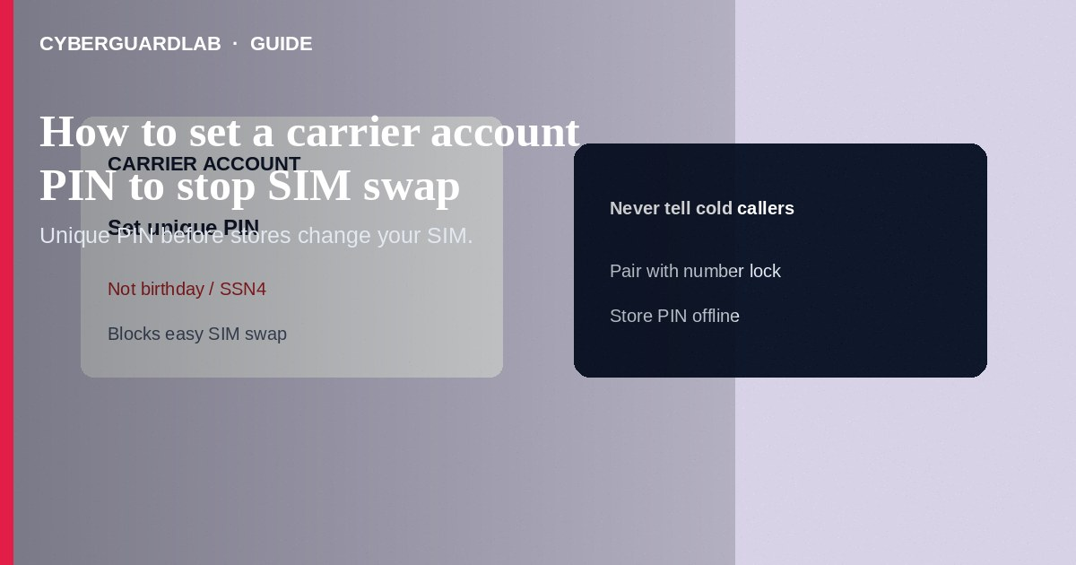
A carrier account PIN (passcode) is a secret you set with your mobile provider so store staff and phone support must verify you before changing SIMs, ports, or account details—raising the bar against SIM-swap social engineering. Create a unique PIN that is not your birthday or the last four of your SSN, store it offline, and never read it to cold callers. Pair it with number lock / SIM protection features your carrier offers. This how-to is about account PINs for anti-SIM-swap hygiene—not number lock toggles alone, not fake 2FA texts, and not moving authenticator apps.

1. Why account PINs matter for SIM swap
In a SIM swap, a scammer convinces the carrier to move your number to a SIM they control, then intercepts SMS codes for email and banking. A strong account PIN—and refusing to share it—blocks many retail and call-center takeover scripts. It does not replace app-based authenticators or stop every port-out; use carrier number lock / SIM protection too.
Paid link
Norton 360 | See the Norton first-year offer

See the Norton first-year offer
Offer page: https://cyberguardlab.com/norton
Scammers spoof carrier caller ID and ask you to confirm the account PIN to “cancel a fraudulent SIM.” End the call and use in-app chat or a number printed on your bill. Tell family members who share a family plan that only the primary holder should change the PIN.

2. PIN vs number lock
Control | What it mainly does | Watch-out
Account PIN / passcode | Extra secret for care and store authentication | Useless if you read it to a scammer
Number lock / port protection | Blocks moving the number until you unlock | Must disable before a legitimate port
SIM protection | Blocks unauthorized SIM/eSIM changes | Disable briefly only when you swap devices yourself

3. Steps: set a carrier account PIN
- Decide a long, unique numeric or alphanumeric PIN per your carrier’s rules. Do not reuse ATM PINs or “1234.”
- Sign in to your carrier account on the official app or site you type yourself (T-Mobile, Verizon, or AT&T help pages list current PIN setup paths).
- Open Profile / Security / Account PIN (labels vary). Set or reset the PIN as the primary account holder when required.
- If the carrier only sets certain PINs by calling care or dialing a short code, use numbers from the official app—not a number in a text ad.
- Confirm whether authorized users can see or change the PIN; limit that privilege.
- Turn on related free protections: SIM protection / number lock / wireless account lock—covered in carrier number lock guide.
- Move high-value accounts from SMS codes to authenticator apps or Google Prompt where possible—see Google Prompt instead of SMS.
- After any suspected swap attempt, call the carrier from a known-good line, secure the number, change email passwords, and scan devices with a trusted tool such as Norton or Bitdefender. Keep one primary real-time antivirus—avoid stacking full suites. TotalAV, McAfee, and Avast are other on-site comparison options.

4. If something goes wrong
- Cold caller asks for your account PIN “to stop fraud”: hang up. Real prevention does not start with you reading the PIN to an inbound stranger.
- You forgot the PIN: use the carrier’s official recovery while on a channel you initiated.
- Sudden loss of service plus “SIM changed” alerts: contact the carrier immediately from another phone; request account lockdown.
- SMS codes for banks still arrive elsewhere: assume number compromise; switch those accounts to app-based 2FA and recover email first.
- Store visit pressure: you can refuse changes until you verify on the official app.

FAQ

Is the account PIN the same as my voicemail PIN?
Usually no. Account PINs protect carrier account changes; voicemail PINs protect the mailbox. Set both strongly and differently.

Is setting a PIN enough to stop SIM swap?
It helps a lot but is not complete. Add number lock / SIM protection and reduce reliance on SMS 2FA.

Can AT&T, Verizon, and T-Mobile all use PINs?
Yes—each documents account PIN or passcode-style authentication. Menus differ; follow that carrier’s current help article.

Should I text my PIN to myself for backup?
No. Store offline or in a reputable password manager. SMS backups are visible after a swap.

If you still want a paid suite
Avoiding how to set a carrier account PIN to stop SIM swap does not require paid antivirus. Careful habits and official support paths are a valid buy-nothing stack. If you want multi-device paid protection later, use only these on-site paid links: TotalAV (paid link), Norton (paid link), Bitdefender (paid link), McAfee (paid link), Avast (paid link).

Sources
- T-Mobile: Protect your account from fraud (PIN / SIM protection)
- Verizon: Port-out / Number Lock FAQs
- AT&T: Wireless Account Lock announcement (account change protection)
- FTC: SIM swap and account security awareness via IdentityTheft.gov
- FTC ReportFraud

Also read
- How to turn on number lock at T-Mobile, Verizon, or AT&T
- How to spot a fake two-factor authentication text
- How to turn on Google Prompt instead of SMS codes
- How to move authenticator apps to a new phone safely
- How to spot a WhatsApp account takeover scam

