
How to protect your car from a key fob relay attack in the driveway
https://cyberguardlab.com/blog/car-key-relay-attack-home-driveway
Independent US household comparison site. Not the vendor. Paid links below may earn a commission. Confirm first-year price, renewal, device limit, and refund terms at checkout.
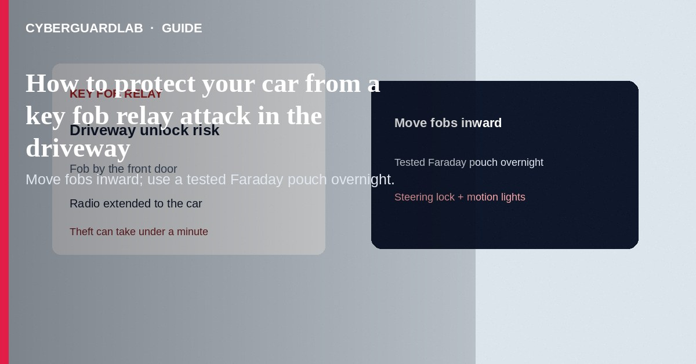
A key fob relay attack uses two radios: one near your house to catch the passive keyless-entry signal, and one by the car in the driveway so the vehicle unlocks—and sometimes starts—as if the fob were next to it. You do not need to buy specialty “antivirus for cars.” Store fobs away from the front door, use a tested Faraday pouch or metal box overnight, and add simple physical deterrence. This guide is home-driveway relay theft—not phone wipe after loss, and not a product ranking of immobilizers.

How a driveway relay attack works
Passive keyless systems wake when the car and fob exchange a short-range radio signal. Attackers extend that path so a fob sitting by the front door, garage entry, or an exterior wall still “answers” a car parked outside. Thefts often take under a minute at night. Relays do not require breaking a window first; visible steering-wheel locks and motion lighting still help by slowing thieves who want a quiet exit.
Paid link
Norton 360 | See the Norton first-year offer

See the Norton first-year offer
Offer page: https://cyberguardlab.com/norton

Practical defenses that help
Defense | Why it helps | Household tip
Move fobs inward | Signal is harder to catch through the whole house | Not on the hallway table by the front door
Faraday pouch / metal box | Blocks the fob radio when closed | Test: sealed pouch should stop unlock when you walk to the car
Manufacturer sleep / disable passive entry | Some fobs or cars can sleep the radio | Check the owner’s manual or dealer—settings vary
Garage when possible | Removes the easy driveway target | Lock the garage; do not leave a spare fob in the car
Steering-wheel lock / visible deterrent | Slows thieves who prefer fast, quiet thefts | AAA and police guidance still recommend visible locks
Lighting / cameras | Raises chance of being seen | Motion lights on the driveway; see also home camera hygiene

What to do tonight (checklist)
- Bring every keyless fob—including spares—away from exterior doors, mail slots, and windows facing the driveway.
- Put overnight fobs in a Faraday pouch or small metal container. Test once: with the pouch sealed, the car should not unlock as you approach.
- Read the manual for “passive entry off,” “key fob sleep,” or similar. Ask the dealer if unclear.
- Park in a locked garage when you can. On the driveway, lock the car, close windows, and avoid leaving bags visible.
- Consider a visible steering-wheel lock if your street sees keyless thefts. It is not high-tech; it is a delay.
- Add motion lighting (and cameras only if you already accept the privacy tradeoffs of home security cameras).
- Keep car keys separate from house keys when you are out, so a stolen car keyring does not hand over the home.
- Phone/PC security is separate from relay theft—but if thieves also phish your garage or camera apps, use Defender or one paid product (Norton, Bitdefender, TotalAV, McAfee, Avast). Buying nothing extra for the fob problem is valid if pouches + placement are solid.

If the car is already gone
- Call local police and your insurer; have the plate, VIN, and last-seen time ready.
- Use any factory stolen-vehicle tracking / connected-car account from a clean login you type yourself.
- Ask the dealer about immobilizer resets and whether spare fobs should be reprogrammed after recovery.
- Review whether a spare fob was missing from the house.

Extra caution on spare fobs in the “junk drawer by the door”
Attackers only need proximity to a live fob. Spares left near the entry are as useful to a relay pair as the daily driver key. Store spares inward and shielded the same way.

FAQ

Does aluminum foil always work?
Improvised wrapping is unreliable. Prefer a pouch you tested against your own car, or a metal box that fully closes.

Will a Faraday pouch stop every car theft?
No. It targets relay and some RF replay risks. Break-ins, OBD attacks, and stolen physical keys are different problems.

Is “buy a $20 gadget on social media” required?
No. Placement + tested signal blocking + physical delay are the core household steps. Skip miracle ads.

Do all keyless cars get relayed?
Risk varies by model year and anti-relay design. Newer distance-bounding features help on some vehicles—ask the manufacturer—but habits still matter for older passive systems.

Is this the same as cloning my key at a store?
No. Relay extends a live fob signal in the moment; it is not the same as cutting a metal key copy.

If you still want a paid suite
Driveway relay defense is mostly fob placement and physical delay—not a software purchase. Buy-nothing is valid. If you still want multi-device paid protection for phones and PCs, use only these on-site paid links: Norton (paid link), Bitdefender (paid link), TotalAV (paid link), McAfee (paid link), Avast (paid link).

Sources
- AAA: 9 ways to prevent car theft (key-fob relay / Faraday)
- AAA: How to protect your car from cybercrime
- CISA: Autonomous Ground Vehicle Security Guide (PDF)

Also read
- Lost phone: lock Apple and Google accounts
- Home security camera hygiene
- How to spot a one-time passcode relay scam call
- Is Microsoft Defender enough?
- Automatic updates on Windows, Mac, and phone
- Change your home router admin password

