
How to spot a buy-now-pay-later account takeover
https://cyberguardlab.com/blog/buy-now-pay-later-account-takeover
Independent US household comparison site. Not the vendor. Paid links below may earn a commission. Confirm first-year price, renewal, device limit, and refund terms at checkout.
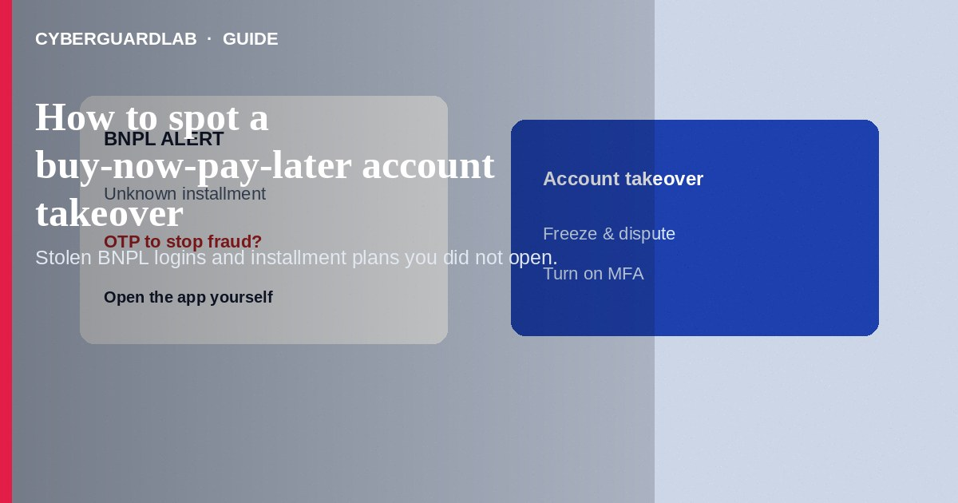
A buy-now-pay-later (BNPL) account takeover happens when someone uses stolen credentials, SIM-swap access, or phishing to open or take over Affirm, Afterpay, Klarna, PayPal Pay in 4, or similar installment accounts—and places orders you did not authorize. Do not approve unexpected BNPL login or purchase prompts. Do not share one-time codes with callers. If you already see unfamiliar installments, freeze access, contact the BNPL provider and merchants, and report to the FTC.
This guide is about unauthorized BNPL credit and account abuse—not fake refund or overpayment schemes where you are tricked into sending extra money back. Phishing pages mimic BNPL login screens—see how to spot a phishing email. Gift-card payment demands overlap with gift card scams. No software purchase required.
Paid link
Norton 360 | See the Norton first-year offer

See the Norton first-year offer
Offer page: https://cyberguardlab.com/norton

1. How buy-now-pay-later takeover scripts work
You get emails or texts about BNPL purchases you did not make, password resets, or verify your Afterpay/Klarna/Affirm payment. Attackers who already have your email or SMS codes may add a new device, change the phone number, and shop at online retailers with installment checkout.
- Phished or reused passwords — Login pages that mimic BNPL brands (FTC phishing guidance).
- OTP social engineering — Callers who need a code to stop fraud.
- SIM-swap recovery — Phone number moves so attackers receive codes.
- Silent shopping — You first notice when a payment reminder or shipment appears.

2. Red flags of takeover
Cue | Likely legitimate | Likely scam
Purchase memory | You recognize the merchant and amount | Orders or payment plans you did not start
Login prompts | Arrive only when you are signing in | Unexpected OTP asks from cold texts/calls
Account changes | You initiated email/phone updates | Phone number or address changed without you
Support contact | You open the BNPL app/help yourself | Caller demands codes to stop fraud
Shipping | Your address on file | Ship-to addresses you do not recognize
Password hygiene | Unique password + MFA on BNPL and email | Reused passwords after a breach notice

3. Safer habits (buy-nothing)
- Do not tap unexpected BNPL links. Open the official app or site yourself.
- Never read installment or login codes to a caller.
- Turn on MFA everywhere you use BNPL and on the email that recovers those accounts.
- Use unique passwords; a password manager helps.
- Review recent orders and linked cards inside the BNPL account.
- Treat gift-card payment demands as fraud—see gift card scam patterns.

4. If you already see takeover signs
- Change passwords for email and every BNPL account from a clean device; enable MFA.
- Contact the BNPL provider’s official fraud/help channel to freeze the account and dispute unauthorized plans.
- Contact merchants for unauthorized orders and your bank/card issuer for linked funding sources (FTC if you were scammed).
- If a phone number was SIM-swapped, contact your mobile carrier’s fraud team.
- Report at ReportFraud.ftc.gov and start a recovery plan at IdentityTheft.gov when identity elements were used.
- Ignore recovery callers who ask for more codes or fees.

FAQ

I never signed up for BNPL. How can there be a plan in my name?
Fraudsters may open accounts with stolen identity data or phish an existing soft account tied to your email. Still report and dispute.

Is this the same as a fake refund overpayment scam?
No. Overpayment scams push you to send money out. BNPL takeover abuses installment credit and account access—often without you intentionally sending a refund.

A text says my Klarna order is on the way. What should I do?
Ignore the link. Open the official Klarna (or other) app yourself to see whether a real order exists.

Will disputing hurt my credit?
Unauthorized fraud should be reported promptly. Follow the provider’s dispute process and IdentityTheft.gov guidance for your situation.

Can retailers stop BNPL fraud alone?
They can help cancel unshipped orders, but you still need the BNPL provider and, when relevant, credit bureaus involved.

Do I need paid antivirus to avoid BNPL takeover?
No. Unique passwords, MFA, and ignoring cold OTP asks are enough. Buy-nothing is valid.

If you still want a paid suite
Avoiding a buy-now-pay-later account takeover does not require paid antivirus. Careful habits and official support paths are a valid buy-nothing stack. If you want multi-device paid protection later, use only these on-site paid links: TotalAV (paid link), Norton (paid link), Bitdefender (paid link), McAfee (paid link), Avast (paid link).

Sources
- ReportFraud.ftc.gov
- IdentityTheft.gov
- Phishing Scams (FTC)
- Imposter Scams (FTC)

Also read
- How to spot a fake refund or overpayment scam
- How to spot a phishing email
- How to spot a gift card scam
- Amazon account hacked: first hour
- How to report a scam to the FTC

