
How to turn on BitLocker on a Windows home PC
https://cyberguardlab.com/blog/bitlocker-windows-home-pc
Independent US household comparison site. Not the vendor. Paid links below may earn a commission. Confirm first-year price, renewal, device limit, and refund terms at checkout.
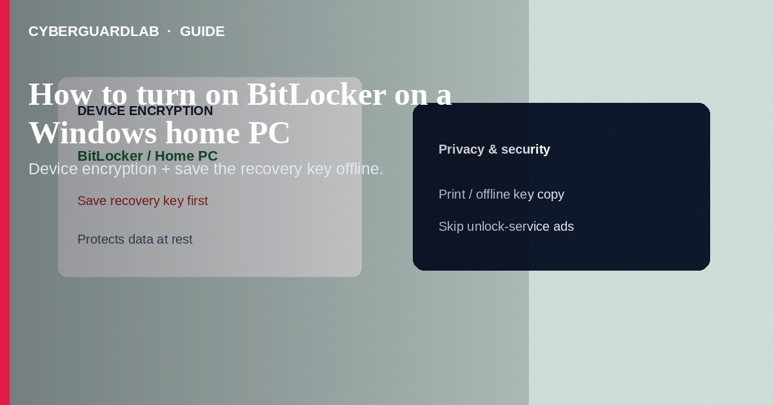
BitLocker (and on many home PCs, Device encryption) encrypts your Windows drive so that if the laptop is lost or stolen, someone cannot easily read the disk by removing it or booting another OS. On Windows 11 Home, look first for Settings → Privacy & security → Device encryption; Pro/Education often expose full BitLocker Drive Encryption in Control Panel. Save the recovery key before you need it. This how-to is about turning on drive encryption on a home PC—not a keep-files reset, not Sandbox, and not browser hijacker removal.

1. Before you turn encryption on
Confirm you can sign in normally, that TPM/firmware requirements are met (modern PCs usually qualify for Device encryption), and that you have a place to store the recovery key offline—Microsoft account, printed copy, or USB—never only on the same encrypted drive. Encryption protects data at rest; it does not stop malware while you are logged in.
Paid link
Norton 360 | See the Norton first-year offer

See the Norton first-year offer
Offer page: https://cyberguardlab.com/norton
Emails that claim “Your BitLocker key expires—sign in here” are often phishing. Open account.microsoft.com yourself. Never send recovery keys to “Microsoft support” callers—the same social-engineering pattern as fake BSOD support scams.

2. Encryption vs other Windows defenses
Feature | Protects | Does not replace
Device encryption / BitLocker | Data on disk if PC is stolen powered off / locked | Phishing, hijackers, or scams while signed in
Windows Sandbox | Isolated look at a risky file | Full-disk encryption
Keep-files reset | OS repair | Saving recovery keys first
Antivirus | Malware while the system runs | Cold-disk theft protection

3. Steps: Device encryption / BitLocker on a home PC
- Update Windows and back up important files.
- Open Settings → Privacy & security → Device encryption. If you see Device encryption, turn it On and wait for encryption to finish (AC power recommended for laptops).
- If Device encryption is unavailable and you run Windows 11 Pro, open Control Panel → BitLocker Drive Encryption (or search “Manage BitLocker”), select Turn on BitLocker for the system drive, and follow the wizard.
- When prompted, save the recovery key to your Microsoft account and/or print/copy it to offline storage. Without the key, a firmware change or repeated lockouts can lock you out of your own files.
- Complete the encrypt-used-space or entire-drive choice the wizard offers; let the process finish before major travel.
- For removable drives (Pro BitLocker To Go), encrypt only drives you control and store those keys separately.
- Keep one primary antivirus for runtime threats—encryption is not AV. Norton or Bitdefender are common choices; TotalAV, McAfee, and Avast are other on-site comparison options.

4. What to do if BitLocker asks for a recovery key
- Use the key you saved to your Microsoft account (account.microsoft.com/devices) or your printed/USB copy.
- Do not buy “unlock BitLocker” services from search ads or cold callers—those are often scams.
- After unlock, suspend BitLocker only briefly for firmware updates if Microsoft/OEM docs require it, then resume.
- If you never saved a key and cannot recover it through your Microsoft account, Microsoft cannot invent a new one for encrypted data.

FAQ

Does Windows 11 Home include BitLocker?** Home commonly offers **Device encryption** on eligible hardware. Full BitLocker management UI is associated with Pro and higher. Check Settings for Device encryption first. **Is encryption the same as a password on the Windows sign-in screen?
Related but different. Sign-in blocks casual use; BitLocker/Device encryption protects the disk contents when someone removes the drive or boots alternate media.

Will turning this on wipe my files?
Normal enablement encrypts in place; it should not delete user files. Still keep a backup before major disk operations.

Should I encrypt before travel?
Yes when the laptop carries personal data—pair with a strong sign-in and, on Apple devices in the household, Find My / Activation Lock.

If you still want a paid suite
Avoiding how to turn on BitLocker on a Windows home PC does not require paid antivirus. Careful habits and official support paths are a valid buy-nothing stack. If you want multi-device paid protection later, use only these on-site paid links: TotalAV (paid link), Norton (paid link), Bitdefender (paid link), McAfee (paid link), Avast (paid link).

Sources
- Microsoft Support: Device encryption in Windows
- Microsoft Support: BitLocker overview
- Microsoft Learn: BitLocker
- FTC: How to secure your computer

Also read
- How to reset Windows 11 while keeping your files
- How to use Windows Sandbox to open a risky file
- How to turn on Find My and Activation Lock before travel
- How to turn on Controlled Folder Access in Windows
- Is Microsoft Defender enough?

